ACCOUNTABILITY AND FINANCIAL TRANSPARENCY OF NURUL ILMI MOSQUE

TITLE
SKRIPSI
UNTUK SEMINAR PROPOSAL



Oleh:
GALVIN YAHYA RUSADI
2201036066
S-1 AKUNTANSI

FAKULTAS EKONOMI DAN BISNIS
UNIVERSITAS MULAWARMAN
SAMARINDA
2025

HALAMAN PENGESAHAN
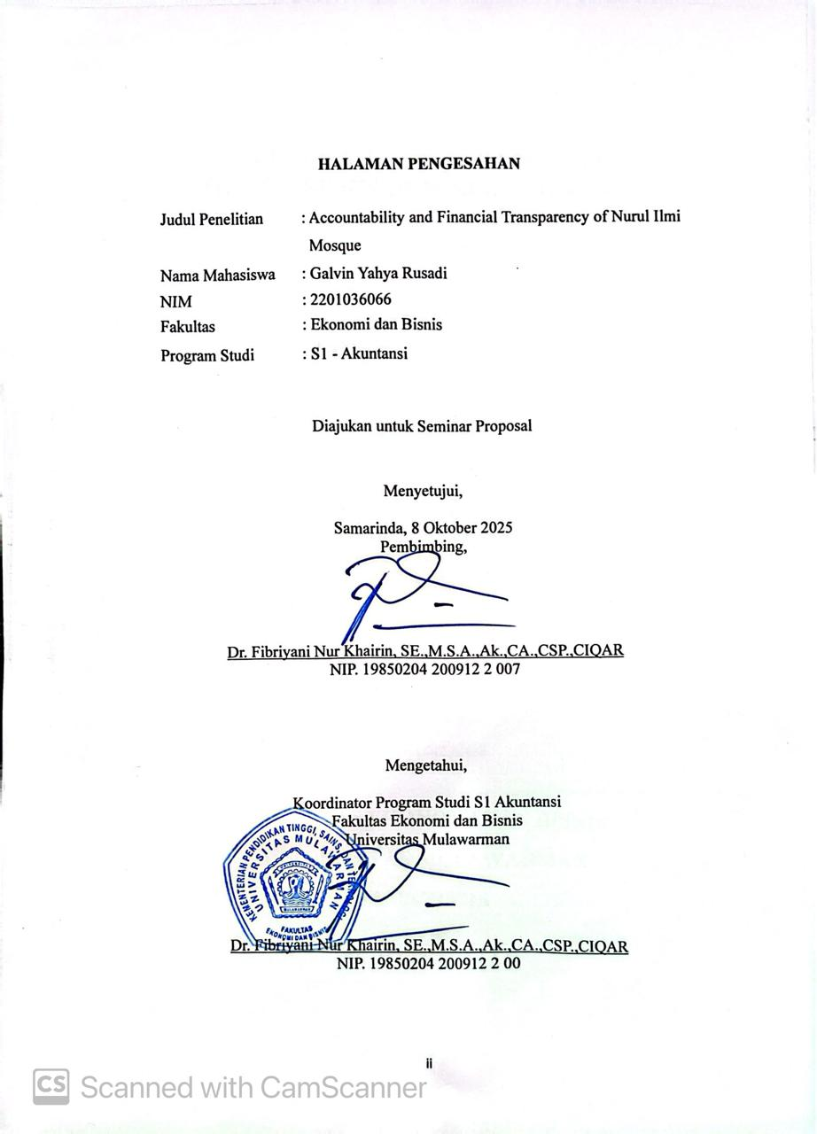

TABLE OF CONTENTS

TITLE i
HALAMAN PENGESAHAN ii
TABLE OF CONTENTS iii
LIST OF TABLES v
LIST OF FIGURE vi
LIST OF ABBREVIATIONS vii
TABLE OF APPENDIX viii
CHAPTER I INTRODUCTION 1
1.1 Background 1
1.2 Problem Formulation 4
1.3 Reseach Objectives 4
1.4 Benefits of Research 5
CHAPTER II LITERATURE REVIEW 7
2.1 Non Profit Organizations 7
2.2 Accountability 8
2.3 Transparency 9
2.4 ISAK 35 10
2.4.1. Statement of financial position 11
2.4.2. Statement of comprehensive income 14
2.4.3. Statement of changes in net assets 17
2.4.4. Statement of cash flow 19
2.4.5. Notes to the financial statements 22
2.5 Previous Research Table 22
2.6 Framework of thinking 24
CHAPTER III METHODOLOGY 26
3.1 Type of Research 26
3.2 Research Focus 27
3.3 Research Informants 27
3.4 Data Collection Techniques 28
3.5 Data Analysis Techniques 29
BIBLIOGRAPHY 31
APPENDIX 34

LIST OF TABLES
Table 2. 1 Previous Research 21

Table 3. 1 Research Informant 27

LIST OF FIGURE
Figure 2. 1 Form of Financial Statement Position A 11
Figure 2. 3 Form of Comprehensive Income Statement A 14
Figure 2. 4 Form of Comprehensive Income Statement B 15
Figure 2. 5 Form of changes in net assets statement 17
Figure 2. 6 Form of cash flow statement (direct method) 19
Figure 2. 7 Form of cash flow statement (undirect method) 20

LIST OF ABBREVIATIONS
ISAK 35 Interpretasi Standar Akuntansi Keuangan 35
PSAK 45 Pernyataan Standar Akuntansi Keuangan 45
NPO Non Profit Organizations
DSAK Dewan Standar Akuntansi
IAI Ikatan Akuntan Indonesia

TABLE OF APPENDIX

Appendix 1: list of interview questions 34

CHAPTER I
INTRODUCTION

Background
The mosque, called a "masjid" in Arabic, occupies a central place in Islamic civilization. Historically, it has served not only as a place of worship, but also as a hub for community activities, education, political discussions, and social welfare. According to Utaberta et al. (2015), "the mosque served many purposes: it acted as an Islamic community center, a place of worship, a place of political discussion, religious instruction and it was also an educational center". This multi-functionality underscores the essential nature of mosques beyond their religious dimension.
Contemporary mosques continue to play a crucial social role. Research indicates that they serve as vital community centers that support social welfare, promote civic engagement, and foster social cohesion, particularly within Muslim minority communities (Peucker, 2017). However, the civic and educational functions of mosques are not always fully utilized. A study conducted in Sri Lanka by Mim (2018) revealed that in some contexts, mosque engagement in broader community development activities remains minimal, primarily because mosques are perceived narrowly as houses of worship rather than community centers.
Moreover, mosques can be understood as part of the broader public sector, particularly in their role as nonprofit religious organizations serving community needs. As nonprofit entities, mosques manage resources entrusted to them by the public,
including donations, grants, and other voluntary contributions. According to Dyah Prameswari et al. (2025) mosques operate to achieve specific objectives without the expectation of profit and are responsible for managing resources obtained from the community with sincerity, transparency, and accountability.
Religious organizations such as mosques for Islam use public funds as a source of funding in the form of donations, contributions, and other forms of financial assistance obtained from the public (Asdar et al., 2014). From a managerial perspective, a mosque is a public sector organization that operates as a non-profit entity. It carries out its activities by managing resources that are voluntarily and sincerely contributed by the community, such as zakat, waqf, infaq, and alms (Siskawati et al., 2016). These diverse sources of funding are generally used to finance the mosque's routine operational needs, such as electricity, water, and religious activities, while also serving as a financial resource that can support the development of the mosque's social and religious functions in the community.
Mosques as non-profit organizations often face obstacles in financial reporting practices. Many mosques do not yet have adequate recording systems, so the financial reports they compile tend to be simple and do not meet accounting standards. As shown in research by Siregar et al. (2023), the financial of Al-Ikhlas Mosque still uses simple bookkeeping (only income and expenses) and has not compiled detailed financial reports in accordance with Interpretasi Standar Akuntansi Keuangan (ISAK) 35. Another study in Bengkulu by asmarita et al. (2022) also found that several mosques have not compiled financial reports in accordance with Pernyataan Standar Akuntansi Keuangan (PSAK) No. 45, so their transparency and accountability are still limited. This situation limits the transparency and accountability of fund management, even though congregations and the community have the right to know how the funds they have donated are being used. Research shows that there are still mosques that are unable to present financial reports in accordance with accountability and transparency indicators, so that the information conveyed to congregations is not optimal.
ISAK 35 is an accounting standard that regulates the presentation of financial statements of non-profit entities, including religious organizations such as mosques. ISAK 35 provides guidelines for non-profit entities to prepare financial statements consisting of a statement of financial position, a statement of comprehensive income or statement of activities, a statement of change in assets, a cash flow statement, and notes to the financial statements. The application of ISAK 35 brings various benefits, including increased transparency, accountability, of financial statements.
Since 1997, non-profit organizations have been regulated by PSAK 45. However, starting in 2019, PSAK 45 was replaced by ISAK 35. With the issuance of this new regulation, non-profit organizations prepare their financial statements in accordance with ISAK 35. However, the emergence of this new regulation has been difficult for non-profit organizations to implement because many non-profit organizations do not have a background in accounting, making it difficult to implement (Purba & Siregar, 2021)
The Nurul Ilmi Mosque in Samarinda is an interesting case study in the context of mosque financial reporting, as it currently functions as a center for religious and social activities with complete facilities. The mosque has a representative administrative office, a large parking area that is rented out commercially, and also provides education for children in the form of playgroups. These conditions make fincial reporting at the Nurul Ilmi Mosque increasingly complex, requiring the implementation of transparent and accountable accounting standards. This study focuses on the financial reporting practices of the Nurul Ilmi Mosque in Samarinda and employs a qualitative descriptive approach to explore accountability and transparency based on ISAK 35 standards.

Problem Formulation
- How tranparant and accountable the financial accounting process of mosques ?
- To what extent are mosque financial reports in accordance with ISAK 35 standards ?

Reseach Objectives
- To understand the transparency and accountability of financial accounting process in mosque
- To construct the conformity of mosque financial reports with ISAK 35 standards.

Benefits of Research
In conducting this research, the researcher hopes that it will provide benefits to interested parties, both theoretical and practical benefits:
- Theoretical Benefits
This study is expected to contribute to the development of accounting literature, particularly in the area of non-profit accounting standards. By analyzing mosque financial reporting, this research enriches the understanding of how non-profit entities, especially religious institutions, can apply accounting standards to enhance financial transparency and accountability. Furthermore, the findings may serve as a reference for future studies on the implementation of ISAK 35 in other non-profit organizations.
- Practical Benefits
the results of this study are expected to provide valuable insights for mosque administrators in improving their financial reporting systems. The research can guide mosque accounting process to align their reporting practices with ISAK 35, thereby increasing the trust of congregants and donors. In addition, the findings may also serve as input for regulators and related institutions in promoting the wider adoption of ISAK 35 within religious organizations, ultimately supporting better governance and accountability in managing public funds.

CHAPTER II
LITERATURE REVIEW
- Non Profit Organizations
Non-profit organizations (NPOs) are entities whose existence is aimed at carrying out social missions and serving the community, not at making a profit. Therefore, the success of an NPO is not measured by the amount of financial profit, but by the extent to which the organization is able to achieve its social goals. The sustainability and legitimacy of NPOs are highly dependent on the level of accountability and transparency demonstrated in financial reporting practices, especially in financial reporting. Ortega-Rodríguez et al. (2020), through a systematic literature review, emphasize that transparency is an essential element in the accountability of non-profit organizations. Transparency is seen as the foundation for building public trust and an important instrument for supporting the achievement of sustainable development goals, including efforts to prevent corruption and improve organizational governance. Dewan Standar Akuntansi Keuangan Ikatan Akuntan Indonesia (DSAK IAI) considers that the main difference between non-profit entities and profit-oriented business entities is the way non-profit entities obtain resources from resource providers who do not expect repayment or economic benefits comparable to the amount of resources provided.
Mosque accounting is a systematic process of recording and managing a mosque's financial activities. Guided by established principles and standards, it ensures the production of accurate and reliable financial information for the organization. According to Ibrahim (2018) The accounting practices for religious organizations, including mosques, are fundamentally designed to serve their congregation. This "public" comprises the members and followers of the faith. For a mosque, this means its accounting is accountable to the global Muslim community in a broad sense, and more directly to the local community it serves.
- Accountability
Accountability means responsibility or a state that must be accounted for. Public accountability is the obligation of the trustee (agent) to provide accountability, present, report, and disclose all activities and actions that are his responsibility to the principal who has the right and authority to request such accountability (Mardiasmo, 2021). According to Damin & Mustaqim (2021) Accountability is defined as the responsibility to manage resources and carry out the activities of a reporting entity that has been entrusted with these tasks, in order to achieve the predetermined objectives within a specific period.
Accountability is fundamental concepts that are key requirements in public sector financial accounting process, including in the application of reporting standards such as ISAK 35. Accountability is generally understood as an organization's obligation to be responsible for its actions and use of managed resources, as well as being able to explain its performance to interested parties (Wicaksono, 2021) Furthermore, accountability not only functions as a control mechanism, but also as a means of measuring the effectiveness and efficiency of an organization's performance so that the results of financial reporting can be accounted for objectively and transparently.
- Transparency
Transparency can also be defined as openness. According to (Mardiasmo, 2021) transparency is built upon the principle of freedom to access information, particularly information related to public interests that should be readily available to those who need it. In the context of financial reporting, transparency enables mosque administrators to provide clear and accessible information, thereby fostering public trust and encouraging the community to continue contributing funds for the mosque’s activities.
Transparency is a crucial aspect in building effective accountability, especially in public financial reporting. The principle of transparency requires organizations to provide easy, honest, and complete access to information related to financial implementation, and accountability (Amalia, 2021). Information that is open and accessible to the public and other stakeholders encourages increased public trust and participation in the oversight of financial management, thereby minimizing the risk of budget misuse (Rusrina, 2021). In addition, transparency also serves as a tool to prevent corruption by increasing the risks and penalties for irresponsible actors, while strengthening the norms of integrity in government administration.
- ISAK 35
ISAK 35 regulates the presentation of financial statements of non-profit entities. ISAK 35, issued by Dewan Standar Akuntansi Keuangan Ikatan Akuntan Indonesia (DSAK IAI), is an interpretation of PSAK 1: Presentation of Financial Statements paragraph 05, which provides examples of how non-profit entities make adjustments to: (i) the descriptions used for certain items in the financial statements; and (ii) the descriptions used for the financial statements themselves. ISAK 35 is supplemented with illustrative examples and a basis for conclusions that are not part of ISAK 35.
In ISAK 35, a non-profit organization needs to prepare at least five types of financial statements, including a statement of financial position, a statement of comprehensive income, a statement of changes in net assets, a cash flow statement, and notes to the financial statements (CALK). The following are the types of financial statements for non-profit organizations that comply with ISAK 35 accounting standards (Ikatan Akuntan Indonesia, 2018). The following is the financial statement format for non-profit entities according to ISAK 35:
- Statement of financial position
The purpose of a financial position report is to provide information about assets, liabilities, and net assets, as well as to understand the relationship between these elements at a given time. The financial position report, including notes to the financial statements, provides relevant information regarding liquidity, financial flexibility, and the relationship between assets and liabilities. The financial position report covers the organization as a whole and must present total assets, liabilities, and net assets. There are two formats of Financial Position Reports presented as examples in this appendix. Each format has its own advantages.
- Format A presents other comprehensive income information separately as part of net assets without restrictions from resource providers. However, if other comprehensive income arises from restricted net assets, then the entity presents that other comprehensive income information according to the class of its net assets.
- Format B does not present other comprehensive income items separately.
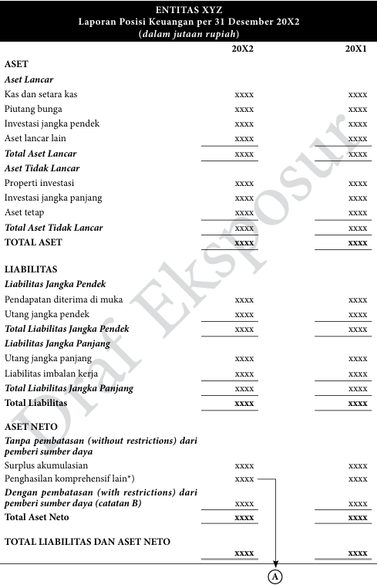
Figure 2. 1 Form of Financial Statement Position A
Source: SAK IAI ONLINE (ISAK 35)
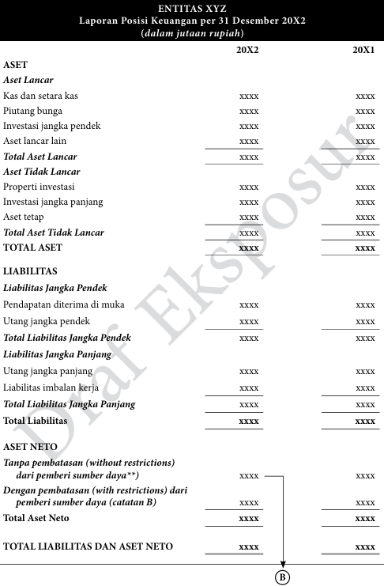
Figure 2. 2 Form of Statement of Financial Position B
Source: SAK IAI ONLINE (ISAK 35
- Statement of comprehensive income
A comprehensive income statement is a financial statement of a non-profit entity that presents all income, expenses, and changes in net assets, both with and without restrictions from resource providers. This statement provides a comprehensive overview of the organization's financial performance, including other comprehensive income, if any, so that transparency and accountability in resource management can be achieved. There are two formats for the Comprehensive Income Statement presented as examples in this appendix. Each format has its own advantages.
- Format A presents information in a single column. Format A facilitates the preparation of comparative reports; or
- Format B presents information in accordance with the classification of net assets.
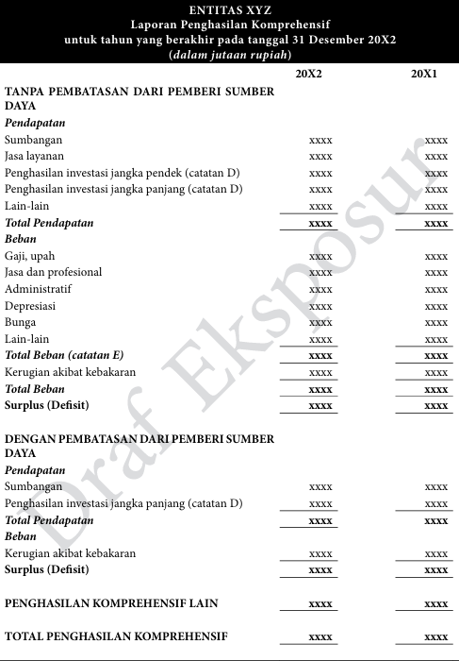
Figure 2. 2 Form of Comprehensive Income Statement A
Source: SAK IAI ONLINE (ISAK 35)
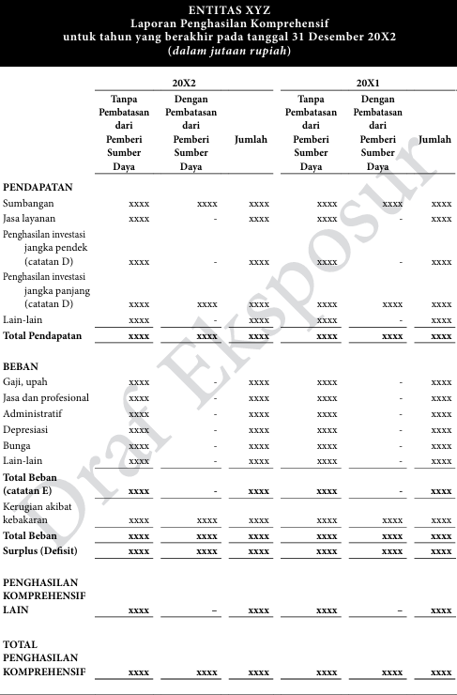
Figure 2. 3 Form of Comprehensive Income Statement B
Source: SAK IAI ONLINE (ISAK 35)
- Statement of changes in net assets
A statement of changes in net assets is a report that shows the movement or changes in the net asset balance of a nonprofit entity during a certain period. These changes may originate from surpluses or deficits in the comprehensive income statement, restricted contributions, the release of restrictions on net assets, and other adjustments such as gains or losses recognized directly in net assets. This report is presented by separating unrestricted net assets and restricted net assets from resource providers, so that users of the report can understand how the organization's resources have increased, been used, or changed in accordance with the conditions attached to the funds.
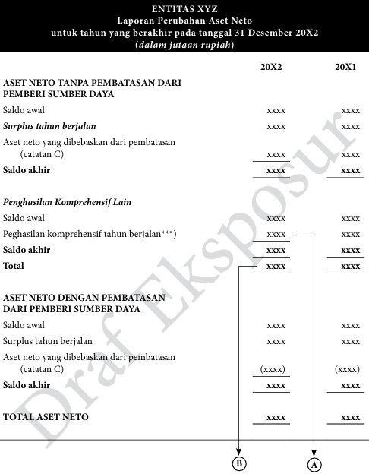
Figure 2. 4 Form of changes in net assets statement
Source: SAK IAI ONLINE (ISAK 35)

- Statement of cash flow
The cash flow statement presents the cash receipts and disbursements of a nonprofit entity in a period classified into operating, investing, and financing activities. This statement shows the organization's ability to generate and manage cash to support program sustainability and goal achievement.
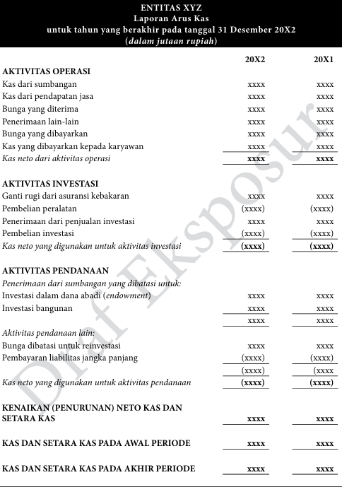
Figure 2. 5 Form of cash flow statement (direct method)
Source: SAK IAI ONLINE (ISAK 35)
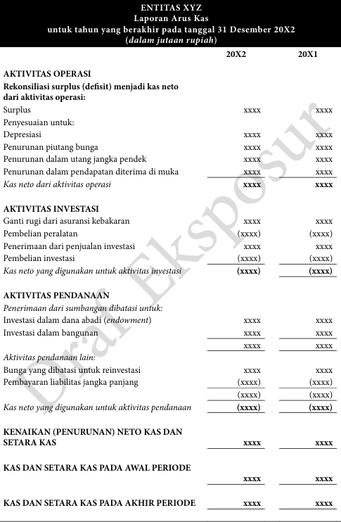
Figure 2. 6 Form of cash flow statement (undirect method)
Source: SAK IAI ONLINE (ISAK 35)
- Notes to the financial statements
Notes to the financial statements are an integral part of the above reports. They are intended to provide additional information about the estimates stated in the financial statements . These notes to the financial statements are details of an estimate presented, such as fixed assets. Notes to the financial statements provide details of the names of assets, liabilities, and net assets. For example, for fixed assets, the notes to the financial statements will explain how to calculate the depreciation of fixed assets, as well as other accounting policies used by the entity.
- Previous Research Table
Table 2. 1 Previous Research
No | Researcher Name | Research Title | Research Methodology | Research Result
1 | Dwikasmanto (2020) | Penyusunan laporan keuangan masjid nurul iman al-hidayah desa barumanis berdasarkan isak 35 | Qualitative | The results of this study can be concluded that the preparation of financial statements for the Nurul Iman Al-Hidayah Mosque in Barumanis Village has not been based on ISAK 35 regarding the presentation of financial statements for non-profit entities.
2 | Octisari et al. (2021) | Akuntabilitas Masjid Berdasarkan Isak 35 di Wilayah Kecamatan Kedungbanteng, Kabupaten Banyumas | Qualitative descriptive | The mosque administrators in the Kedungbanteng subdistrict have managed the mosque's finances in an accountable manner in accordance with the specified criteria. Record keeping is done well, although it is still simple.
3 | Alfarizi et al. (2024) | Analisis Penerapan ISAK 35 tentang Penyajian Laporan Keuangan Entitas Berorientasi Nonlaba | Qualitative descriptive | Of the five ISAK 35 structures, only three have been prepared in accordance with ISAK 35, namely the statement of financial position, the statement of comprehensive income, and the notes to the financial statements.
4 | Darojatul Ula et al. (2021) | Penerapan isak 35 pada masjid baitul hidayah puger jember | Qualitative | The basis of recording applied at the Baitul Hidayah Puger Mosque was incomplete and not sequential according to applicable standards. The financial statements that made a report, a report on changes in net assets, a cash flow statements and notes on financial statements
5 | Purba & Siregar (2021) | Penyajian Laporan Keuangan Entitas Berorientasi Non Laba Berdasarkan ISAK 35 Pada Gereja HKBP Km 55 | Qualitative | The financial statements of HKBP KM 55 Church are prepared in accordance with ISAK 35, covering comprehensive income statements, financial position, cash flow, and notes. In January 2020, there was a decrease in net assets of IDR 3,006,500. The total financial position reached IDR 12.31 billion with a closing cash balance of IDR 1.2 billion.
6 | Novita Alaika Sari et al. (2022) | Akuntabilitas Dan Transparansi Laporan Keuangan Pada Masjid Sabilillah Di Kota Malang Berdasarkan ISAK 35 | Qualitative | The Sabilillah Mosque has implemented several forms of accountability and transparency, ranging from planning and implementation to financial accountability, which have been carried out openly in front of the congregation and leaders. However, the financial reports are still not based on ISAK 35 and still refer to the old standards.
7 | Juniaswati & Murdiansyah (2022) | Akuntabilitas Pengelolaan Keuangan Masjid Sabilillah Kota Malang Berdasarkan ISAK 35 | qualitative | Sabilillah Mosque Malang has implemented accountability indicators but is not yet accountable because the financial statements of the Sabilillah Mosque Malang have not implemented ISAK 35. Meanwhile, transparency has not been fully implemented because it has not complied with Law No. 28 of 2004.
8 | Simbolon & Purba (2022) | Application of ISAK 35 Concerning Financial Statements of Non-Profit Organizations at the HKBP Bolon Pangururan Church | qualitative | The financial statements of HKBP Bolon are limited to income and expenditure reports, which do not comply with current standards, particularly ISAK 35. This study concludes that HKBP Bolon has not yet structured its financial reporting in line with the applicable standards, especially ISAK 35.
9 | (Saiffuddin, 2020) | Akuntabilitas dan transparansi keuangan masjid berdasarkan psak no.45 tentang pelaporan organisasi | qualitative | it was proven that the mosque had managed its finance accountably. In other words, there was financial statement book-keeping. In addition, the financial statement was reported well and in had successfully increased society on mosque financial statement report.

- Framework of thinking
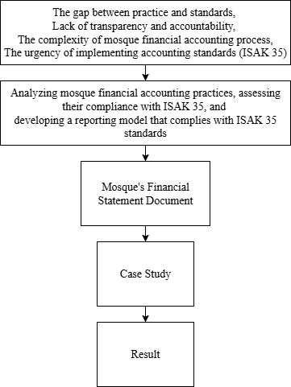
Figure 2. 7 framework of thinking

CHAPTER III
METHODOLOGY
- Type of Research
This research employs a qualitative approach with a case study method. A qualitative approach is used because this study seeks to explore and understand the financial reporting practices of mosques in their real life context.
The case study design was chosen because it allows researchers to conduct an in-depth investigation of a single unit of analysis, namely the financial reporting practices at the Nurul Ilmi Mosque in Samarinda. According to Creswell (2013) a case study is an approach in which the researcher explores a real-life, contemporary bounded system through detailed, in-depth data collection involving multiple sources of information. By applying this approach, the study can comprehensively capture how the mosque implements financial reporting and to what extent these reports conform to ISAK 35 standards.
Thus, the use of a qualitative case study provides a suitable framework to analyze the financial reporting practices of the mosque

- Research Focus
The focus of this research is on the financial accounting practices of mosques, with special attention to their conformity with ISAK 35 as an accounting standard for non-profit entities.
- Research Informants
This study involves five key informants who are critical to understanding the financial statement practices system at Nurul Ilmi Mosque,. The informants were selected due to their direct involvement in the mosque's preparation of financial reports and governance, providing essential insights into the financial statement practices.
Table 3. 1 Research Informant
No | Subject | Reason
1 | The Mosque Treasurer | The Mosque Treasurer was selected as an informant due to their direct responsibility for managing the mosque's financial resources. As the person in charge of overseeing the mosque’s financial transactions, the Treasurer has valuable insights into the financial reporting statement
2 | Head of Mosque | The head of mosque is selected as an informant because he holds a central leadership role in managing and overseeing the mosque’s financial activities. As the highest decision-maker, the chairman is directly responsible for ensuring accountability and transparency in the use of funds collected from the community.
3 | Ikatan Remaja Masjid (IRMA) | The leader of IRMA (Ikatan Remaja Masjid) is selected as an informant because this individual represents the younger generation actively involved in mosque activities and community programs. Their perspective is valuable in understanding how transparency and accountability are perceived and practiced among youth members.
4 | Ustadz | The ustadz is selected as an informant because he plays an influential role in guiding the mosque’s moral and ethical direction, including the principles of honesty and accountability in financial reporting. As a respected religious leader, the ustadz often acts as a mediator between the management and the congregation, promoting trust and integrity within the organization.

- Data Collection Techniques
To gather relevant data for this study, several techniques will be employed to ensure comprehensive insights into the financial statement at Nurul Ilmi Mosque. The primary methods of data collection will include interviews, document analysis, and observation. These techniques will provide both qualitative and contextual data that will contribute to understanding of the mosque’s financial statement:

- Interviews
In this interview technique, researchers conduct interviews using a semi-structured method, which allows for more freedom in its implementation. The purpose of this interview is to discover more open issues about the financial reporting.
- Document Analysis
Document analysis focuses on existing mosque financial reports, such as cash receipts and expenditure records, monthly/annual reports, transaction evidence, and other supporting documents. This technique helps researchers understand the current reporting format and identify gaps between actual reports and the provisions contained in ISAK 35.
- Observation
The observation technique is a careful and statistical direct observation of existing activities to obtain results in line with the objectives. In this study, the author observed several things related to financial reports, such as income
obtained from zakat, infaq, sodakoh, and funds from parties who provide donations.
- Data Analysis Techniques
This study employed a thematic analysis approach to interpret the data. Thematic analysis is a qualitative method used to discover, examine, and present recurring patterns or themes within the data. According to Miles & Huberman (1994), the thematic analysis process consists of the following steps:

- Data Reduction
The data will be transcribed, coded, and organized to focus on key themes relevant to the research questions. Unnecessary data will be filtered out, and key concepts related to financial statement will be identified.
- Data Presentation
Data presentation involves organizing and presenting the reduced data in an accessible form so that relationships and patterns can be easily understood. The data will be presented in the form of narrative descriptions, tables, and comparative matrices. For example, the existing financial statements of the mosque will be compared with the requirements outlined in ISAK 35. This stage allows the researcher to systematically examine linkages between financial practices and theoretical concepts such as accountability and stewardship.
- Conclusion Drawing
The final stage consists of drawing conclusions and verifying them continuously throughout the research process. Conclusions will be formulated based on the interpretation of the data presented, and verification will be conducted through cross-checking among the different sources of evidence (interviews, documents, and observations). This iterative process ensures the validity and reliability of the findings. Ultimately, the analysis will lead to a reconstructed model of the mosque’s financial statements in accordance with ISAK 35, highlighting its implications for transparency and accountability.

BIBLIOGRAPHY
Alfarizi, M. R., Lubis, A. W., & Nurwani, N. (2024). Analisis Penerapan ISAK 35 tentang Penyajian Laporan Keuangan Entitas Berorientasi Nonlaba. Al Qalam: Jurnal Ilmiah Keagamaan Dan Kemasyarakatan, 18(4), 2508. https://doi.org/10.35931/aq.v18i4.3611
Amalia. (2021). PENGARUH AKUNTABILITAS, TRANSPARANSI, DAN KUALITAS PELAYANAN TERHADAP MINAT MUZAKI MEMBAYAR ZAKAT (STUDI PADA LAZ SURABAYA).
Asdar, A., Ludigdo, U., & Widya P, Y. (2014). Phenomenological Study of Financial Accountability of Mosque. IOSR Journal of Economics and Finance, 5(4), 10–17. https://doi.org/10.9790/5933-0541017
asmarita, deva, wagini, & yanti, rina trisna. (2022). Analysis of the Application of PSAK No.45 Concerning Financial Reporting of Non-Profit Organizations in Achieving Transparency and Accountability (Case Study of At-Taqwa Great Mosque, Miftahul Jannah Mosque, Annasuha Mosque, Baitul Atieq Mosque, and Bengkulu City An-Nur Mosque).
Creswell, J. (2013). Qualitative, quantitative, and mixed methods approaches. In Research design.
Damin, M., & Mustaqim, F. (2021). AKUNTABILITAS PENGELOLAAN KEUANGAN MASJID MELALUI PENDEKATAN FENOMENOLOGI. ENTRIES, 3(2), 276–288.
Darojatul Ula, I., Halim, M., & Sita Nastiti, A. (2021). PENERAPAN ISAK 35 PADA MASJID BAITUL HIDAYAH PUGER JEMBER. PROGRESS, 4(2).
Dwikasmanto, Y. (2020). 2020-PENYUSUNAN LAPORAN KEUANGAN MASJID NURUL IMAN AL-HIDAYAH DESA BARUMANIS BERDASARKAN ISAK 35.
Dyah Prameswari, R., Nasution, H., Nindito, M., & Studi Akuntansi Sektor Publik, P. (2025). ANALISIS SISTEM PENGENDALIAN INTERNAL ATAS PENERIMAAN DAN PENGELUARAN KAS PADA MASJID JAMI’ AN-NUR JAKARTA SELATANANALISIS SISTEM PENGENDALIAN INTERNAL ATAS PENERIMAAN DAN PENGELUARAN KAS PADA MASJID JAMI’ AN-NUR JAKARTA SELATAN. https://doi.org/10.46306/rev.v5i2
Ibrahim, R. (2018). Akuntabilitas dan Transparansi Pengelolaan Keuangan Masjid Di Kota Banda Aceh. Jurnal Ilmiah Mahasiswa Ekonomi Akuntansi, 3(1), 111–119.
Juniaswati, K. T., & Murdiansyah, I. (2022). Akuntabilitas Pengelolaan Keuangan Masjid Sabilillah Kota Malang Berdasarkan ISAK 35. AKTSAR: Jurnal Akuntansi Syariah, 5(1), 118. https://doi.org/10.21043/aktsar.v5i1.15273
Mardiasmo, M. B. A. (2021). Akuntansi sektor publik-edisi terbaru. Penerbit Andi.
Miles, & Huberman. (1994). Qualitative Data Analysis.
Mim, J. (2018). Mosque Engagement in the Community Organizing: An Empirical Study in Sri Lanka. https://www.researchgate.net/publication/348298597
Novita Alaika Sari, Ana Sopanah, & Dwi Anggarani. (2022). Akuntabilitas Dan Transparansi Laporan Keuangan Pada Masjid Sabilillah Di Kota Malang Berdasarkan ISAK 35. Journal of Public and Business Accounting, 3(1), 27–40. https://doi.org/10.31328/jopba.v3i1.223
Octisari, S. K., Murdijaningsih, T., & Suworo, H. I. (2021). Akuntabilitas Masjid Berdasarkan Isak 35 di Wilayah Kecamatan Kedungbanteng, Kabupaten Banyumas. Jurnal Ilmiah Universitas Batanghari Jambi, 21(3), 1249. https://doi.org/10.33087/jiubj.v21i3.1648
Ortega-Rodríguez, C., Licerán-Gutiérrez, A., & Moreno-Albarracín, A. L. (2020). Transparency as a key element in accountability in non-profit organizations: A systematic literature review. In Sustainability (Switzerland) (Vol. 12, Issue 14). MDPI. https://doi.org/10.3390/su12145834
Peucker, M. (2017). The civic potential of Muslim community organisations for promoting social cohesion in Victoria (research report). https://www.researchgate.net/publication/315707534
Purba, S., & Siregar, A. (2021). Penyajian Laporan Keuangan Entitas Berorientasi Non Laba Berdasarkan ISAK 35 Pada Gereja HKBP Km 55. 14(2), 308–339. http://journal.stekom.ac.id/index.php/kompak€page308
Rusrina, R. (2021). Pengaruh Nilai-Nilai Transparansi dan Akuntabilitas terhadap The Effect of the Values of Transparency and Accountability on Public Sector Financial Management at the Regional Revenue Agency of South Sulawesi Province.
Saiffuddin, A. (2020). AKUNTABILITAS DAN TRANSPARANSI KEUANGAN MASJID BERDASARKAN PSAK NO.45 TENTANG PELAPORAN ORGANISASI.
Simbolon, S. I., & Purba, S. (2022). Application of ISAK 35 concerning Financial Statements of Non-profit Organizations at the HKBP Bolon Pangururan Church. Asian Journal of Applied Business and Management, 1(1), 19–30. https://doi.org/10.55927/ajabm.v1i1.1806
Siregar, D. P., Soemitra, A., & Nasution, J. (2023). Accountability and Financial Management of Mosques Based on ISAK 35 Concerning Financial Reporting of Non-Profit Organizations: Case Study at Al-Ikhlas Mosque. Journal of Business Management and Economic Development, 1(03), 505–509. https://doi.org/10.59653/jbmed.v1i03.212
Siskawati, E., Ferdawati, & Surya, F. (2016). Pemaknaan Akuntabilitas Masjid: Bagaimana Masjid dan Masyarakat Saling Memakmurkan? Jurnal Akuntansi Multiparadigma, 7(1). https://doi.org/10.18202/jamal.2016.04.7006
Standar, D., Keuangan, A., Akuntan Indonesia, I., Laporan, P., & Entitas Berorientasi, K. (2018). Draf Eksposur ini diterbitkan oleh ISAK 35.
Utaberta, N., Yin, L. C., Usman, I. M. S., Malaysia, P., Bina, J. S., Bina, A., & Kejuruteraan, F. (2015). Journal Design + Built Critical Analysis on The Role of Mosque as An Educational Institution Within the Contemporary Muslim Society in Malaysia CRITICAL ANALYSIS ON THE ROLE OF MOSQUE AS AN EDUCATIONAL INSTITUTION WITHIN THE CONTEMPORARY MUSLIM SOCIETY IN MALAYSIA.
Wicaksono, K. W. (2021). Akuntabilitas Organisasi Sektor Publik.

APPENDIX
Appendix 1: list of interview questions
No | Category | Interview Question
1 | Understanding of accountability | What is meant by accountability in mosque management?
2 |  | What form of accountability do mosque administrators take towards the congregation or the public?
3 | Understanding of transparency | What is the importance of transparency in managing mosque finances?
4 |  | How do mosque administrators convey financial information to the congregation or community?
5 |  | Are mosque financial reports accessible to the congregation at any time? If so, what is the mechanism?
6 | Source of funds | Where do the sources of funding for this mosque come from?
7 |  | Do the congregation or community know where the mosque funds come from?
8 | Use of funds | What is the mechanism for using funds received by the mosque?
9 | Financial reporting | How is the process of preparing mosque financial reports carried out each period?
10 |  | How is the mosque’s financial report prepared in each reporting period?
11 |  | Who is responsible for preparing and presenting the mosque’s financial statements?
12 |  | Are the mosque’s financial reports prepared according to a specific standard, such as ISAK 35?

