THE INFLUENCE OF THE FRAUD PENTAGON THEORY ON PROCUREMENT FRAUD IN THE GOVERNMENT OF SAMARINDA CITY

MINOR THESIS

FOR THESIS EXAMINATION



From:

NABILAH NUR AFIFAH
2101036084
BACHELOR OF ACCOUNTING

FACULTY OF ECONOMICS AND BUSINESS
MULAWARMAN UNIVERSITY
SAMARINDA
2025

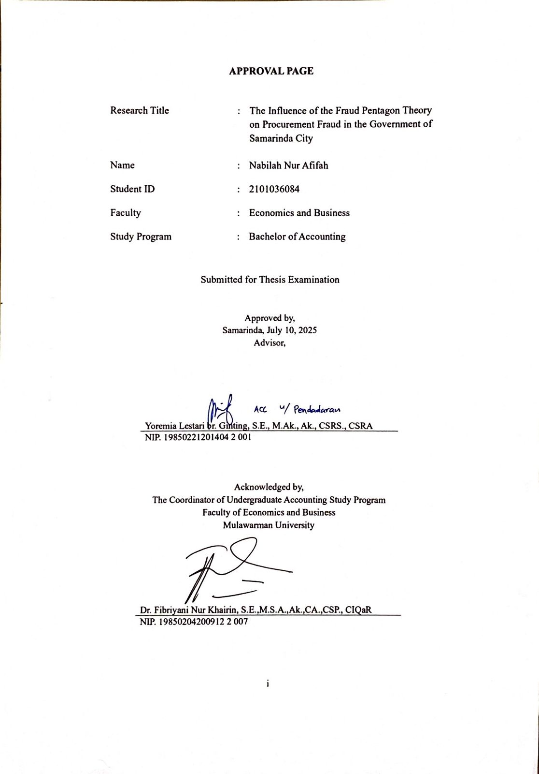APPROVAL PAGE

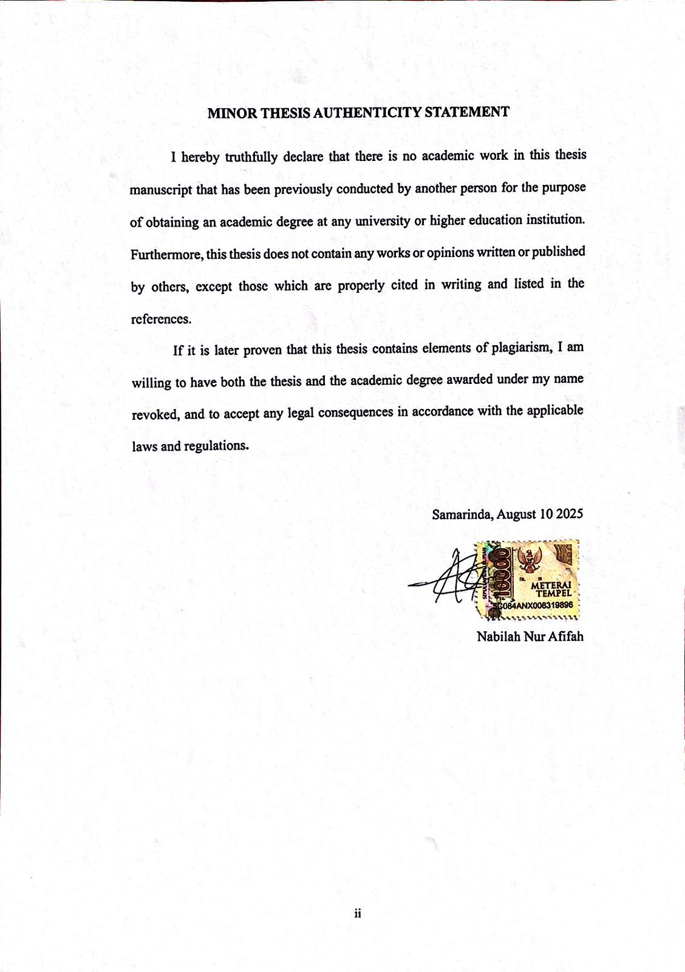 MINOR THESIS AUTHENTICITY STATEMENT

CURRICULUM VITAE


Nabilah Nur Afifah was born in Berau on March 9, 2003. The author is the first child of three siblings, born to Mr. Rofiq and Mrs. Rita. The author began formal education at SD Negeri 002 Tembudan in 2009 and continued until 2011, after which the author transferred to SD Negeri 027 Samarinda and graduated in 2015. The author then pursued junior high school education at SMP Negeri 16 Samarinda from 2015 to 2018. For senior high school education, the author attended SMA Negeri 1 Samarinda from 2018 and graduated in 2021.
In 2021, the author continued formal education at the Faculty of Economics and Business, Mulawarman University, majoring in Accounting. In 2024, the author participated in the Community Service Program (KKN) Batch 50 of Mulawarman University, which took place in Berbas Pantai Village, Bontang Selatan District, East Kalimantan Province.

PREFACE
Alhamdulillahi rabbil ‘alamin. All praise and gratitude are due to Allah SWT, the Almighty God, for His grace and blessings. Salutations and peace be upon the Prophet Muhammad SAW, our greatest role model, through whose inspiration the author was able to complete this thesis as a requirement to obtain a Bachelor’s degree in Accounting at the Faculty of Economics and Business, Mulawarman University.
The writing of this thesis, titled “The Influence of Fraud Pentagon Theory on Procurement Fraud in the Government of Samarinda City”, was made possible with the help, guidance, and support of many parties. This study also draws upon various references from previous journals and research as the foundation for its preparation. The author realizes that the process of completing this thesis came with many challenges, and its completion would not have been possible without the contribution of numerous individuals.
With great respect and humility, the author would like to express sincere gratitude to:
- Prof. Dr. Ir. H. Abdunnur, M.Si., IPU, as the Rector of Mulawarman University.
- Dr. Zainal Abidin, SE., M.M., as the Dean of the Faculty of Economics and Business, Mulawarman University.
- Dr. Wulan Lyhig Ratna Sari, SE., M.Si., CMA., CSP., as the Head of the Accounting Department, Faculty of Economics and Business, Mulawarman University.
- Dr. Fibriyani Nur Khairin, SE., M.S.A., Ak., CA., CSP., CIQaR., as the Coordinator of the Undergraduate Accounting Program, Faculty of Economics and Business, Mulawarman University.
- Mrs. Yoremia Lestari br. Ginting, SE., M.Ak., Ak., CSRS., CSRA., as the thesis supervisor, for her guidance, advice, insights, and patience throughout the writing process.
- Dr. Hariman Bone, SE., M.Sc., CSRS., CSRA., as the Academic Advisor during the author’s study at the Faculty of Economics and Business, Mulawarman University.
- All lecturers at the Faculty of Economics and Business, especially those in the Accounting Undergraduate Program, for their valuable knowledge and lessons.
- All academic and administrative staff of the Faculty of Economics and Business, Mulawarman University, for their excellent services and assistance.
- All regional government agencies (OPD) in the City of Samarinda and all respondents who willingly participated in this research.
- The author’s beloved parents, Mr. Rofiq and Mrs. Rita, and siblings Zafirah and Nadia, for their endless prayers, motivation, and support, both moral and material. Every step in completing this thesis has been guided by their sincere prayers and encouragement. The spirit and belief instilled by my beloved parents have been the author’s greatest source of strength in reaching this point.
- The author would also like to express heartfelt gratitude to dearest friends Nadila, Geffira, Cinta, Faisha, Ana, Atikah, Sara, Salsa, Tya, Lyra, Nurul, Amin, Sisi, and Wita, who have always been there to offer support, encouragement, and a listening ear throughout the ups and downs of college life and the thesis-writing process. Their presence has truly brought meaning and color to this journey.
- High school friends in the group Balon Penghuni Surga for the friendship, laughter, and constant encouragement over the years. The bond that has been built since high school has been a source of motivation throughout this academic journey.
- The author would also sincerely thank all classmates from the 2021 KBI Accounting Program and all students of the Accounting Class of 2021, Faculty of Economics and Business, for their teamwork and shared experiences during the learning process.

ABSTRAK
Fraud Pentagon Theory merupakan pengembangan dari Fraud Triangle dan Fraud Diamond yang terdiri dari lima elemen utama, yaitu tekanan (pressure), kesempatan (opportunity), kompetensi (capability), rasionalisasi (rationalization), dan arogansi (arrogance). Penelitian ini bertujuan untuk menguji pengaruh elemen fraud pentagon theory terhadap fraud pengadaan barang dan jasa di Pemerintah Kota Samarinda. Penelitian ini menggunakan pendekatan kuantitatif dengan data primer yang diperoleh melalui penyebaran kuesioner kepada pegawai yang terlibat langsung dalam proses pengadaan pada 30 Organisasi Perangkat Daerah (OPD). Sampel penelitian ini dipilih menggunakan teknik purposive sampling yaitu penentuan sampel berdasarkan pertimbangan tertentu. Responden dalam penelitian ini adalah pegawai yang memiliki peran langsung dalam proses pengadaan barang dan jasa. Data yang terkumpul pada penelitian ini dianalisis menggunakan Partial Least Squares Structural Equation Modeling (PLS-SEM) dengan aplikasi Smart PLS versi 4.0. Hasil penelitian ini menunjukkan bahwa 1) tekanan berpengaruh signifikan positif terhadap fraud pengadaan barang dan jasa, 2) kesempatan tidak berpengaruh terhadap fraud pengadaan barang dan jasa, 3) kompetensi berpengaruh signifikan positif terhadap fraud pengadaan barang dan jasa, 4) rasionalisasi tidak berpengaruh terhadap fraud pengadaan barang dan jasa, 5) arogansi berpengaruh signifikan positif terhadap fraud pengadaan barang dan jasa. Hasil penelitian ini berimplikasi pada perlunya kebijakan dan prosedur yang lebih efektif dalam mencegah fraud, antara lain melalui penguatan sistem pengawasan serta peningkatan transparansi dalam setiap tahapan pengadaan.

Kata Kunci: Fraud Pentagon Theory, Fraud Pengadaan Barang dan Jasa

ABSTRACT
The Fraud Pentagon Theory is an extension of the Fraud Triangle and Fraud Diamond, comprising five key elements, namely pressure, opportunity, capability, rationalization, and arrogance. This study aims to examine the effect of fraud pentagon theory elements on fraud in the procurement of goods and services in the Samarinda City Government. A quantitative approach was employed, using primary data collected through questionnaires distributed to employees directly involved in procurement processes across 30 Local Government Organization (OPD). The sampling technique used was purposive sampling, resulting in a total of 109 respondents. The data collected in this study were analyzed using Partial Least Squares Structural Equation Modeling (PLS-SEM) with the Smart PLS version 4.0 application. The results of this study show that 1) pressure has a significant positive effect on fraud in the procurement of goods and services, 2) opportunity has no effect on fraud in the procurement of goods and services, 3) competence has a significant positive effect on fraud in the procurement of goods and services, 4) rationalization has no effect on fraud in the procurement of goods and services, 5) arrogance has a significant positive effect on fraud in the procurement of goods and services. These findings imply the need for more effective policies and procedures to prevent fraud, including strengthening internal control systems and enhancing transparency throughout all stages of the procurement process.
Keywords: Fraud, Pentagon Theory, Goods and Services Procurement Fraud

TABLE OF CONTENTS
Pages
APPROVAL PAGE i
MINOR THESIS AUTHENTICITY STATEMENT ii
CURRICULUM VITAE iii
ABSTRAK vii
ABSTRACT viii
TABLE OF CONTENTS ix
LIST OF TABLES xi
LIST OF FIGURES xii
LIST OF APPENDIX xiii
CHAPTER I INTRODUCTION 1
1.1. Background 1
1.2. Research Problem 6
1.3. Research Objectives 6
1.4. Benefits of Research 7
CHAPTER II LITERATURE REVIEW 9
2.1. Theoritical Foundation 9
2.1.1. Fraud Pentagon Theory 9
2.1.2. Fraud 11
2.1.3. Procurement of Goods and Services 12
2.2. Previous Research 14
2.3. Conceptual Framework 17
2.4. Hypothesis Development 17
2.4.1. The Influence of Pressure on Procurement Fraud 17
2.4.2. The Influence of Opportunity on Procurement Fraud 18
2.4.3. The Influence of Competence on Procurement Fraud 19
2.4.4. The Influence of Rationalization on Procurement Fraud 20
2.4.5. The Influence of Arrogance on Procurement Fraud 20
CHAPTER III RESEARCH METHOD 22
3.1. Type of Research 22
3.2. Operational Definitions and Variable Measurement 22
3.2.1. Independent Variable (X) 22
3.2.2 Dependent Variable (Y) 24
3.3. Population and Sample 27
3.3.1. Population 27
3.3.2. Sample 27
3.4. Type and Source of Data 29
3.4.1. Type of Data 29
3.4.2. Source of Data 29
3.5. Data Collection Method 29
3.6. Data Analysis Tool 30
3.6.1. Model Pengukuran (Outer Model) 30
3.6.2. Inner Model 31
3.6.3. Hypothesis Testing 32
3.6.4. Pilot Test 32
CHAPTER IV RESULTS AND DISCUSSION 38
4.1. Research Result 38
4.1.1. Questionnaire Distribution Results 38
4.1.2. Respondent Demographic Characteristics 38
4.2. Data Analysis Results 40
4.2.1. Outer Model 40
4.2.2. Inner Model 43
4.2.3. Hypothesis Testing 44
4.3. Discussion 45
4.3.1. The Influence of Pressure on Procurement Fraud 45
4.3.2. The Influence of Opportunity on Procurement Fraud 47
4.3.3. The Influence of Competence on Procurement Fraud 48
4.3.4. The Influence of Rationalization on Procurement Fraud 49
4.3.5. The Influence of Arrogance on Procurement Fraud 50
CHAPTER V CLOSING 53
5.1 Conclusion 53
5.2 Recommendations 54
REFRENCES 55
APPENDICES 59

LIST OF TABLES
Table 2. 1 Previous Research 14
Table 3. 1 Indicator Variable 25
Table 3. 2 List of Regional Government Organizations in Samarinda City 28
Table 3. 3 Likert Scala Values 29
Table 3. 4 Outer Loading Result 33
Table 3.5 Outer Loading Result (Final) 34
Table 3.6 AVE (Average Variance Extracted) 35
Table 3.7 Cross Loadings Result 35
Table 3.8 Composite Reliability and Cronbach’s Alpha Result 37
Table 4.1 Questionnaire Distribution Results 38
Table 4.2 Respondent’s Gender 38
Table 4.3 Respondents’ Age 39
Table 4.4 Respondents’ Education Level 39
Table 4.5 Respondent’s Job Position 40
Table 4.6 Outer Loadings Result 40
Table 4.7 Average Variance Extracted (AVE) 41
Table 4.8 Cross Loading Result 42
Table 4.9 Composite Reliability and Cronbach’s Alpha Result 43
Table 4.10 R-Square Result 43
Table 4.11 Path Coefficient Result 44

LIST OF FIGURES

Figure 2. 1 Fraud Pentagon 9
Figure 2. 2 Conceptual Framework 17
Figure 2. 3 Research Model 21

LIST OF APPENDIX
Appendix 1 Research Questionnaire 60
Appendix 2 Pilot Test Data (35 Samples) 65
Appendix 3 Data Tabulation 70
Appendix 4 SmartPLS 4.0 Processed Data 77
Appendix 5 Research Permit Letter 81
Appendix 6 Documentation 84

CHAPTER I
INTRODUCTION
- Background
In this era of reform, the government is required to be able to realize an open and democratic government system, including in terms of managing the procurement in the government sector. Procurement within the government sector represent a vital function in public administration, as it facilitates the fulfillment of governmental needs through collaboration with external parties, primarily business entities, or independent service providers, who supply the necessary goods and services, thus requiring a very large allocation of the state budget. Therefore, proper and accountable management is crucial to ensure that the state budget is used effectively and efficiently (Arsena, 2016). However, there are various forms of irregularities, especially fraud, which often occur during the procurement in the government sector, which harm the state and reduce public trust in the government (Indrawan et al., 2020).
According to the Association of Certified Fraud Examiners (ACFE), fraud is an act committed intentionally and unlawfully by individuals or groups with the aim of achieving certain interests or goals. Fraud is classified into three, namely: Financial Statement Fraud, Asset Misappropriation, and Corruption. Fraud is committed with the aim of personal or group gain, which results in both financial and non-financial losses for other parties. Fraud can occur anywhere, regardless of person, time, or place (Kuntadi et al., 2022). An action can be categorized as fraud if it meets four criteria, namely the existence of a victim of fraud, the perpetrator acts intentionally, the victim follows or complies with the wishes of the perpetrator, and the victim suffers losses as a result of these actions. (Elia, 2019).
According to data from the Corruption Eradication Commission (KPK) as of January 10, 2024, more than 90% of fraud cases in Indonesia occur in the procurement in the public sector. Of the 1,512 corruption cases that have been handled by the KPK, 339 cases originated from the procurement sector, making it the second largest category of cases after bribery. These cases range from bribery, price inflation, to collusion between government officials and service providers to win certain tenders. KPK states that the various modus operandi in public procurement involve manipulation of tender documents, collusion between providers, and corruption at every stage, from planning to contract execution (suarasurabaya).
In a joint working meeting with Commission III of the House of Representatives, the Corruption Eradication Commission (KPK) revealed that as many as 100 people had been named as suspects in corruption cases processed throughout 2024, based on data as of May 31, 2024. The highest cases handled by the KPK during 2024 were related to corruption in the procurement, with 43 cases out of the total cases. In addition, of the total 100 suspects, the most dominant perpetrators of corruption crimes came from among state officials, ranging from Echelon I to Echelon IV (Rizaldi, 2024).
Corruption Eradication Commission (KPK) investigators have named five people as suspects in an alleged bribery case related to a road procurement project in East Kalimantan in November 2023. The suspects include the Director of CV Banjasari (NM), the owner of PT Fajar Pasir Lestari (ANR), the staff of PT Fajar Pasir Lestari (HS), as well as the Head of the Work Unit of the East Kalimantan National Road Implementation Center (BBPJN) (RF), and the Commitment Making Officer (PPK) (RS) in the project. This case began when RF was appointed as Head of the East Kalimantan BBPJN Work Unit and RS as the project's PPK. To win the project, NM, ANR, and HS regularly communicated with RS to offer a sum of money in the form of a bribe. After an agreement was reached, RS approved the agreement, then RF ordered RS to ensure that NM, ANR, and HS's company could win the tender by modifying and manipulating data in the electronic catalog application of the Government Goods and Services Procurement Policy Agency (LKPP). The project was financed from the State Budget (APBN) for the procurement of national roads in East Kalimantan with a value of Rp49.7 billion.(antaranews, 2023). The case further emphasizes the mode of corruption in the goods and services procurement sector as a source of personal gain for dishonest local officials. It has happened repeatedly and shows the weak supervision of the procurement of goods and services at the government level.
Procurement in the government sector is very vulnerable to corruption due to various factors, namely (1) conspiracy of tenderers, (2) bribery to win tenders, (3) the absence of clarity and openness in the execution of tender process, (4) tenderers or suppliers set the highest price, (5) the element of nepotism in winning tenders, (6) tenderers do not even have complete administration, (7) some tender events are not announced, (8) the tender process is not accessible for participants in a region (Wardhani et al., 2021). Open tender systems designed to increase transparency in procurement are often manipulated by certain parties, both from service providers and government officials, for personal or group interests.
The Indonesian government has issued several policies to strengthen transparency and accountability in the procurement of goods and services, one of which is the implementation of e-procurement and e-catalogue systems. Through this system, the entire procurement process is carried out electronically in the hope of increasing transparency and minimizing fraud. However, despite the digital system, the implementation still faces challenges, such as weak external oversight and limited access for independent parties to directly monitor the procurement process (detikNews).
In addition to the application of technology, the government has also issued various regulations to regulate the procurement. One of the main regulations is Presidential Regulation (Perpres) No.16 of 2018, which was later updated through Perpres No. 12 of 2021, becoming the main legal basis governing public procurement procedures in Indonesia. The Presidential Regulation emphasizes the importance of efficiency, transparency, and accountability in all stages of procurement, from planning, supplier recovery, to contract execution and monitoring in the procurement process.
One of the theories related to fraud is the Fraud Pentagon Theory, which expands upon the concepts introduced in the Fraud Triangle Theory and the Fraud Diamond Theory frameworks. This theory was originally formulated by Crowe Horwath, a public accounting firm in 2011. In its development, this theory adds two new elements, namely competence and arrogance, to the three elements of the Fraud Triangle, so it is known as the Fraud Pentagon. This theory is composed of five core components, namely pressure, opportunity, competence, rationalization, and arrogance. According to Howarth (2011), an individual’s skills or expertise may facilitate the execution of fraudulent actions. This competency element aligns conceptually with capability component introduced in the Fraud Diamond Theory.
Research on fraud in the procurement of goods and services in the government sector is an interesting topic to research, because research related to the government sector continues to develop continuously. This can be seen in previous research conducted by Purwanto et al., (2017) It is found that pressure, opportunity, rationalization and capability contribute to the occurrence of fraud in the government sector. Pressure faced by officials such as demands to meet budget targets or achieve certain profits can create a strong impetus to commit fraud. Opportunities arise when the supervisory system is weak, thus providing space for officials or providers to take advantage of the situation for personal gain. Fraudsters also often rationalize their actions with various justifications, such as the assumption that what they are doing is commonplace in the work environment. In addition, actors who have high technical skills in procurement often find it easier to cover up the traces of their fraudulent actions, while arrogance makes them feel immune to the law. Research conducted by Fitri & Nadir, (2020) It is found that pressure and capability affect fraud in the procurement, while opportunity and rationalization have no effect on fraud in the procurement of goods and services. On the other hand, research related to the Fraud Pentagon focuses more on financial statement fraud, especially in manufacturing companies. Such as research conducted by Renata & Yudowati (2020) and Wulandari et al. (2023) examined the Fraud Pentagon in the consumer goods industry subsector.
Based on the research gaps identified in previous studies, the phenomenon of fraud in the procurement, particularly in the public sector, has prompted the researcher to conduct a more in-depth investigation entitled: The Influence of the Fraud Pentagon Theory on Procurement Fraud in the Government of Samarinda City. This study aims to examine the validity of the Fraud Pentagon Theory, as it is considered more comprehensive and encompasses all the variables included in the Fraud Diamond Theory.
- Research Problem
In light of the background described above, the formulation of the research problems is as follows:
- Does the pressure element in the Fraud Pentagon Theory have an influence on procurement fraud?
- Does the opportunity element in the Fraud Pentagon Theory have an influence on procurement fraud?
- Does the competence element in the Fraud Pentagon Theory have an influence on procurement fraud?
- Does the rationalization element in the Fraud Pentagon Theory have an influence on procurement fraud?
- Does the arrogance element in the Fraud Pentagon Theory have an influence on procurement fraud?
- Research Objectives
Based on the previously formulated research problems, the objectives of this study are as follows:
- To analyze the influence of the pressure element in the Fraud Pentagon Theory on procurement fraud in the government sector of Samarinda City.
- To analyze the influence of the opportunity element in the Fraud Pentagon Theory on procurement fraud in the government sector of Samarinda City.
- To analyze the influence of the rationalization element in the Fraud Pentagon Theory on procurement fraud in the government sector of Samarinda City.
- To analyze the influence of the competence element in the Fraud Pentagon Theory on procurement fraud in the government sector of Samarinda City.
- To analyze the influence of the arrogance aspect in the Fraud Pentagon Theory on procurement fraud in the government sector of Samarinda City.
- Benefits of Research
The results of this study are expected to provide valuable benefits for several parties, including:
- Academic Benefits
This research is expected to contribute to the development of knowledge in the fields of forensic accounting and public sector accounting. By analyzing the influence of the elements within the Fraud Pentagon Theory, the study will enrich the body of reference and serve as a foundation for future research related to fraud in the public sector.
- Practical Benefits
- For Institutions
This study can offer a deeper understanding of how the elements of the Fraud Pentagon Theory affect procurement fraud. The findings may serve as a basis for designing more effective policies and procedures for fraud prevention, such as strengthening oversight systems and enhancing transparency.
- For Researchers
The results of this study may serve as empirical input and a reference for further analysis, particularly concerning specific organizational actions. The research aims to identify the influence of various elements of the Fraud Pentagon Theory on efforts to control procurement fraud in the public sector.

CHAPTER II
LITERATURE REVIEW
- Theoritical Foundation
- Fraud Pentagon Theory
Fraud Pentagon Theory evolved from earlier frameworks, particulary the Fraud Triangle model proposed by Cressey (1953) and the Fraud Diamond framework introduced by Wolfe and Hermanson (2004). The fraud triangle outlines three primary drivers that may lead an individual to commit fraud; pressure, opportunity, and rationalization. In the fraud diamond, there is one additional factor, namely capability. Horwarth (2011) expanded this theory by adding the competence factor, which has the same meaning as capability, and the arrogance factor, thus forming the Fraud Pentagon.
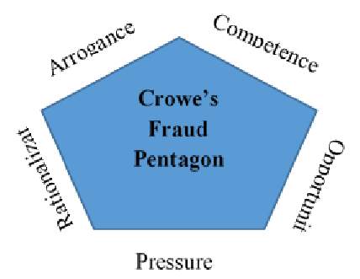
Figure 2. 1 Fraud Pentagon
Source: (Horwarth, 2011)
- Pressure (pressure)
Pressure is one of the primary elements contributing to an individual’s tendency to engage in fraudulent behavior. Pressure usually comes from unrealistic job targets, personal financial problems, or other demands (Alfuzanni & Djamil, 2019). Pressure is often the dominant factor motivating cheating, especially when individuals feel they have no other options to achieve the desired outcome (Albrecht et al., 2006).
- Opportunity
Opportunity is a situation that allows fraud to occur. Opportunities arise when there are weaknesses in the control system or internal supervision that provide a gap for someone to commit fraud without being detected (Djamil, 2024).
- Rationalization
Rationalization is an attempt to justify a mistake, where the individual convinces himself that the mistake is acceptable (Fitriana & Baridwan, 2012). According to Hildayani & Sherly (2021) rationalization occurs when the perpetrator of fraud feels that his actions are legitimate, even though they are actually considered unethical. When someone is proven to have committed fraud, they tend to look for reasons to justify these actions so that they are not blamed.
- Competence
Competence is an employee's ability to disregard internal controls, design disguise strategies, and observe social conditions in order to achieve their personal interests (Horwarth, 2011).
- Arrogance
Arrogance is an attitude of feeling superior or entitled so that a person considers that internal controls and Company policies do not apply to them (Horwarth, 2011).
Fraud Pentagon Theory is the grand theory in this study because it provides a broader analytical framework to understand the causes and motivations behind fraud in the procurement, especially in the government environmen.
- Fraud
Fraud is an act of deception or crime that aims to gain financial or personal gain. As a crime, fraud encompasses all forms of means devised by humans to gain an advantage through untruthful means and statements. (Sayidah et al., 2019).
According to Association of Certified Fraud Examiners (ACFE), Fraud is considered a criminal offense when there is a conscious falsification of the truth or concealment of important facts to influence another party to act in an adverse manner. Fraud can be classified into two types, fraud against individuals and fraud against organizations. Individual fraud occurs when an individual is the target of fraud such as identify theft, phishing scams, and advance-fee schemes. Internal organizational fraud occurs when an employee, manager, or executive defrauds the organization by committing embezzlement, tax manipulation, and fraud against investors and shareholders. External organizational fraud occurs when an outside party defrauds the organization such as asking employees for bribes, or unreasonably increasing cost.
Association of Certified Fraud Examiners (ACFE) classifies fraud into three types based on its actions.
- Asset Misappropriation, which involves the misuse or theft of assets owned by the company or external entities. This type is the easiest form of fraud to identify because it has a measurable and quantifiable nature (defined value).
- Fraudulent Statements, includes actions taken by officials or executives of a company or government agency to hide the true financial condition by manipulating financial statements for profit.
- Corruption, including abuse of power or conflicts of interest, bribery, unauthorized or illegal acceptance, and financial extortion. This type of fraud is often difficult to detect because the parties involved collaborate to gain mutual benefit or symbiotic mutualism.
- Procurement of Goods and Services
Procurement of goods and services is a process carried out by an organization to obtain goods and services to meet internal and external needs. Procurement is a function that exists in the public and private sectors to provide goods and services for an organization or government. Public procurement is a legal authority that plays a role in advising, planning, acquiring, and evaluating the use of government budgets related to goods and services needed in carrying out activities, fulfilling obligations, and achieving government goals (Hamkah et al., 2023).
Based on the Presidential Regulation of the Republic of Indonesia of 2021 concerning Amendments to Presidential Regulation Number 16 of 2018 concerning Government Procurement of Goods / Services, 2021, government procurement of goods and services aims to support the smooth provision of government needs in an efficient and timely manner, and ensure that the procurement process is carried out with the principles of openness and fair competition. This regulation emphasizes that every stage of procurement must be carried out transparently, provide broad access to information to the public, and be accountable, so that every process can be accounted for by the parties involved. Public procurement of goods and services is carried out based on the procedures set out in the Presidential Regulation of the Republic of Indonesia Year 2021 which includes eight main stages, namely:
- Preparation of supplier selection which includes identification of needs, preparation of planning documents, and provision of procurement documents.
- Provider selection planning which involves establishing recovery methods, funding sources, qualification criteria, evaluation criteria, and recovery schedules.
- Implementation of provider selection through tender or selection.
- Implementation of provider selection through e-purchasing, direct appointment, direct procurement and rapid tendering.
- Consolidate by combining several procurement packages to increase efficiency and strengthen the competitiveness of providers and avoid unnecessary fragmentation of procurement.
- Implementation of procurement contracts which include signing contracts, providing implementation guarantees, carrying out work, payment, and dispute resolution.
- Handover of goods that are in accordance with the terms of the contract with the preparation of minutes as proof of completion before payment is made to the provider.
- Conducting an assessment or evaluation to measure the provider's performance based on the quality and conformity to the approved contract to become a reference in assessing the provider's eligibility for the next procurement.
- Previous Research
Table 2. 1 Previous Research
No. | Author | Research Method | Variable | Result
1. | Arifianti et al., 2015 | Perspective of Triangle Fraud Theory in the Procurement of Goods / Services in the NTB Provincial Government | - Characteristics of the ULP Working Group /Procurement Official (X1)  - Compensation Suitability (X2)  - Internal Control System (X3)  - Procurement Fraud (Y) | The characteristics of the ULP working group/procurement official and the internal control system affect fraud in the procurement of goods and services.  Compensation suitability has no effect on fraud in the procurement.
2. | Purwanto et al., 2017 | Study of the Diamond Fraud Theory Concept in Supporting the Effectiveness of Goods/Services Procurement in Bogor City Government | - Pressure (X1)  - Opportunity (X2)  - Rationalization (X3)  - Capability (X4)  - Procurement Fraud (Y) | Diamond Fraud Theory affects Goods / Services Procurement fraud in the Bogor city government
continued to next page

Table 2.1. Continues
No. | Author | Research Method | Variable | Result
3. | Hidayati & Mulyadi, 2017 | Factors Affecting Fraud in Procurement Activities | - Quality of Procurement Committee (X1)  - Income of Procurement Committee (X2)  - Procurement System and Procedures (X3)  - Procurement Ethics (X4)  - Internal Control System (X5)  - Procurement Fraud (Y) | The quality of the procurement committee, procurement systems and procedures, procurement ethics and internal control systems affect the occurrence of goods / services procurement fraud. The income of the procurement committee, procurement systems and procedures, procurement ethics and internal control systems affect the occurrence of fraud in the procurement of goods / services. Income  The procurement committee has no effect on the occurrence of  Fraud in the procurement.
4. | Fitri & Nadir, 2020 | The Influence of Pressure, Opportunity, Rationalization, and Capability on Fraudulent Procurement in the Aceh Government with Moderating Organizational Ethical Culture | - Pressure (X1)  - Opportunity (X2)  - Rationalization (X3)  - Capability (X4)  - Organizational Ethical Culture (X5)  - Procurement Fraud (Y) | Pressure and Capability affect fraud in the procurement of goods / services in the Aceh Government. Opportunity and Rationalization have no effect on fraud in the procurement of goods / services in the Aceh Government.
5. | Bimawan, 2021 | Factors Affecting Procurement Fraud  of Goods and Services in Semarang City | - Ethics of goods and services procurement (X1)  - Work Procedures for Procurement of goods and services (X2)  - Quality of Goods and Services Providers (X3) | Ethics, work procedures, quality of providers, procurement of goods and services and information on the needs of goods and services have an effect on fraud in the procurement of goods and services.
continued to next page

Table 2.1. Continues
No. | Author | Research Method | Variable | Result
6. | Windartanti & Urumsah, 2022 | A Conceptual Model of the Determinants of Procurement Fraud Control in Higher Education Institutions Using the Fraud Pentagon Theory | - Pressure (X1)  - Opportunity (X2)  - Rationalization (X3)  - Competence (X4)  - Arrogance (X5)  - Procurement Fraud (Y) | Fraud Pentagon affects fraud in the procurement of goods and services
7. | Mulyandani et al., 2023 | Analysis of the Role of Fraud Pentagon Theory in Detecting Fraud in Procurement of Goods and Services: (Empirical Study on Garut Regency Government) | - Pressure (X1)  - Opportunity (X2)  - Rationalization (X3)  - Kapabilitas (X4)  - Arrogance  - Procurement of Goods and Services Fraud Prevention (Y) | Pressure, Opportunity, and Capability affect the fraudulent procurement of goods and services.  Rationalization and Arrogance have no effect on fraud in the procurement of goods and services.
8. | Lestari & Asyik, 2023 | Analysis of Fraud Pentagon Theory in the Public Procurement Process (Empirical Study on Village Governments in Sekaran District) | - Pressure (X1)  - Opportunity (X2)  - Competence (X3)  - Rationalization (X4)  - Arrogance (X5)  - Fraud Behavior (Y) | Fraud Pentagon Theory does not affect the behavior of Fraud Procurement of Goods and Services
9. | Johari et al., 2023 | Procurement Fraud in The Public Sector: An Analysis of Fraud Triangle Elements and Workplace Spirituality | - Pressure (X1)  - Opportunity (X2)  - Rationalization (X3)  - Workplace Spirituality (X4)  - Procurement Fraud Occurrences (Y) | Fraud Triangle affect the Procurement Fraud In The Public Sector
10. | F. Akbar et al., 2023 | Pengaruh E-Procurement dan Whistleblowing System terhadap Pencegahan Fraud Pengadaan Barang dan Jasa | - E-Procurement (X1)  - Whistleblowing System (X2)  - Procurement Fraud (Y) | E-Procurement and Whistleblowing System affect the Prevention of Fraud in Procurement of Goods and Services.
Source: Data Processed (2024)

- Conceptual Framework
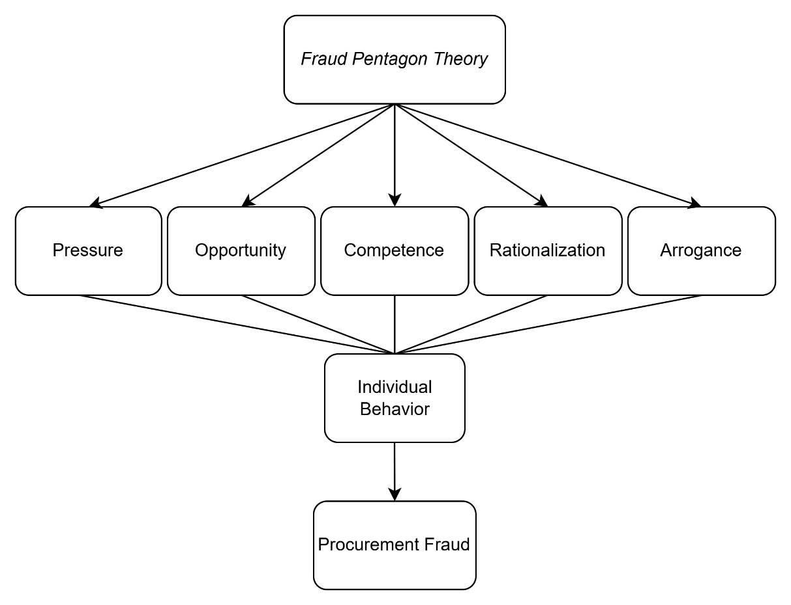
Figure 2. 2 Conceptual Framework
Source: Data Processed (2024)
- Hypothesis Development
- The Influence of Pressure on Procurement Fraud
According to the Fraud Pentagon Theory, pressure is one of the key factors that motivates individuals to commit fraudulent acts. Sources of pressure may vary, including the need to meet specific performance targets, unstable economic conditions, or personal financial difficulties. In the context of goods and services procurement, pressure can manifest in the form of demands to complete projects within limited budgets, strict deadlines, or directives from superiors to deliver rapid results—even if it requires bypassing established procedures.
A study conducted by Bimawan (2021) on factors influencing procurement fraud in Semarang found that pressure experienced by procurement personnel both internal and external has a significant impact on fraudulent behavior. Similarly, research by Hidayati & Mulyadi (2017) oncluded that time pressure significantly increases the risk of fraud in procurement activities. Based on the above discussion, the following hypothesis is proposed:
H1: Pressure has a positive influence on procurement fraud
- The Influence of Opportunity on Procurement Fraud
According to the Fraud Pentagon Theory, opportunity arises when there are weaknesses in the internal control system that allow individuals to commit fraud without being detected. In the context of goods and services procurement, opportunities often emerge when internal controls are weak—for example, when individuals take advantage of their long tenure to identify and exploit existing loopholes. Opportunities for fraud may also be created by inadequate external controls, such as infrequent audits or the ineffective enforcement of institutional regulations.
Bimawan (2021) found that opportunities for procurement fraud arise due to weaknesses in internal controls, the lack of independent audits, and unclear procurement procedures. Non-transparent procurement processes and weak supervision open the door for data manipulation or price mark-ups to occur undetected. A study by Qomaruddin & Kurniawan (2021) on the implementation of e-procurement policies in Surabaya revealed that while e-procurement has the potential to reduce the level of fraud, there are still many opportunities for abuse, particularly when procurement officials or bidders do not fully understand the system. A lack of technical understanding of e-procurement may create vulnerabilities that lead to fraud due to suboptimal operational oversight. Based on the above discussion, the following hypothesis is proposed:
H2: Opportunity has a positive influence on procurement fraud
- The Influence of Competence on Procurement Fraud
According to the Fraud Pentagon Theory, competence refers to an individual's ability to commit fraud, including their understanding of systems, processes, and organizational loopholes that can be exploited. Individuals with high competence often hold elevated positions, granting them access to critical information and decision-making processes, which makes it easier for them to identify and take advantage of opportunities for fraud. Additionally, their intelligence and creativity can be used to design sophisticated fraudulent schemes that are difficult to detect. High self-confidence may also reinforce their belief that their actions will go unnoticed. Furthermore, competence may be utilized to influence or pressure others (coercion), and to conceal the truth through deceptive actions (deceit). Fraud perpetrators often possess the ability to manage stress and control their emotions, allowing them to act calmly and avoid detection.
A study conducted by Pujoyono et al. (2019) ound that low competence among procurement staff in government institutions increases the risk of fraud. Incompetent employees tend to make procedural errors or even become involved in manipulation due to a lack of understanding of regulations. Based on the above discussion, the following hypothesis is proposed:
H3: Competence has a positive influence on procurement fraud
- The Influence of Rationalization on Procurement Fraud
The Fraud Pentagon Theory explains that rationalization is the process by which fraud perpetrators justify their actions, often reasoning that their misconduct does not cause significant harm. Rationalization may arise when the work environment or leadership displays a lack of respect for ethical values, thereby fostering a deviant organizational culture. Perpetrators may view fraud as a common or acceptable part of daily operations, especially in urgent situations. Additionally, fraudulent behavior is often justified if the outcome is perceived to serve a greater good or a positive purpose.
The study by Hidayati & Mulyadi (2017) found that many individuals involved in procurement fraud rationalize their actions, believing they cause minimal harm particularly when such actions are carried out to meet company targets or to comply with a superior’s requests. Based on the above discussion, the following hypothesis is proposed:
H4: Rationalization has a positive influence on procurement fraud
- The Influence of Arrogance on Procurement Fraud
Within the Fraud Pentagon Theory, arrogance represents a sense of superiority or the belief that one is above the law or organizational rules. Perpetrators may feel confident they will not be caught, especially when they occupy influential positions that shield them from the consequences of fraudulent acts. Arrogance can manifest in various forms, such as a big ego, where excessive self-confidence leads individuals to disregard others' opinions and consider themselves superior. Another form is the fear of losing position or status, in which the anxiety over losing power or reputation drives individuals to commit fraud in order to maintain their role.
Research conducted by Swanjaya & Apryani (2022) revealed that arrogance is often observed in the procurement processes within the public sector. Individuals holding high-ranking positions or those with strong connections to decision-makers may feel immune to existing regulations and sanctions, thereby increasing the risk of fraudulent behavior. Based on the above discussion, the following hypothesis is proposed:
H5: Arrogance has a positive influence on procurement fraud

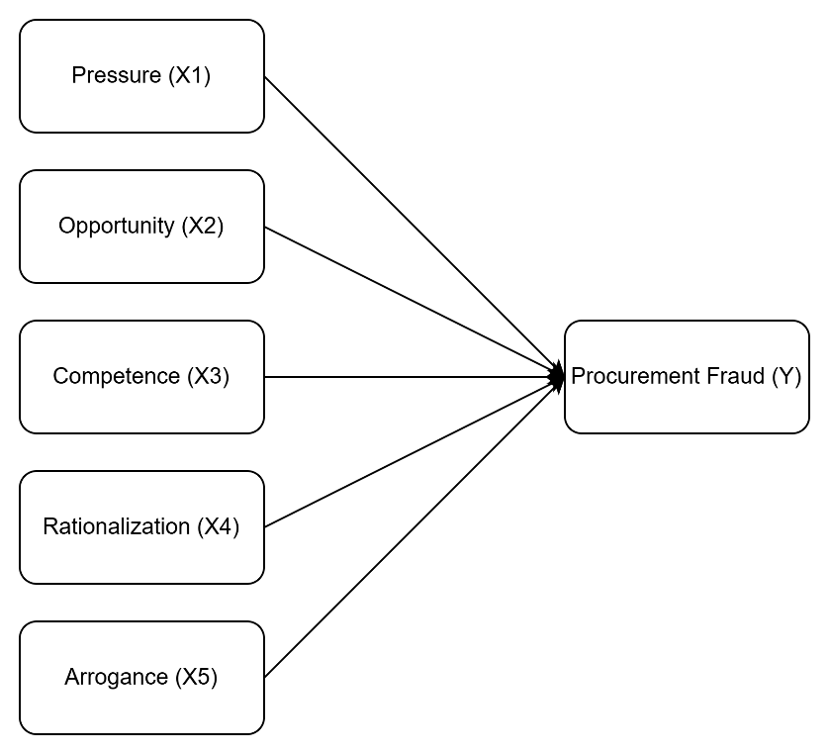
Figure 2. 3 Research Model
Source: Data Processed (2024)

CHAPTER III
RESEARCH METHOD
- Type of Research
This study employs a quantitative research approach, which is grounded in the philosophy of positivism, emphasizing objective measurement and statistical analysis of social phenomena. The primary aim of this method is to test hypotheses or theories through the collection of numerical data, which is then analyzed using statistical techniques (Sugiyono, 2020).
- Operational Definitions and Variable Measurement
- Independent Variable (X)
Independent variables, also known as predictor or explanatory variables, refer to factors that exert influence on or lead to variations in the dependent variable. Within the scope of this research, the independent variables consist of:
- Pressure
Pressure refers to the push or demands experienced by individuals that may lead them to commit fraud. According to Albrecht et al. (2006), pressure can be measured using the following indicators:
- Financial factors, such as urgent financial needs.
- External pressure, such as demands from superiors to meet certain targets.
- Unethical habits or behaviors that increase the risk of fraud.
- Other pressures, such as the desire to maintain a luxurious lifestyle.
- Opportunity
Opportunity refers to conditions that enable individuals to commit fraud due to weaknesses in internal or external controls. According to Nurlia & Hermanto (2021) opportunity can be measured by the following indicators:
- Exploiting one’s position for personal gain.
- Long tenure in a position, increasing the chances of identifying system loopholes.
- Weak internal controls, such as deficiencies in internal oversight procedures.
- Weak external controls, such as insufficient external supervision.
- Lack of strict regulations that allow room for fraudulent behavior.
- Competence
Competence refers to an individual’s ability to understand systems, identify vulnerabilities, and use such knowledge to commit fraud. According to Rustiarini et al. (2019) ompetence can be measured using the following indicators:
- Positioning, the ability to place oneself in a strategic role for committing fraud.
- Intelligence and creativity, the intellectual and creative capacity to devise fraudulent methods.
- Confidence, the belief that one can commit fraud without being detected.
- Coercion, the ability to pressure others into participating in fraudulent acts.
- Deceit, the capability to manipulate data or information.
- Stress, psychological pressure that may influence decisions to engage in fraud.
- Rationalization
Rationalization is the justification used by individuals to legitimize fraudulent behavior. According to Nurlia & Hermanto (2021), rationalization can be measured with the following indicators:
- Low ethical standards from superiors, such as when supervisors disregard ethics, making fraud seem acceptable.
- Fraud is perceived as a common or normal practice.
- A sense of entitlement to greater compensation due to perceived imbalance between effort and reward, leading to fraud as a form of self-compensation.
- Arrogance
Arrogance refers to a sense of superiority in which individuals feel they are above laws or organizational rules. According to Suryandari & Pratama (2021), arrogance can be measured using the following indicators:
- Big ego, the belief that one is more important and exempt from rules.
- Fear of losing position or status, the fear of losing authority or reputation, prompting rule violations.
- Autocratic, an authoritarian attitude that prioritizes personal will over regulations.
- Circumvent internal control, the ability to bypass or manipulate internal control systems unethically.
    - Dependent Variable (Y)
The dependent variable is the outcome that is influenced or determined by changes in the independent variables. It reflects the impact or results that emerges as a consequence of variation in the independent variables (Sugiyono, 2020). In this study, the dependent variable is procurement fraud.
- Procurement Fraud
Procurement fraud involves various actions that violate official procedures and established regulations within the procurement process. The indicators of procurement fraud include:
- Gratification, the receipt or offering of unauthorized gifts or incentives during the procurement process.
- Mark-up, the manipulation of prices, where goods or services are listed at inflated prices that do not reflect their actual value.
- Deviation from procurement procedures, occurs when individuals fail to comply with the established rules and procedures governing the procurement process.
- Not transparent, which refers to the absence of openness in the procurement process.
Table 3. 1 Indicator Variable
Variable | Indicator | Statement
Pressure (X₁) | Financial Factors | - The income I receive is insufficient to meet my needs  - I would feel pressured if I had a large amount of debt
Pressure (X₁) | External Pressure | - I am expected to perform perfectly in my work at all times  - I feel unappreciated at work despite the good performance I have delivered  - I face pressure from my family to earn income by any means necessary
Pressure (X₁) | Unhealthy Habits | - Unhealthy habits such as gambling or consuming alcohol may push someone to seek extra funds to sustain those behaviors
Pressure (X₁) | Other Pressure | - I maintain a luxurious lifestyle
continued to next page

Table 3.1. Continues
Variable | Indicator | Statement
Opportunity (X₂) | Exploiting Tenure | - I take advantage of my position to obtain personal benefits
Opportunity (X₂) | Holding a Position for an Extended Time | - I have held a position long enough to understand how to exploit available opportunities
Opportunity (X₂) | Weak Internal Control | - The organization’s internal control system is weak, allowing me to benefit from it for personal gain
Opportunity (X₂) | External Supervision | - External auditors are unable to uncover all fraudulent acts that occur in my institution
Opportunity (X₂) | Lack of Firm Regulations | - The institution rarely takes firm action against employees who commit fraud
Competence (X₃) | Positioning | - A high-ranking position can be a contributing factor to procurement fraud
Competence (X₃) | Intelligence and Creativity | - Good knowledge and understanding may enable fraudulent actions to be executed effectively
Competence (X₃) | Confidence | - A person may commit fraud if they are confident their actions will go undetected
Competence (X₃) | Coercion | - Fraud perpetrators have the ability to pressure others into keeping their misconduct secret
Competence (X₃) | Deceit | - Fraud perpetrators will persist in their lies
Competence (X₃) | Stress | - Fraud perpetrators are capable of managing stress and emotions to avoid detection
Rationalization (X₄) | Supervisor's Low Ethical Concern | - The institution where I work does not place strong emphasis on the ethical values of actions
Rationalization (X₄) | Fraud is Considered Normal | - Gaining financial benefit by exploiting weaknesses in institutional regulations is considered normal  - Fraudulent acts may be justified if carried out under urgent circumstances
Rationalization (X₄) | Fraudulent Gains Used for Good | - The additional income I receive, though not rightfully mine, is allocated for charitable or good purposes
Rationalization (X₄) | Entitled to Higher Compensation Due to Imbalance | - The extra income I obtain, though not my rightful entitlement, is a reward for my hard work  - I deserve greater compensation because what I receive is not proportional to the effort I have put in
Arogance (X₅) | Big Ego | - Being unable to accept differing opinions is a sign of arrogance  - Considering those who dislike us as enemies reflects an arrogant attitude  - Arrogant individuals tend to conceal their weaknesses through boastful behavior
Arogance (X₅) | Fear of Losing Position or Status | - The fear of losing one’s position can lead to selfishness and fraudulent acts
continued to next page

Table 3.1. Continues
Variable | Indicator | Statement
 | Auto Cratic | - Believing one's abilities are superior to others can result in claiming entitlements without seeking confirmation
 | Circumvent Internal Control | - Fraud perpetrators tend to bypass internal controls due to their ego and belief that their actions are not wrong
Procurement Fraud (Y) | Gratification | - It is not a problem if leftover budget funds are distributed among employees as bonuses
Procurement Fraud (Y) | Mark-Up | - Fraud is commonly committed through price mark-up schemes
Procurement Fraud (Y) | Deviation from Procurement Procedures | - Conducting procurement without adherence to proper systems and procedures constitutes fraud
Procurement Fraud (Y) | Lack of Transparency | - It is considered normal in my institution if expenditures occur without supporting documents
Source: Data Processed (2024)
- Population and Sample
- Population
The term opulation denotes a group or domain comprising entities or individuals possessing specific characteristics and quantities, identified by the researcher as the focus of investigation, from which conclusions are intended to be drawn based on the research findings (Sugiyono, 2020). In this study, the population comprises all members of the procurement implementation committees within all Regional Government Organizations (OPD) under the Government of Samarinda City.
- Sample
A sample is a subset of the population that represents the quantity and characteristics of the overall population (Sugiyono, 2020). This study uses a purposive sampling technique, which involves selecting samples based on specific criteria aligned with the objectives of the research.
The criteria for selecting respondents include individuals serving as Auditors, Treasurers, Inventory Treasurers, Expenditure Treasurers, Assistant Expenditure Treasurers, Division Heads, Budget User Proxies, Technical Activity Executing Officers (PPTK), Commitment-Making Officials (PPK), Procurement Officials, and Finance Staff. This selection is based on their responsibilities in the procurement process and their direct involvement, which is expected to enhance the validity of the study.
Based on the collected data, the total number of respondents in this study is 109 individuals.
Table 3. 2 List of Regional Government Organizations in Samarinda City
No. | Name | Total Respondents
1. | Dinas Penanggulangan Bencana Daerah Kota Samarinda | 5
2. | Dinas Kependudukan dan Pencatatan Sipil Kota Samarinda | 10
3. | Dinas Pengendalian Penduduk dan Keluarga Berencana | 4
4. | Dinas Kesehatan Kota Samarinda | 5
5. | Dinas Sosial dan Pemberdayaan Masyarakat Kota Samarinda | 3
6. | Dinas Pemberdayaan Perempuan dan Perlindungan Anak Kota Samarinda | 3
7. | Dinas Pendidikan dan Kebudayaan Kota Samarinda | 2
8. | Dinas Tenaga Kerja Kota Samarinda | 3
9. | Dinas Perpustakaan dan Kearsipan Kota Samarinda | 5
10. | Dinas Ketahanan Pangan dan Pertanian Kota Samarinda | 3
11. | Dinas Lingkungan Hidup Kota Samarinda | 2
12. | Dinas Perikanan Kota Samarinda | 3
13. | Dinas Pekerjaan Umum dan Penataan Ruang Kota Samarinda | 2
14. | Dinas Perumahan dan PemukimanKota Samarinda | 3
15. | Dinas Perhubungan Kota Samarinda | 2
16. | Dinas Penanaman Modal dan Pelayanan Terpadu Satu Pintu Kota Samarinda | 2
17. | Dinas Perdagangan Kota Samarinda | 5
18. | Dinas Koperasi, Usaha Kecil, Menengah dan Perindustrian Kota Samarinda | 2
19. | Badan Kepegawaian dan Pengembangan SourceDaya Manusia Kota Samarinda | 6
20. | Badan Perencanaan Pembangunan, Riset dan Inovasi Daerah Kota Samarinda | 3
21. | Dinas Pemadam Kebakaran dan Penyelamat Kota Samarinda | 6
22. | Satuan Polisi Pamong Praja Kota Samarinda | 2
23. | Badan Kesatuan Bangsa dan Politik Kota Samarinda | 2
24. | Dinas Pemuda, Olahraga dan Pariiwisata Kota Samarinda | 5
25. | Dinas Komunikasi dan Informatika Kota Samarinda | 2
26. | Badan Pendapatan Kota Samarinda | 5
27. | Badan Pengelolaan Keuangan dan Aset Daerah Kota Samarinda | 6
28. | Inspektorat Daerah Kota Samarinda | 3
continued to next page

Table 3.2. Continues
No. | Name | Total Respondents
29. | Sekretariat Dewan Perwakilan Rakyar Daerah Kota Samarinda | 3
30. | Sekretariat Daerah Kota Samarinda | 2
Total |  | 109
Source: Data Processed (2024)
- Type and Source of Data
- Type of Data
This research employs a quantitative method that relies on numerical data obtained through questionnaires. These data are then statistically analyzed to test hypotheses regarding the relationships among the predetermined variables.
- Source of Data
The data source used in this research is primary data, which is collected directly from respondents through the distribution of questionnaires.
- Data Collection Method
The data collection technique used in this study is a questionnaire. A questionnaire is a research instrument that involves presenting a series of written questions to respondent (Sugiyono, 2020). The questionnaire used in this research contains items related to the elements of the Fraud Pentagon Theory, and respondents are asked to provide answers based on a provided Likert scale.
Table 3. 3 Likert Scala Values
Assessment Criteria | Score
Strongly Disagree | 1
Disagree | 2
Neutral | 3
Agree | 4
Strongly Agree | 5
Source: (Sugiyono, 2020)
The Likert scale is used to measure respondents’ attitudes, opinions, and perceptions regarding the research variables. Each answer choice on the Likert scale instrument ranges from very negative to very positive (Sugiyono, 2020).
- Data Analysis Tool
The data obtained in this research were analyzed through Partial Least Squares Structural Equation Modeling (PLS-SEM) utilizing the SmartPLS software version 4.0. PLS-SEM is a variance-based statistical analysis method used to examine the relationships between variables as measured by their respective indicators (Ghozali & Kusumadewi, 2023).
- Outer Model
According to Ghozali & Latan (2015) the measurement model, also known as the outer model, is used to assess the validity and reliability of the indicators employed in measuring constructs within research that applies Structural Equation Modeling Partial Least Squares (SEM-PLS). The outer model is designed to ensure that the indicators appropriately represent the constructs being measured.
- Validity Test
The validity test evaluates the precision and accuracy of the measurement instruments in representing the variables studied, to ensure that the survey conducted is valid and capable of producing accurate and relevant data. Validity testing is carried out using two approaches: convergent validity and discriminant validity.
Convergent validity is used to ensure that indicators measuring the same variable have a high level of correlation. According to Ghozali & Latan (2015), convergent validity is assessed by evaluating the loading factor values and comparing them with the established rule of thumb (>0.70). If the loading factor exceeds 0.70, the indicator is considered valid. The Average Variance Extracted (AVE) value is also analyzed and compared to the rule of thumb threshold (>0.50). If the AVE value exceeds 0.50, it indicates that more than 50% of the variance in the indicators can be explained by the construct.
Discriminant validity involves comparing the square root value of the AVE for each latent construct and its correlation with other construct within the model. Discriminant validity is considered satisfactory if the square root of the AVE is greater than the correlation with other latent variables.
- Reliability Test
The reliability test is used to measure the questionnaire as an indicator of the research variable. If there is consistency in the respondents’ answers to the questions provided, the variable is considered reliable and effective in measuring what it is intended to measure. Reliability is assessed through Composite Reliability and Cronbach’s Alpha. Composite Reliability evaluates the overall internal consistency, with a recommended value greater than 0.70. Meanwhile, Cronbach’s Alpha measures the reliability of individual indicators within a latent variable. A Cronbach’s Alpha value greater than 0.60 indicates that the variable is reliable and meets the Cronbach’s Alpha standard (Ghozali & Latan, 2015).
- Inner Model
Inner model is used to assess the relationship between latent variables. The inner model plays a crucial role in determining the degree to which one latent variable influence another, in accordance with the hypotheses developed in the study.
- R-Square
According to Ghozali & Latan (2015) R-Square indicates the extent to which independent variables explain the variance of the dependent variable. The R-Square value is classified as follows: a value of 0.25 reflects a model with low explanatory power, 0.50 denotes a model with moderate explanatory strength, while a value of 0.75 represents a model with substantial or strong explanatory capability.
- Hypothesis Testing
Hypothesis testing aims to evaluate the significance of the relationships between latent variables. The assessment of significance is conducted by analyzing the t-statistics and p-values. A hypothesis is considered statistically significant if the t-statistic exceeds 1.96 at a 5% significance level (0.05), or if the p-value is less than 0.05. Conversely, the hypothesis is rejected if the path coefficient is negative or the p-value exceeds 0.05.
- Pilot Test
A Pilot is conducted to ensure that the instruments used are valid and reliable for measuring the research variables. In this study, the researcher employed a sample of 35 respondents to test the validity and reliability of the instrument using the PLS-SEM method through SmartPLS software.
- Instrument Validity Test
Instrument validity is assessed using two approaches: convergent validity and discriminant validity. Convergent validity is evaluated based on the loading factor values of each indicator, with a rule of thumb that the loading factor must be greater than 0.70, while the Average Variance Extracted (AVE) must be greater than 0.50 for the indicators to be considered valid in measuring the construct. Meanwhile, discriminant validity is assessed by comparing the square root of the AVE for each construct with the correlations between latent constructs. Discriminant validity is considered to be met if the square root of the AVE is higher than the correlations between constructs, indicating a clear distinction between the constructs being measured.
Table 3. 4 Outer Loading Result
Variable | Indicator | Outer Loading
Pressure (X₁) | TK1 | 0,821
Pressure (X₁) | TK2 | 0,829
 | TK3 | 0,783
 | TK4 | 0,721
 | TK5 | 0,689
 | TK6 | 0,651
 | TK7 | 0,447
Opportunity (X₂) | K1 | 0,604
Opportunity (X₂) | K2 | 0,681
Opportunity (X₂) | K3 | 0,821
Opportunity (X₂) | K4 | 0,789
Opportunity (X₂) | K5 | 0,785
Competence (X₃) | KP1 | 0,904
Competence (X₃) | KP2 | 0,874
Competence (X₃) | KP3 | 0,885
Competence (X₃) | KP4 | 0,887
Competence (X₃) | KP5 | 0,764
Competence (X₃) | KP6 | 0,674
Rationalization (X₄) | RA1 | 0,617
Rationalization (X₄) | RA2 | 0,581
Rationalization (X₄) | RA3 | 0,714
Rationalization (X₄) | RA4 | 0,727
Rationalization (X₄) | RA5 | 0,841
Rationalization (X₄) | RA6 | 0,663
Arrogance (X₅) | AR1 | 0,762
Arrogance (X₅) | AR2 | 0,785
Arrogance (X₅) | AR3 | 0,861
continued to next page

Table 3.4. Continues
Variable | Indicator | Outer Loading
 | AR4 | 0,776
 | AR5 | 0,669
 | AR6 | 0,874
Procurement Fraud (Y) | FPBJ1 | 0,687
Procurement Fraud (Y) | FPBJ2 | 0,919
Procurement Fraud (Y) | FPBJ3 | 0,887
Procurement Fraud (Y) | FPBJ4 | 0,699
Source: Data Processed (2024)
The table above shows that several indicators did not meet the required criteria and therefore had to be excluded from the research model. The excluded indicators are TK5, TK6, TK7, PL1, PL2, KP6, RA1, RA2, RA6, AR5, FPBJ1, and FPBJ.
Table 3.5 Outer Loading Result (Final)
Variable | Indicator | Outer Loading
Pressure (X₁) | TK1 | 0,821
Pressure (X₁) | TK2 | 0,829
Pressure (X₁) | TK3 | 0,783
Pressure (X₁) | TK4 | 0,721
Pressure (X₁) | TK5 | 0,727
Opportunity (X₂) | K3 | 0,821
Opportunity (X₂) | K4 | 0,789
Opportunity (X₂) | K5 | 0,785
Competence (X₃) | KP1 | 0,904
Competence (X₃) | KP2 | 0,874
Competence (X₃) | KP3 | 0,885
Competence (X₃) | KP4 | 0,887
Competence (X₃) | KP5 | 0,764
Rationalization (X₄) | RA3 | 0,714
Rationalization (X₄) | RA4 | 0,727
Rationalization (X₄) | RA5 | 0,841
Arrogance (X₅) | AR1 | 0,762
Arrogance (X₅) | AR2 | 0,785
Arrogance (X₅) | AR3 | 0,861
Arrogance (X₅) | AR4 | 0,776
continued to next page

Table 3.5. Continues
Variable | Indicator | Outer Loading
 | AR6 | 0,874
Procurement Fraud (Y) | FPBJ2 | 0,919
Procurement Fraud (Y) | FPBJ3 | 0,887
Source: Data Processed (2024)
The table also shows that all remaining indicators have achieved loading values above 0.70, indicating that the constructs are acceptable.
Table 3.6 AVE (Average Variance Extracted)
Variable | AVE Value | Description
Pressure (X₁) | 0,603 | Valid
Opportunity (X₂) | 0,731 | Valid
Competence (X₃) | 0,763 | Valid
Rationalization (X₄) | 0,645 | Valid
Arrogance (X₅) | 0,670 | Valid
Procurement Fraud (Y) | 0,739 | Valid
Source: Data Processed (2024)
The table above shows that the AVE values for each variable are greater than 0.50, indicating that they are valid and meet the required threshold for AVE.
Table 3.7 Cross Loadings Result
Variable | TK | PL | KP | RA | AR | FPBJ
TK1 | 0,817 | 0,460 | 0,354 | 0,388 | 0,401 | 0,223
TK2 | 0,866 | 0,088 | 0,449 | 0,245 | 0,622 | 0,440
TK3 | 0,790 | 0,399 | 0,709 | 0,188 | 0,728 | 0,365
TK4 | 0,707 | 0,447 | 0,331 | 0,188 | 0,337 | 0,160
PL3 | 0,416 | 0,848 | 0,332 | 0,087 | 0,170 | 0,180
PL4 | 0,275 | 0,837 | 0,192 | 0,236 | 0,179 | 0,132
PL5 | 0,315 | 0,878 | 0,262 | 0,240 | 0,115 | 0,197
KP1 | 0,534 | 0,342 | 0,913 | 0,163 | 0,730 | 0,627
KP2 | 0,580 | 0,279 | 0,878 | 0,155 | 0,717 | 0,606
KP3 | 0,587 | 0,292 | 0,903 | 0,296 | 0,724 | 0,655
KP4 | 0,579 | 0,334 | 0,880 | 0,250 | 0,754 | 0,669
continued to next page

Table 3.5. Continues
Variable | TK | PL | KP | RA | AR | FPBJ
KP5 | 0,249 | 0,083 | 0,788 | 0,058 | 0,484 | 0,493
RA3 | 0,192 | 0,119 | 0,174 | 0,755 | 0,302 | 0,285
RA4 | 0,180 | 0,061 | 0,183 | 0,850 | 0,299 | 0,310
RA5 | 0,346 | 0,323 | 0,172 | 0,801 | 0,346 | 0,335
AR1 | 0,510 | 0,065 | 0,450 | 0,354 | 0,731 | 0,456
AR2 | 0,684 | -0,004 | 0,511 | 0,342 | 0,779 | 0,346
AR3 | 0,533 | 0,155 | 0,713 | 0,362 | 0,881 | 0,696
AR4 | 0,649 | 0,220 | 0,739 | 0,124 | 0,794 | 0,489
AR6 | 0,546 | 0,209 | 0,741 | 0,407 | 0,896 | 0,753
FPBJ2 | 0,435 | 0,260 | 0,753 | 0,467 | 0,759 | 0,942
FPBJ3 | 0,318 | 0,138 | 0,589 | 0,299 | 0,603 | 0,917
Source: Data Processed (2024)
Based on the table, it can be concluded that the correlation between each latent variable and its indicators is greater than the correlation between the latent variables themselves. This indicates that there are no issues of discriminant validity in the cross-loading analysis.
- Instrument Reliability Test
The reliability test aims to assess the consistency of the instrument in measuring the construct, ensuring that the measurement results are dependable. Composite reliability values are used in this test to evaluate the construct reliability using reflective indicators in SmartPLS. A good composite reliability value is above 0.70, which indicates an adequate level of internal consistency. Cronbach’s Alpha is also used as an additional measure of reliability, where a value above 0.60 is considered to have met the acceptable reliability standard (Ghozali & Latan, 2015).

Table 3.8 Composite Reliability and Cronbach’s Alpha Result
Variable | Composite Reliability | Cronbach's Alpha | Description
Pressure (X₁) | 0,936 | 0,846 | Reliable
Opportunity (X₂) | 0,840 | 0,818 | Reliable
Competence (X₃) | 0,930 | 0,724 | Reliable
Rationalization (X₄) | 0,728 | 0,724 | Reliable
Arrogance (X₅) | 0,925 | 0,879 | Reliable
Procurement Fraud (Y) | 0,893 | 0,824 | Reliable
Source: Data Processed (2024)
The table above shows that both measurement values exceed 0.70, indicating that the constructs in this study are considered reliable.

CHAPTER IV
RESULTS AND DISCUSSION
- Research Result
- Questionnaire Distribution Results
Data collection in this study was carried out by distributing questionnaires directly. The researcher distributed 109 questionnaire forms to the respondents. The selected respondents consisted of employees involved in the procurement. The following table presents the detailed results of the questionnaire distribution.
Table 4.1 Questionnaire Distribution Results
Description | Total
Number of OPD | 30
Questionnaires Distributed | 109
Questionnaires Returned | 109
Questionnaires Not Usable | 7
Questionnaires Analyzed | 102
Source: Data Processed (2025)
- Respondent Demographic Characteristics
To determine the characteristics of respondents, the researcher grouped them based on several categories, including gender, age, educational background, and job position.
- Gender
Based on the 102 respondents who completed the questionnaire, gender was categorized into male and female, with 64 males (63%) and 38 females (37%)
Table 4.2 Respondent’s Gender
Gender | Total | Percentage (%)
Male | 64 | 63%
continued to next page

Table 4.2 Continues
Gender | Total | Percentage (%)
Female | 38 | 37%
Total | 102 | 100%
Source: Data Processed (2025)
- Age
Based on the responses of 102 individuals, age distribution was grouped into the following categories: 20–30 years, 31–40 years, 41–50 years, and 51–60 years.
Table 4.3 Respondents’ Age
Age Group (Years) | Total | Percentage (%)
20 - 30 | 14 | 14%
31 - 40 | 40 | 39%
41 - 50 | 42 | 41%
51 - 60 | 6 | 6%
Total | 102 | 100%
Source: Data Processed (2025)
- Educational Background
Based on 102 responses, the respondents’ education levels were grouped into High School, Diploma, Bachelor’s Degree (S1), Master’s Degree (S2), and Doctoral Degree (S3).
Table 4.4 Respondents’ Education Level
Education Level | Total | Percentage (%)
High School | 12 | 12%
Diploma | 10 | 10%
S1 | 68 | 67%
S2 | 12 | 12%
S3 | 0 | 0%
Total | 102 | 100%
Source: Data Processed (2025)
- Job Position
Based on the 102 respondents, job positions were classified as auditor, treasurer, goods treasurer, expenditure treasurer, assistant expenditure treasurer, division head, budget user authority, technical activity implementation officer (PPTK), commitment-making official (PPK), procurement official, and financial staff.
Table 4.5 Respondent’s Job Position
Job Position | Total | Percentage (%)
Auditor | 2 | 2%
Treasurer | 5 | 5%
Goods Treasurer | 8 | 8%
Expenditure Treasurer | 5 | 5%
Assistant Expenditure Treasurer | 6 | 6%
Division Head | 10 | 10%
Budget User Authority | 2 | 2%
Technical Implementation Officer | 9 | 9%
Commitment-Making Official | 10 | 10%
Procurement Officer | 6 | 6%
Financial Staff | 39 | 38%
Total | 102 | 100%
Source: Data Processed (2025)
- Data Analysis Results
- Outer Model
- Convergent Validity Test
The rule of thumb for convergent validity requires that the loading factor value must exceed 0.70, and the Average Variance Extracted (AVE) must be greater than 0.50 for an indicator to be considered valid. (Ghozali & Latan, 2015).
Table 4.6 Outer Loadings Result
Variable | Indicator | Outer Loading | Description
Pressure (X1) | TK1 | 0,786 | Valid
Pressure (X1) | TK2 | 0,866 | Valid
Pressure (X1) | TK3 | 0,893 | Valid
Pressure (X1) | TK4 | 0,841 | Valid
continued to next page
Table 4.6 Continues
Variable | Indicator | Outer Loading | Description
Opportunity (X2) | K3 | 0,937 | Valid
Opportunity (X2) | K4 | 0,935 | Valid
Opportunity (X2) | K5 | 0,950 | Valid
Competence (X3) | KP1 | 0,757 | Valid
Competence (X3) | KP2 | 0,817 | Valid
Competence (X3) | KP3 | 0,900 | Valid
Competence (X3) | KP4 | 0,897 | Valid
Competence (X3) | KP5 | 0,787 | Valid
Rationalization (X4) | RA3 | 0,936 | Valid
Rationalization (X4) | RA4 | 0,901 | Valid
Rationalization (X4) | RA5 | 0,932 | Valid
Arrogance (X5) | AR1 | 0,800 | Valid
Arrogance (X5) | AR2 | 0,808 | Valid
Arrogance (X5) | AR3 | 0,910 | Valid
Arrogance (X5) | AR4 | 0,851 | Valid
Arrogance (X5) | AR6 | 0,880 | Valid
Procurement Fraud (Y) | FPBJ2 | 0,919 | Valid
Procurement Fraud (Y) | FPBJ3 | 0,887 | Valid
Source: Data Processed (2025)
The table above shows that all indicators have achieved loading factor values exceeding 0.70, indicating that the constructs are acceptable.
Table 4.7 Average Variance Extracted (AVE)
Variable | Average Variance Extracted (AVE) | Description
Pressure (X1) | 0,718 | Valid
Opportunity (X2) | 0,885 | Valid
Competence (X3) | 0,695 | Valid
Rationalization (X4) | 0,852 | Valid
Arrogance (X5) | 0,724 | Valid
Procurement Fraud (Y) | 0,921 | Valid
Source: Data Processed (2025)
Furthermore, the AVE values for each variable are above 0.50, confirming that the constructs meet the required validity threshold.
- Discriminant Validity Test
Discriminant validity measures the extent to which indicators accurately represent their intended constructs by examining the cross-loading values. The assessment is conducted by comparing each indicator’s loading on its associated construct with its loadings on other constructs. Discriminant validity is considered to be met when the cross-loading value for each variable exceeds 0.70 (Ghozali & Latan, 2015).
Table 4.8 Cross Loading Result
Variable | TK | K | KP | RA | AR | FPBJ
TK1 | 0,786 | -0,196 | 0,015 | -0,147 | 0,204 | 0,463
TK2 | 0,866 | -0,195 | 0,227 | -0,003 | 0,233 | 0,595
TK3 | 0,893 | -0,204 | 0,095 | -0,135 | 0,141 | 0,546
TK4 | 0,841 | -0,098 | 0,114 | -0,173 | 0,199 | 0,515
K3 | -0,194 | 0,937 | 0,113 | 0,183 | 0,083 | -0,139
K4 | -0,180 | 0,935 | 0,096 | 0,109 | 0,149 | -0,063
K5 | -0,198 | 0,950 | 0,109 | 0,134 | 0,098 | -0,138
KP1 | -0,020 | 0,200 | 0,757 | 0,172 | 0,140 | 0,254
KP2 | 0,126 | 0,075 | 0,817 | 0,078 | 0,172 | 0,265
KP3 | 0,172 | 0,122 | 0,900 | 0,037 | 0,354 | 0,335
KP4 | 0,121 | 0,054 | 0,897 | 0,120 | 0,364 | 0,294
KP5 | 0,157 | 0,039 | 0,787 | 0,023 | 0,371 | 0,314
RA3 | -0,127 | 0,149 | 0,064 | 0,936 | -0,175 | -0,118
RA4 | -0,079 | 0,100 | 0,086 | 0,901 | -0,146 | -0,086
RA5 | -0,145 | 0,182 | 0,123 | 0,932 | -0,155 | -0,103
AR1 | 0,139 | 0,084 | 0,180 | -0,169 | 0,800 | 0,251
AR2 | 0,192 | 0,023 | 0,225 | -0,178 | 0,808 | 0,254
AR3 | 0,280 | 0,107 | 0,306 | -0,184 | 0,910 | 0,346
AR4 | 0,153 | 0,097 | 0,459 | -0,158 | 0,851 | 0,365
AR6 | 0,201 | 0,122 | 0,259 | -0,076 | 0,880 | 0,398
FPBJ2 | 0,628 | -0,094 | 0,370 | -0,080 | 0,379 | 0,963
FPBJ3 | 0,577 | -0,162 | 0,306 | -0,138 | 0,369 | 0,956
Source: Data Processed (2025)
The table above demonstrates that all cross-loading values exceed 0.70, indicating that the relationship between each latent variable and its indicators is stronger than the relationship with other latent variables. Therefore, it can be concluded that there are no issues with discriminant validity in the cross-loading analysis.
- Reliability Test
The reliability test is intended to confirm whether the research instruments applied in this study possess an adequate degree of accuracy, stability, and exactness in capturing the intended constructs. Construct reliability is evaluated through two approaches: Composite Reliability and Cronbach’s Alpha. A construct is deemed reliable when the values of both composite reliability and Cronbach’s alpha surpass the threshold of 0.70 (Ghozali & Latan, 2015).
Table 4.9 Composite Reliability and Cronbach’s Alpha Result
Variable | Composite Reliability | Cronbach's Alpha | Description
Pressure (X1) | 0,910 | 0,869 | Reliable
Opportunity (X2) | 0,958 | 0,937 | Reliable
Competence (X3) | 0,919 | 0,889 | Reliable
Rationalization (X4) | 0,945 | 0,914 | Reliable
Arrogance (X5) | 0,929 | 0,906 | Reliable
Procurement Fraud (Y) | 0,959 | 0,914 | Reliable
Source: Data Processed (2025)
The table above shows that both measurement values exceed 0.70, indicating that the constructs in this study are considered reliable.
- Inner Model
- R-Square
The R-Square value represents the coefficient of determination for the endogenous construct. The R-Square value is categorized as strong if it reaches 0.75, moderate at 0.50, and weak at 0.25. The adjusted coefficient of determination (Adjusted R-Square) serves to describe the extent to which the independent variables influence the dependent variable (Ghozali & Latan, 2015).
Table 4.10 R-Square Result
Variable | R Square | R Square Adjusted
Procurement Fraud | 0,503 | 0,477
Source: Data Processed (2025)
The table above indicates a moderate R-Square category with a value of 0.503, suggesting that 50.3% of fraudulent behavior in the procurement can be explained by the five elements of the Fraud Pentagon Theory, namely Pressure, Opportunity, Competence, Rationalization, and Arrogance. Meanwhile, the remaining 49.7% is explained by other variables not included in this study.
- Hypothesis Testing
Table 4.11 Path Coefficient Result
Variable | Original Sample (O) | Sample Mean (M) | Standard Deviation (STDRV) | T Statistic | P Values
Pressure -> Procurement Fraud | 0,538 | 0,520 | 0,078 | 6,867 | 0,000
Opportunity -> Procurement Fraud | -0,065 | -0,067 | 0,099 | 0,653 | 0,514
Competence -> Procurement Fraud | 0,221 | 0,228 | 0,091 | 2,439 | 0,015
Rationalization -> Procurement Fraud | -0,021 | -0,023 | 0,075 | 0,280 | 0,780
Arrogance -> Procurement Fraud | 0,193 | 0,197 | 0,087 | 2,214 | 0,027
Source: Data Processed (2025)
Based on the hypothesis testing results presented in the table above, the findings can be explained as follows:
- First Hypothesis (H1): The p-value is 0.000, which is less than 0.05, and the original sample value is 0.538. This indicates that Pressure has a significant and positive effect on fraudulent procurement of goods and services. Therefore, the first hypothesis (H1) is accepted.
- Second Hypothesis (H2): The p-value is 0.514, which is greater than 0.05, and the original sample value is -0.065. This implies that Opportunity does not have a significant effect on fraudulent procurement of goods and services. Hence, the second hypothesis (H2) is rejected.
- Third Hypothesis (H3): The p-value is 0.015, which is less than 0.05, and the original sample value is 0.221. This demonstrates that Competence has a significant and positive influence on fraudulent procurement of goods and services. Thus, the third hypothesis (H3) is accepted.
- Fourth Hypothesis (H4): The p-value is 0.780, which is greater than 0.05, and the original sample value is -0.021. This indicates that Rationalization does not significantly influence fraudulent procurement of goods and services. Consequently, the fourth hypothesis (H4) is rejected.
- Fifth Hypothesis (H5): The p-value is 0.027, which is less than 0.05, and the original sample value is 0.193. This suggests that Arrogance has a significant and positive effect on fraudulent procurement of goods and services. Therefore, the fifth hypothesis (H5) is accepted.
- Discussion
- The Influence of Pressure on Procurement Fraud
Based on the results of the first hypothesis test (H1), it is concluded that Pressure has a significant and positive effect on procurement fraud. This is evidenced by an original sample value of 0.538, a T-statistic of 6.867 (greater than 1.96), and a p-value of 0.000 (less than 0.05). These results indicate that the greater the pressure experienced by an individual, the higher the likelihood of committing fraudulent acts in the procurement process.
Pressure may manifest in various forms such as financial pressure, unrealistic job targets, excessive workloads, or lifestyle demands. Individuals facing personal financial difficulties, including debt, high living costs, or a consumptive lifestyle, tend to seek shortcuts to meet their needs, including engaging in fraudulent behavior. The highest loading indicator in this construct shows that external pressure, particularly the expectation to always perform perfectly at work, is the most significant factor influencing fraud in the procurement process. This is due to the pressure placed on individuals to meet targets or performance standards that are often unrealistic, such as completing the procurement tender process within an irrational timeframe or being implicitly instructed to ensure the selection of a specific vendor. Such pressure may originate from a superior who has a personal relationship with a particular vendor, thereby encouraging and instructing procurement staff to ensure that the vendor is selected during the tender process.
In such situations, individuals are placed in a dilemma where they are expected to comply with established procurement regulations while simultaneously facing pressure to fulfill their superior’s demands in order to maintain professional relationships and secure their positions. This pressure has the potential to drive fraudulent actions, such as designing tender specifications that favor a certain vendor, manipulating estimated prices to align with the preferred vendor’s offer, or disregarding other vendors who may actually offer better technical quality or more competitive pricing. As a result, individuals may resort to any means necessary to appear as though they have successfully met performance targets, including manipulation within the procurement process.
Based on theory, this aligns with the first element of the Fraud Pentagon, namely Pressure. Pressure serves as a primary driving factor behind fraudulent behavior, compelling individuals to consider unethical actions as a means to cope with the pressures they face. In the context of procurement of goods and services, perpetrators may manipulate documents or accept gratuities due to escalating external and internal pressures. The findings of this study are consistent with those of Mulyandani et al., (2023) which demonstrated that pressure significantly influences fraudulent behavior in the procurement process.
- The Influence of Opportunity on Procurement Fraud
Based on the results of the second hypothesis test (H2), it is stated that opportunity does not have a significant effect on procurement fraud. This is indicated by the original sample value of -0.065, a t-statistic of 0.653 < 1.96, and a p-value of 0.514 > 0.05. These findings are consistent with the study conducted by Lestari & Asyik (2023) which also found that opportunity does not influence procurement fraud.
In the Fraud Pentagon theory, opportunity refers to gaps or weaknesses in the organizational system that can be exploited by individuals to commit fraud, such as weak internal controls, lack of supervision, and limited internal audits. The results of this study indicate that opportunity is not a contributing factor in driving procurement fraud. This is due to the hierarchical structure of government organizations, which typically have clearly defined roles and responsibilities, thereby limiting access or authority to strategic decision-making processes. Based on the respondents’ job positions, the majority serve as technical implementation staff rather than authorized decision-makers in procurement processes such as the preparation of self-estimated pricing (HPS), provider evaluations, or tender winner determinations. As a result, they do not have access or authority that would enable them to exploit system weaknesses. With such limited positions, weaknesses in internal control systems are not perceived by employees as opportunities to commit fraud.
These findings are supported by (Fitri & Nadir, 2020), who explained that the delegation of authority and segregation of duties within organizations limits individual involvement in procurement activities. Only employees with direct responsibilities in the procurement field are granted access and authority. This condition results in limited opportunities to exploit system loopholes, thus rendering opportunity an insignificant factor influencing procurement fraud.
- The Influence of Competence on Procurement Fraud
Based on the results of hypothesis testing (H3), it is concluded that competence has a significant and positive effect on procurement fraud. This is evidenced by the original sample value of 0.221, a T-statistic of 2.439 (greater than 1.96), and a p-value of 0.015 (less than 0.05). These results indicate that the higher an individual's competence, the greater the likelihood of engaging in fraudulent activities in the procurement of goods and services.
In the Fraud Pentagon theory, competence refers to an individual's ability to commit fraud effectively and conceal it from internal controls. Individuals with high competence tend to possess a greater understanding of organizational structures, operational processes, and regulatory provisions, enabling them to identify loopholes and exploit them without being detected. In the procurement, such individuals may manipulate data or procedures in a way that appears administratively compliant, such as fabricating prices that seem reasonable on paper but have been manipulated beforehand. Based on the indicator with the highest value, confidence is identified as the most influential factor contributing to fraud in the procurement process. This confidence often stems from work experience, mastery of procurement platforms like the e-catalogue, and a strong understanding of applicable regulations.
Although the e-catalogue system is designed to promote transparency and efficiency in procurement, it is sometimes misused to inflate prices unreasonably. Because all processes are carried out within an official system, such actions are often not perceived as violations, making perpetrators feel secure from sanctions. Excessive confidence, if not accompanied by strong integrity, may drive individuals to use their knowledge and skills for personal gain, thereby increasing the risk of fraudulent behavior in procurement activities. The findings of this study are consistent with the research conducted by Mulyandani et al., (2023) which demonstrated that competence has a significant influence on procurement fraud. Individuals with high technical expertise and extensive experience, coupled with positions that grant them access to sensitive information and important documents, are more likely to exploit their knowledge to discreetly manipulate system weaknesses. As a result, the fraudulent acts they commit become difficult to detect through the existing internal control mechanisms.
- The Influence of Rationalization on Procurement Fraud
Based on the results of the fourth hypothesis test (H4), it was found that rationalization does not have a significant influence on procurement fraud. This is indicated by the original sample value of -0.021, a t-statistic of 0.280 < 1.96, and a p-value of 0.780 > 0.05, which demonstrates that the fourth hypothesis is rejected.
In the Fraud Pentagon Theory, rationalization describes an individual's effort to justify fraudulent behavior in order to avoid feelings of guilt. However, the results of this study indicate that individuals do not always feel the need to justify fraudulent actions, particularly in permissive organizational environments where deviant behavior has become normalized or is no longer perceived as a serious violation. In such settings, perpetrators may not experience moral conflict that necessitates rationalization, as the behavior is already accepted within the prevailing work culture.
These findings are consistent with the studies conducted by Mulyandani et al., (2023) and Lestari & Asyik (2023) which also found that rationalization does not significantly influence procurement fraud. This is because fraud perpetrators are often accustomed to engaging in such misconduct and therefore do not feel the need to justify their actions. Moreover, fraudulent acts are typically committed deliberately and with prior planning, rather than arising from a moral conflict that requires justification. A permissive organizational culture that tolerates fraud leads individuals to feel no sense of guilt, rendering the rationalization process inapplicable.
- The Influence of Arrogance on Procurement Fraud
Based on the results of the fifth hypothesis test (H5), it was found that arrogance has a significant and positive effect on procurement fraud. This is indicated by the original sample value of 0.193, a T-statistic of 2.214 > 1.96, and a p-value of 0.027 < 0.05. These results indicate that the higher the level of arrogance in an individual, the greater the likelihood that they will engage in fraudulent activities in the procurement of goods and services.
In the fraud pentagon theory, arrogance is defined as a superior attitude in which an individual perceives themselves as being above applicable rules and oversight. This attitude encourages individuals to act arbitrarily, believing they are immune to sanctions or detection, thereby increasing the risk of fraudulent behavior in the execution of their duties or responsibilities. Based on the indicator with the highest score, big ego which reflects an individual who attempts to conceal their weaknesses by displaying arrogance was identified as the most influential factor contributing to procurement fraud.
A big ego typically arises in individuals who have held a particular position for an extended period, possess extensive experience, and exert significant influence within their organization. Such individuals often believe they are the most competent, making them resistant to criticism and inclined to disregard regulations, as they perceive their opinions to be always correct, even when those decisions contradict official procurement procedures. Fraud perpetrators with arrogant attitudes may make unilateral decisions, such as replacing a previously selected vendor due to personal connections or close relationships with another provider. These decisions are often justified on the grounds of institutional benefit or perceived quality based on past experiences. However, such actions violate the principle of transparency by undermining fair competition. This attitude leads the perpetrator to believe that their actions require no accountability, as they are confident that their position or influence is sufficient to avoid any existing sanctions.
The findings of this study are consistent with the research conducted by Windartanti & Urumsah (2022) which indicates that arrogance has a significant influence on procurement fraud. Individuals with an excessive level of self-confidence often tend to disregard the legal and ethical consequences of their actions. Such arrogance enables perpetrators to act with greater freedom in committing planned fraud, making their fraudulent activities more difficult to detect.

CHAPTER V
CLOSING

Conclusion
Based on the research findings, the following conclusions can be drawn:
- Pressure has a significant and positive influence on procurement fraud. The greater the pressure experienced by an individual such as financial pressure, job performance targets, and lifestyle demands the higher the risk of engaging in fraudulent behavior as a means of coping with that pressure.
- Opportunity does not significantly affect procurement fraud. This is due to the hierarchical structure of government organizations, where duties and responsibilities are clearly defined, thereby limiting employee access or authority in decision-making processes that directly affect procurement activities.
- Competence has a significant and positive influence on procurement fraud. Individuals with strong technical skills, sufficient experience, and access to critical information and documents tend to be more capable of manipulating systems and concealing fraudulent actions, making them more difficult to detect.
- Rationalization does not significantly affect procurement fraud. A permissive organizational culture and the habitual, conscious commission of fraud without moral justification diminish the relevance of rationalization as a contributing factor to fraudulent behavior.
- Arrogance has a significant and positive influence on procurement fraud. Excessive self-confidence causes individuals to feel immune to regulations and oversight, leading them to act beyond their authority for personal gain, including manipulation within the procurement process.
  - Recommendations
Based on the research findings and conclusions, the researcher proposes several recommendations that are expected to provide positive contributions and serve as valuable considerations for relevant stakeholders, as follows:
- Based on the results of this study, it is recommended that the Government of Samarinda City implement policies aimed at managing the potential pressure experienced by employees through proportional workload adjustments and the establishment of realistic performance targets. Furthermore, to enhance vigilance against potential abuse of authority by individuals with high competence, internal supervision should be strengthened, periodic job rotations should be applied, and a fair and balanced distribution of authority must be ensured. The cultivation of integrity values, professional ethics training, and firm enforcement of sanctions for any violations are also necessary to prevent the emergence of rationalizations used to justify fraudulent behavior.
- Future research is advised to adopt more recent and detailed fraud theories compared to previous models in order to gain deeper insights into individual motivations behind fraudulent behavior, particularly in public procurement settings.

REFRENCES
Akbar, A. A. (2023). KPK Tahan 5 Tersangka Suap Proyek Jalan di Kalimantan Timur. Antaranews. https://kaltim.antaranews.com/berita/201762/kpk-tahan-5-tersangka-suap-proyek-jalan-di-kalimantan-timur
Akbar, F., Maria, M., & Choiruddin, C. (2023). Pengaruh E-Procurement dan Whistleblowing Systemterhadap Pencegahan Fraud Pengadaan Barang dan Jasa. Jurnal Ilmiah Ekonomi Dan Bisnis, 2(2), 464–472. https://doi.org/10.57141/kompeten.v2i2.81
Albrecht, W. S., Albrecht, C. C., & Albrecht, C. O. (2006). Fraud Examination (2nd ed.). South-Western College Pub.
Alfuzanni, & Djamil, N. (2019). Peran Satuan Pemeriksaan Internal Untuk Mewujudkan Good University Governance dengan Audit Kepatuhan sebagai Variable Moderating. SOROT: Jurnal Ilmu-Ilmu Sosial, 14(2), 41–51. https://doi.org/10.31258/sorot.14.2.41-51
Arifianti, R., Santoso, B., & Handajani, L. (2015). Perspektif Triangle Fraud Theory dalam Pengadaan Barang/Jasa di Pemerintah Provinsi NTB. Jurnal InFestasi, 11(2), 195–213.
Arsena, I. P. J. (2016). Manajemen Pengadaan Barang dan Jasa Pemerintah (Vol. 1). Deepublish.
Association of Certified Fraud Examiners. (n.d.). Fraud 101: What Is Fraud? Retrieved October 7, 2024, from https://www.acfe.com/fraud-resources/fraud-101-what-is-fraud
Bimawan, F. (2021). Faktor - Faktor Yang Mempengaruhi Fraud Pengadaan Barang Dan Jasa di Kota Semarang. Edisi Oktober Management & Accountancy in Practice Journal, 2(2), 114–123.
Djamil, N. (2024). Dimensi Fraud Triangle Terhadap Perilaku Fraud Pada Jasa Transportasi Berbasis Online Gojek. Jurnal Ilmiah Ekonomi Dan Bisnis, 21(2), 300–309. https://doi.org/https://doi.org/10.31849/jieb.v21i2.22571
Elia, C. (2019). Analisis Faktor-Faktor yang Mempengaruhi Kecenderungan Kecurangan (Fraud) di Dinas Kesehatan Kota Pontianak Berdasarkan Teori Fraud Triangle. JRAMB, Prodi Akuntansi, Fakultas Ekonomi, UMB Yogyakarta, 5(2), 67–83.
Fitri, F., & Nadir, N. (2020). Pengaruh Pressure (Pressure), Opportunity (Opportunity), Rationalization (Rationalization), dan Kapabilitas (Capability) terhadap Kecurangan Pengadaan Barang/Jasa di Pemerintahan Aceh dengan Pemoderasi Budaya Etis Organisasi. Jurnal Ilmiah Mahasiswa Ekonomi Akuntansi (JIMEKA) , 5(1), 69–84. https://doi.org/10.24815/jimeka.v5i1.15437
Fitriana, A., & Baridwan, Z. (2012). Perilaku Kecurangan Akademik Mahasiswa Akuntansi: Dimensi Fraud Triangle. Jurnal Akuntansi Multiparadigma JAMAL, 3(2), 161–331.
Ghozali, I., & Kusumadewi, K. A. (2023). Partial Least Squares SmartPLS 4.0 (1st ed.). Yoga Pratama.
Ghozali, I., & Latan, H. (2015). Partial Least Squares Konsep, Teknik dan Aplikasi Menggunakan Program SmartPLS 3.0 (2nd ed.). Badan Penerbit - Undip.
Hamkah, Sahar, N., Sarie, F., Arysata, A. N. A., Gustang, A., Rustam, M. S. P. A. R., Badrun, B., Rachman, R., Sari, P. D., Pratyahara, S. G., & Tukimun. (2023). Pengantar Manajemen Rantai Pasok dan Pengadaan Barang Atau Jasa Pemerintah (S. Gusty & M. Syarif, Eds.). CV. Tohar Media. https://toharmedia.co.id
Hidayati, N., & Mulyadi, J. M. V. (2017). Faktor-Faktor Yang Mempengaruhi Fraud Dalam Kegiatan Pengadaan Barang dan Jasa. Jurnal Riset Akuntansi Dan Perpajakan JRAP , 4(2), 275–294.
Hildayani, R., & Sherly, V. (2021). Pengaruh Pressure, Peluang, Rationalization dan Nilai Etika terhadap Intensi Kecurangan Karyawan: Studi Kasus pada Perusahaan BUMN. Jurnal Eksplorasi Akuntansi (JEA), 3(4), 734–748. https://doi.org/https://doi.org/10.24036/jea.v3i4.422
Howarth, C. (2011). Why the Fraud Triangle is No Longer Enough. https://www.crowe.com/global
Indrawan, J., Ilmar, A., & Simanihuruk, H. (2020). Korupsi dalam Pengadaan Barang dan Jasa di Pemerintah Daerah. Jurnal Transformative TRANSFORMATIVE, 6(2), 127–147. https://doi.org/10.21776/ub.transformative.2020.006.02.1
Johari, R. J., Faudzi, N. A. F., Hussin, S. A. H. S., Rosnidah, I., & Musyaffi, A. M. (2023). Procurement Fraud In The Public Sector: An Analysis Of Fraud Triangle Elements And Workplace Spirituality. Review of Economics and Finance, 21, 114–123. https://doi.org/10.55365/1923.x2023.21.12
Kuntadi, C., Puspita, B. A., & Taufik, A. (2022). Faktor-Faktor yang Memengaruhi Pencegahan Kecurangan: Sistem Pengendalian Internal, Competence SourceDaya Manusia, Kesesuaian Kompensasi. Jurnal Ekonomi, Manajemen, Dan Sistem Informasi, 3(5), 530–539. https://doi.org/https://doi.org/10.31933/jemsi.v3i5
Kusuma, F. (2024, March 6). KPK Sebut 90 Persen Kasus Korupsi Terkait Pengadaan Barang dan Jasa. Suarasurabaya. https://www.suarasurabaya.net/kelanakota/2024/kpk-sebut-90-persen-kasus-korupsi-terkait-pengadaan-barang-dan-jasa/
Lestari, D., & Asyik, N. F. (2023). Analisis Fraud Pentagon Theory dalam Proses Pengadaan Barang dan Jasa Pemerintah: Studi Empiris pada Pemerintah Desa di Kecamatan Sekaran. JAE (Jurnal Akuntansi Dan Ekonomi), 8, 77–87. https://doi.org/10.29407/jae.v8i2.20184
Mulyandani, V. Ci., Nugraha, A. A., & Kusumastuti, E. D. (2023). Analisis Peran Fraud Pentagon Theory dalam Pendeteksian Fraud Pengadaan Barang dan Jasa: (Studi Empiris pada Pemerintah Kabupaten Garut). ACCOUNTHINK: Journal of Accounting and Finance, 8(01). https://doi.org/10.35706/acc.v8i01.7130
Nufus, W. H. (2024, June 13). Pimpinan KPK Buka-bukaan Modus Korupsi Pengadaan Barang dan Jasa. DetikNews. https://news.detik.com/berita/d-7388793/pimpinan-kpk-buka-bukaan-modus-korupsi-pengadaan-barang-dan-jasa
Nurlia, A. P., & Hermanto, S. B. (2021). Pengaruh Pressure, Opportunity, Rationalization dan Pengendalian Internal terhadap Kecurangan Akuntansi. Jurnal Ilmu Dan Riset Akuntansi, 10(8), 1–22.
Peraturan Presiden Republik Indonesia Tahun 2021 tentang Perubahan atas Peraturan Presiden Nomor 16 Tahun 2018 tentang Pengadaan Barang/Jasa Pemerintah. (2021).
Pujoyono, S., Akbar, B., Djaenuri, A., & Ilham, Muh. (2019). Pentingnya Kepemimpinan dan Competence dalam Kinerja Pengadaan Barang dan Jasa Pemerintah. Jurnal Ilmu Administrasi Publik Pemerintah Dan Politik, 2(3), 145–151. https://doi.org/10.54783/japp.v2i3.23
Purwanto, E., Mulyadi, J., & Anwar, C. (2017). Kajian Konsep Diamond Fraud Theory dalam Menunjang Efektivitas Pengadaan Barang/Jasa di Pemerintah Kota Bogor. Jurnal Manajemen Indonesia, 17, 149–162. https://doi.org/https://doi.org/10.25124/jmi.v17i3.1153
Qomaruddin, & Kurniawan, B. (2021). Impelementasi Kebijakan Pengadaan Barang dan Jasa secara Elektronik pada Pemerintah Kota Surabaya. Publika, 9(3), 257–266. https://doi.org/https://doi.org/10.26740/publika.v9n3.p257-266
Renata, M. P., & Yudowati, S. P. (2020). Pendeteksian Kecurangan Laporan Keuangan Menggunakan Fraud Pentagon (Studi pada Perusahaan Manufaktur Sub Sektor Makanan dan Minuman yang Terdaftar di Bursa Efek Indonesia Periode 2016-2018). Jurnal Mitra Manajemen(JMM Online), 4(8), 1208–1223. https://doi.org/https://doi.org/10.52160/ejmm.v4i8.446
Rizaldi, B. A. (2024, July 1). KPK rapat dengan DPR ungkap ada 100 tersangka korupsi selama 2024. Antaranews.Com. https://www.antaranews.com/berita/4175733/kpk-rapat-dengan-dpr-ungkap-ada-100-tersangka-korupsi-selama-2024#:~:text=Dalam%20paparannya%2C%20Total%20perkara%20tertinggi%20yang%20ditangani%20KPK,jasa%2C%20yakni%20sebanyak%2043%20perkara%20dari%20perkara%20keseluruhan.
Rustiarini, N. W., Sutrisno, T., Nurkholis, & Andayani, W. (2019). Why People Commit Public Procurement Fraud? The Fraud Diamond View. Journal of Public Procurement, 19(4), 345–362. https://doi.org/10.1108/JOPP-02-2019-0012
Sayidah, N. S., Sulis, A., & Muhajir, J. H. (2019). Akutansi Forensik dan Audit Investigatif (1st ed.). Zifatama Jawara. https://www.researchgate.net/publication/349728357
Sugiyono. (2020). METODE PENELITIAN KUANTITATIF KUALITATIF DAN R&D (S. Pd., M. Dr. Ir. Sutopo, Ed.; Edisi Kedua). ALFABETS.
Suryandari, E., & Pratama, L. V. (2021). Determinan Fraud Dana Desa: Pengujian Elemen Fraud Hexagon, Machiavellian, dan Love of Money. Reviu Akuntansi Dan Bisnis Indonesia, 5(1), 55–78. https://doi.org/10.18196/rabin.v5i1.11688
Swanjaya, I. D. M. A., & Apryani, N. W. E. (2022). Blacklist: Pengaturan dan Pengaruhnya terhadap Penyedia dalam Pengadaan Barang/Jasa Pemerintah. Kertha Semaya: Journal Ilmu Hukum, 10(9), 2168. https://doi.org/10.24843/ks.2022.v10.i09.p17
Wardhani, I. I., Pratami, A., & Pratama, I. (2021). E-Procurement sebagai Upaya Pencegahan Fraud terhadap Pengadaan Barang dan Jasa di Unit Layanan Pengadaan Provinsi Sumatera Utara. Jurnal Akuntansi Dan Bisnis, 7(2), 126–139. https://doi.org/10.31289/jab.v7i2.5293
Windartanti, D., & Urumsah, D. (2022). Model Konseptual Determinan Pengendalian Procurement Fraud di Perguruan Tinggi menggunakan Pentagon Theory. Proceeding of National Conference on Accounting & Finance, 4, 167–175. https://doi.org/10.20885/ncaf.vol4.art22
Wulandari, R., Mubarok, A., & Irawati, W. (2023). Faktor-Faktor yang Mempengaruhi Fraudelent Financial Reporting dengan Menggunakan Analisis Fraud Pentagon. JURNAL ILMIAH AKUNTANSI UNIVERSITAS PAMULANG, 11, 60–72. https://doi.org/10.32493/jiaup.v11i1.37613

APPENDICES

Appendix 1 Research Questionnaire
LEMBAR KUESIONER PENELITIAN
Kepada Yth.

Bapak/Ibu/Saudara(i) Pegawai/Pejabat Organisasi Perangkat Daerah (OPD) Kota Samarinda

Di Tempat

Dengan hormat,
Perkenalkan, saya Nabilah Nur Afifah (2101036084), mahasiswi Program Studi Akuntansi, Fakultas Ekonomi dan Bisnis, Universitas Mulawarman. Saat ini, saya sedang melaksanakan penelitian skripsi yang berjudul "Pengaruh Fraud Pentagon Theory terhadap Akuntabilitas dalam Pencegahan Fraud Pengadaan Barang dan Jasa.". Saya memohon kesediaan Bapak/Ibu/Saudara(i) untuk meluangkan waktu dalam mengisi kuesioner yang telah saya lampirkan. Kuesioner ini ditujukan kepada pegawai yang terlibat dalam proses pengadaan barang dan jasa, dengan tujuan mengumpulkan data yang relevan guna mendukung penelitian ini. Saya menjamin bahwa seluruh informasi dan data yang diberikan akan dijaga kerahasiaannya serta digunakan semata-mata untuk kepentingan akademis dan tidak akan memengaruhi karir Bapak/Ibu/Saudara(i) sekalian. Atas perhatian dan kesediaan Bapak/Ibu/Saudara(i) dalam mengisi kuesioner ini, saya mengucapkan terima kasih.

Hormat saya,

Nabilah Nur Afifah
NIM. 2101036084

- Identitas Responden
Nama :
Jenis Kelamin : abc Laki-laki abc Perempuan
Usia :
Tingkat Pendidikan : abc SMA abc S1 abc S3
abc Diploma abc S2
Nama Instansi :
Jabatan :
Nomor Telepon :

- Petunjuk Umum Pengisian
Berilah tanda ceklis (√) untuk pernyataan yang menurut Bapak/Ibu paling sesuai. Semakin tinggi skor yang dipilih, artinya semakin Bapak/Ibu setuju dengan pernyataan tersebut. Skor untuk menanggapi setiap pernyataan berupa skala dengan rincian sebagai berikut:
STS : Sangat Tidak Setuju (1)
TS : Tidak Setuju (2)
N : Netral (3)
S : Setuju (4)
SS : Sangat Setuju (5)

DAFTAR PERTANYAAN

Pressure (X₁)
No. | Pertanyaan | STS | TS | N | S | SS
1. | Pendapatan yang diterima terkadang kurang mencukupi untuk memenuhi kebutuhan
2. | Saya akan merasa tertekan jika memiliki utang yang besar
3. | Saya dituntut untuk selalu sempurna dalam melakukan pekerjaan
4. | Saya merasa tidak dihargai di lingkungan kantor atas pekerjaan yang sudah saya lakukan dengan baik
5. | Saya memiliki tuntutan dari pihak keluarga untuk mendapatkan penghasilan dengan cara apapun
6. | Kebiasaan buruk seperti berjudi dan mengonsumsi minuman beralkohol dapat mendorong seseorang untuk mencari dana guna memenuhi kebiasaannya tersebut
7. | Saya memiliki gaya hidup yang mewah

Opportunity (X₂)

No. | Pertanyaan | STS | TS | N | S | SS
1. | Saya memanfaatkan masa jabatan untuk mendapatkan hal-hal yang diinginkan
2. | Saya menduduki suatu jabatan yang cukup lama, sehingga tahu bagaimana memanfaatkan Opportunity tersebut untuk mendapatkan hal-hal yang saya ingingkan
3. | Sistem pengendalian internal organisasi lemah, sehingga dapat memanfaatkannya untuk mendapatkan hal-hal yang diinginkan
4. | Auditor eksternal tidak dapat mengungkapkan semua kecurangan yang terjadi di instansi saya bekerja
5. | Instansi jarang mengambil tindakan tegas terhadap pegawai yang berbuat curang

Competence (X₃)
No. | Pertanyaan | STS | TS | N | S | SS
1. | Kedudukan yang tinggi dapat menjadi faktor adanya kecurangan pengadaan barang dan jasa
2. | Pengetahuan dan pemahaman yang baik dapat membuat tindakan kecurangan terlaksana dengan baik
3. | Seseorang bisa melakukan tindakan curang jika memiliki kepercayaan diri yang tinggi bahwa tindakannya tidak terdeteksi
4. | Pelaku kecurangan memiliki kemampuan memaksa orang lain untuk merahasiakan tindakannya
5. | Pelaku kecurangan akan tetap pada kebohongannya
6. | Pelaku kecurangan memiliki kemampuan mengendalikan stress dan emosinya agar tindakannya tidak terdeteksi

Rationalization (X₄)
No. | Pertanyaan | STS | TS | N | S | SS
1. | Instansi tempat saya bekerja tidak terlalu memandang nilai etis dari suatu tindakan
2. | Mendapatkan keuntungan finansial dengan memanfaatkan kelemahan dalam sistem peraturan di instansi saya bekerja adalah hal yang wajar
3. | Tindakan kecurangan boleh dilakukan jika dalam keadaan terdesak
4. | Pendapatan tambahan yang saya peroleh, yang seharusnya tidak menjadi hak saya, saya alokasikan untuk tujuan amal atau kebaikan
5. | Pendapatan tambahan yang saya peroleh, yang seharusnya tidak menjadi hak saya merupakan bonus dari kerja keras saya
6. | Saya berhak menerima imbalan yang lebih besar karena apa yang saya terima tidak sebanding dengan upaya kerja keras yang telah saya lakukan

Arrogance (X₅)
No. | Pertanyaan | STS | TS | N | S | SS
1. | Merasa sulit menerima orang lain yang tidak sepaham merupakan sifat arogan
2. | Sikap menganggap orang yang tidak menyukai kita adalah musuh merupakan sikap arogan/sombong
3. | Seseorang yang arogan akan menutupi kelemahannya dengan kesombongan yang dimiliki
4. | Adanya rasa takut kehilangan jabatan menimbulkan keegoisan dengan melakukan kecurangan
5. | Sikap merasa kemampuan kita lebih baik dari orang lain sehingga merasa berhak atas sesuatu tanpa konfirmasi
6. | Pelaku kecurangan akan menghindari pengendalian internal karena memiliki ego dan merasa tidak bersalah atas tindakannya

Fraud Pengadaan Barang dan Jasa (Y)
No. | Pertanyaan | STS | TS | N | S | SS
1. | Bukan suatu masalah bila sisa anggaran dibagikan kepada pegawai sebagai bonus
2. | Modus tindakan kecurangan biasanya dilakukan dengan cara mark-up
3. | Pengadaan barang dan jasa tidak sesuai dengan sistem dan prosedur merupakan tindakan kecurangan
4. | Suatu hal yang wajar apabila di instansi saya ditemukan adanya pengeluaran tanpa dokumen pendukung

Appendix 2 Pilot Test Data (35 Samples)
Tabulasi Data
Pressure |  |  |  |  |  |  | Opportunity
TK1 | TK2 | TK3 | TK4 | TK5 | TK6 | TK7 | PL1 | PL2 | PL3 | PL4 | PL5
4 | 5 | 2 | 2 | 2 | 2 | 1 | 2 | 2 | 3 | 4 | 2
1 | 5 | 5 | 1 | 1 | 2 | 1 | 1 | 1 | 1 | 1 | 1
2 | 2 | 1 | 1 | 1 | 1 | 2 | 1 | 2 | 1 | 2 | 2
4 | 5 | 4 | 4 | 4 | 4 | 3 | 1 | 2 | 4 | 4 | 4
4 | 4 | 4 | 3 | 4 | 4 | 2 | 2 | 2 | 3 | 3 | 4
4 | 4 | 5 | 2 | 2 | 5 | 4 | 2 | 4 | 4 | 4 | 4
4 | 4 | 4 | 2 | 4 | 4 | 4 | 4 | 4 | 4 | 4 | 4
5 | 5 | 4 | 5 | 5 | 5 | 5 | 5 | 5 | 2 | 5 | 5
4 | 5 | 3 | 3 | 2 | 3 | 2 | 1 | 2 | 4 | 3 | 4
5 | 5 | 5 | 5 | 4 | 5 | 5 | 2 | 4 | 4 | 4 | 4
4 | 4 | 4 | 4 | 4 | 3 | 2 | 2 | 2 | 4 | 2 | 4
4 | 4 | 4 | 2 | 2 | 5 | 4 | 4 | 4 | 2 | 2 | 4
2 | 3 | 2 | 2 | 1 | 1 | 4 | 2 | 2 | 2 | 2 | 3
3 | 4 | 3 | 3 | 3 | 5 | 3 | 3 | 3 | 3 | 4 | 3
4 | 5 | 4 | 4 | 5 | 5 | 2 | 2 | 2 | 4 | 4 | 4
5 | 4 | 5 | 4 | 4 | 4 | 5 | 4 | 4 | 4 | 2 | 4
4 | 4 | 4 | 2 | 2 | 4 | 1 | 2 | 2 | 4 | 2 | 4
5 | 5 | 2 | 2 | 2 | 2 | 2 | 1 | 2 | 2 | 2 | 2
4 | 5 | 2 | 2 | 4 | 5 | 2 | 1 | 1 | 2 | 2 | 2
4 | 5 | 4 | 4 | 2 | 4 | 5 | 4 | 4 | 2 | 2 | 2
4 | 5 | 4 | 2 | 5 | 4 | 4 | 4 | 4 | 3 | 3 | 4
1 | 2 | 2 | 1 | 1 | 5 | 1 | 1 | 1 | 4 | 4 | 4
5 | 4 | 4 | 2 | 4 | 4 | 4 | 3 | 4 | 4 | 4 | 4
3 | 3 | 3 | 2 | 2 | 4 | 3 | 2 | 2 | 2 | 3 | 2
4 | 5 | 5 | 2 | 4 | 5 | 5 | 2 | 1 | 1 | 3 | 3
5 | 4 | 5 | 2 | 4 | 5 | 4 | 5 | 4 | 5 | 4 | 4
4 | 5 | 5 | 3 | 2 | 5 | 3 | 4 | 5 | 2 | 1 | 1
4 | 5 | 4 | 2 | 4 | 4 | 2 | 2 | 2 | 4 | 4 | 4
5 | 5 | 5 | 5 | 4 | 5 | 4 | 4 | 5 | 5 | 5 | 4
4 | 5 | 4 | 4 | 2 | 5 | 2 | 5 | 4 | 4 | 2 | 1
4 | 4 | 3 | 2 | 2 | 4 | 2 | 4 | 4 | 4 | 4 | 3
4 | 4 | 4 | 2 | 2 | 4 | 2 | 4 | 4 | 4 | 4 | 2
4 | 5 | 2 | 1 | 5 | 5 | 1 | 1 | 1 | 2 | 1 | 1
4 | 5 | 4 | 4 | 4 | 4 | 4 | 4 | 4 | 4 | 4 | 4
1 | 2 | 1 | 1 | 1 | 2 | 3 | 2 | 2 | 1 | 2 | 2

Opportunity |  |  |  |  |  | Rationalization
KP1 | KP2 | KP3 | KP4 | KP5 | KP6 | RA1 | RA2 | RA3 | RA4 | RA5 | RA6
2 | 4 | 3 | 4 | 1 | 5 | 2 | 2 | 4 | 4 | 3 | 4
5 | 5 | 5 | 5 | 5 | 5 | 1 | 1 | 1 | 1 | 1 | 1
2 | 2 | 3 | 2 | 2 | 3 | 2 | 1 | 1 | 1 | 2 | 2
5 | 4 | 4 | 4 | 4 | 4 | 3 | 3 | 1 | 2 | 3 | 4
5 | 5 | 3 | 4 | 4 | 4 | 2 | 3 | 2 | 1 | 1 | 1
4 | 5 | 5 | 5 | 5 | 5 | 4 | 2 | 4 | 2 | 2 | 4
4 | 5 | 4 | 4 | 4 | 4 | 4 | 4 | 2 | 4 | 4 | 4
5 | 4 | 5 | 5 | 5 | 5 | 5 | 4 | 5 | 5 | 5 | 4
5 | 5 | 5 | 4 | 5 | 4 | 2 | 1 | 1 | 3 | 3 | 4
5 | 5 | 5 | 5 | 5 | 5 | 5 | 1 | 1 | 1 | 3 | 4
4 | 4 | 4 | 4 | 4 | 4 | 2 | 2 | 2 | 2 | 2 | 2
4 | 4 | 4 | 4 | 4 | 4 | 4 | 2 | 2 | 4 | 4 | 4
3 | 3 | 3 | 3 | 3 | 3 | 3 | 2 | 3 | 4 | 4 | 3
4 | 4 | 4 | 3 | 5 | 4 | 3 | 3 | 3 | 3 | 3 | 3
4 | 4 | 5 | 4 | 4 | 2 | 2 | 2 | 1 | 5 | 4 | 4
4 | 5 | 5 | 4 | 4 | 4 | 3 | 4 | 4 | 4 | 3 | 3
4 | 4 | 4 | 4 | 4 | 4 | 2 | 2 | 2 | 4 | 4 | 2
4 | 4 | 4 | 4 | 4 | 5 | 2 | 2 | 4 | 5 | 4 | 4
1 | 2 | 2 | 2 | 1 | 2 | 1 | 2 | 1 | 1 | 1 | 4
5 | 5 | 5 | 5 | 5 | 5 | 1 | 2 | 2 | 2 | 2 | 4
4 | 4 | 4 | 5 | 4 | 5 | 1 | 4 | 1 | 4 | 5 | 4
5 | 4 | 5 | 5 | 5 | 4 | 1 | 1 | 2 | 4 | 1 | 1
5 | 4 | 4 | 5 | 5 | 4 | 1 | 2 | 1 | 1 | 2 | 4
4 | 4 | 4 | 3 | 4 | 4 | 2 | 2 | 1 | 2 | 2 | 3
5 | 5 | 5 | 5 | 5 | 4 | 4 | 4 | 5 | 5 | 5 | 5
5 | 4 | 5 | 4 | 4 | 5 | 2 | 2 | 4 | 4 | 4 | 5
5 | 4 | 5 | 4 | 5 | 4 | 2 | 1 | 2 | 5 | 2 | 5
4 | 5 | 5 | 4 | 5 | 4 | 2 | 4 | 3 | 2 | 2 | 2
5 | 4 | 5 | 5 | 2 | 4 | 1 | 2 | 3 | 5 | 2 | 5
5 | 4 | 5 | 4 | 5 | 4 | 2 | 2 | 3 | 5 | 2 | 5
4 | 4 | 4 | 4 | 3 | 4 | 2 | 4 | 4 | 3 | 3 | 4
4 | 4 | 4 | 4 | 4 | 4 | 2 | 2 | 2 | 4 | 2 | 3
4 | 5 | 5 | 5 | 4 | 2 | 1 | 2 | 3 | 4 | 1 | 2
4 | 4 | 4 | 4 | 2 | 4 | 3 | 3 | 3 | 3 | 3 | 4
2 | 2 | 1 | 2 | 3 | 2 | 1 | 1 | 2 | 3 | 1 | 1

Arrogance |  |  |  |  |  | Procurement Fraud
AR1 | AR2 | AR3 | AR4 | AR5 | AR6 | FPBJ1 | FPBJ2 | FPBJ3 | FPBJ4
4 | 2 | 4 | 2 | 4 | 4 | 4 | 4 | 5 | 4
5 | 5 | 5 | 5 | 5 | 5 | 4 | 5 | 5 | 4
2 | 1 | 2 | 2 | 2 | 2 | 1 | 1 | 2 | 1
4 | 3 | 4 | 4 | 4 | 4 | 4 | 4 | 4 | 4
4 | 4 | 4 | 4 | 4 | 4 | 2 | 3 | 5 | 1
4 | 4 | 5 | 5 | 4 | 4 | 2 | 5 | 5 | 2
4 | 4 | 4 | 4 | 4 | 4 | 2 | 4 | 5 | 4
4 | 5 | 5 | 4 | 4 | 5 | 5 | 5 | 5 | 5
3 | 3 | 4 | 4 | 4 | 4 | 2 | 4 | 5 | 5
5 | 5 | 5 | 4 | 4 | 5 | 4 | 4 | 4 | 4
4 | 2 | 2 | 4 | 4 | 4 | 5 | 4 | 4 | 4
4 | 4 | 4 | 4 | 4 | 5 | 3 | 5 | 4 | 4
5 | 3 | 4 | 3 | 5 | 4 | 5 | 4 | 5 | 5
3 | 4 | 3 | 3 | 3 | 5 | 4 | 4 | 4 | 2
2 | 4 | 4 | 4 | 4 | 4 | 4 | 4 | 5 | 1
5 | 4 | 3 | 3 | 3 | 3 | 4 | 3 | 2 | 2
1 | 1 | 4 | 4 | 1 | 4 | 2 | 4 | 4 | 2
4 | 4 | 4 | 2 | 4 | 4 | 5 | 5 | 5 | 5
1 | 3 | 2 | 2 | 2 | 2 | 1 | 1 | 2 | 1
4 | 4 | 4 | 5 | 4 | 4 | 2 | 4 | 4 | 4
4 | 5 | 5 | 4 | 4 | 5 | 5 | 5 | 4 | 2
1 | 1 | 4 | 2 | 1 | 4 | 4 | 5 | 5 | 4
2 | 2 | 4 | 4 | 5 | 4 | 4 | 4 | 4 | 5
3 | 2 | 4 | 4 | 2 | 4 | 2 | 4 | 4 | 2
5 | 5 | 5 | 5 | 5 | 5 | 2 | 5 | 5 | 1
5 | 4 | 4 | 5 | 2 | 5 | 2 | 5 | 4 | 4
4 | 5 | 5 | 4 | 2 | 5 | 2 | 5 | 5 | 4
5 | 4 | 4 | 4 | 4 | 4 | 4 | 5 | 5 | 4
5 | 4 | 5 | 4 | 5 | 5 | 3 | 4 | 4 | 3
4 | 4 | 5 | 5 | 4 | 4 | 5 | 4 | 5 | 5
4 | 3 | 4 | 4 | 4 | 4 | 3 | 4 | 4 | 2
3 | 4 | 4 | 4 | 4 | 4 | 2 | 2 | 1 | 2
4 | 4 | 5 | 4 | 5 | 5 | 5 | 4 | 5 | 5
4 | 4 | 5 | 4 | 3 | 4 | 5 | 4 | 4 | 5
2 | 2 | 2 | 1 | 2 | 2 | 1 | 1 | 1 | 1

Appendix 3 Data Tabulation
TK1 | TK2 | TK3 | TK4 | K3 | K4 | K5
2 | 2 | 2 | 1 | 1 | 2 | 2
2 | 2 | 1 | 2 | 4 | 3 | 3
2 | 4 | 3 | 2 | 3 | 4 | 4
4 | 4 | 4 | 4 | 4 | 4 | 4
2 | 2 | 2 | 2 | 1 | 1 | 2
5 | 5 | 5 | 4 | 2 | 1 | 1
2 | 2 | 2 | 2 | 2 | 2 | 2
4 | 4 | 2 | 2 | 2 | 2 | 2
3 | 2 | 2 | 2 | 2 | 2 | 2
4 | 4 | 2 | 4 | 2 | 2 | 2
3 | 4 | 4 | 2 | 1 | 1 | 1
5 | 5 | 4 | 2 | 2 | 1 | 1
3 | 3 | 3 | 3 | 1 | 2 | 1
2 | 4 | 3 | 3 | 2 | 2 | 2
2 | 5 | 4 | 4 | 3 | 3 | 3
2 | 4 | 4 | 3 | 3 | 3 | 2
4 | 4 | 4 | 3 | 2 | 3 | 3
4 | 4 | 4 | 4 | 2 | 3 | 2
4 | 3 | 3 | 3 | 3 | 3 | 3
3 | 3 | 3 | 3 | 2 | 3 | 3
3 | 3 | 3 | 3 | 3 | 2 | 2
1 | 2 | 1 | 1 | 2 | 2 | 2
3 | 4 | 2 | 2 | 2 | 3 | 3
3 | 4 | 3 | 4 | 2 | 2 | 2
2 | 1 | 2 | 3 | 2 | 2 | 2
2 | 5 | 2 | 2 | 1 | 1 | 1
1 | 4 | 5 | 4 | 3 | 4 | 4
1 | 2 | 2 | 1 | 3 | 3 | 3
2 | 2 | 4 | 3 | 3 | 4 | 5
4 | 4 | 4 | 2 | 4 | 3 | 3
3 | 4 | 3 | 3 | 1 | 2 | 2
3 | 4 | 4 | 3 | 2 | 2 | 2
4 | 4 | 4 | 3 | 3 | 2 | 2
3 | 2 | 3 | 3 | 3 | 2 | 2
4 | 4 | 4 | 4 | 3 | 3 | 3
2 | 3 | 2 | 3 | 2 | 2 | 2
2 | 4 | 4 | 4 | 3 | 3 | 2
4 | 4 | 4 | 4 | 3 | 3 | 4
4 | 5 | 4 | 4 | 3 | 3 | 3
4 | 4 | 4 | 4 | 2 | 4 | 4
4 | 5 | 4 | 2 | 2 | 3 | 2
3 | 5 | 5 | 4 | 1 | 1 | 1
3 | 5 | 4 | 4 | 2 | 2 | 2
3 | 5 | 3 | 3 | 2 | 2 | 2
2 | 1 | 2 | 1 | 3 | 4 | 4
4 | 4 | 4 | 2 | 2 | 2 | 2
3 | 3 | 3 | 3 | 3 | 2 | 2
3 | 5 | 3 | 2 | 2 | 2 | 2
5 | 5 | 4 | 3 | 1 | 1 | 1
3 | 4 | 4 | 4 | 2 | 2 | 2
5 | 5 | 4 | 4 | 1 | 2 | 2
4 | 4 | 2 | 4 | 4 | 4 | 5
3 | 4 | 4 | 4 | 4 | 4 | 5
3 | 3 | 3 | 4 | 2 | 2 | 1
5 | 5 | 4 | 4 | 2 | 2 | 2
4 | 5 | 4 | 4 | 2 | 2 | 2
1 | 2 | 2 | 2 | 4 | 3 | 4
4 | 5 | 5 | 4 | 2 | 2 | 3
5 | 5 | 5 | 5 | 2 | 2 | 2
3 | 5 | 5 | 4 | 2 | 2 | 2
4 | 5 | 5 | 4 | 2 | 2 | 2
4 | 4 | 4 | 4 | 2 | 2 | 2
3 | 3 | 3 | 3 | 3 | 3 | 3
5 | 5 | 5 | 5 | 1 | 1 | 1
3 | 2 | 3 | 3 | 1 | 1 | 2
2 | 1 | 2 | 2 | 4 | 4 | 4
2 | 2 | 2 | 2 | 1 | 1 | 1
3 | 4 | 3 | 3 | 2 | 2 | 2
3 | 3 | 4 | 4 | 2 | 2 | 2
4 | 4 | 4 | 4 | 3 | 3 | 3
3 | 5 | 4 | 4 | 2 | 2 | 3
4 | 4 | 4 | 4 | 2 | 2 | 2
3 | 4 | 3 | 3 | 2 | 3 | 3
4 | 5 | 5 | 4 | 1 | 1 | 1
4 | 4 | 3 | 4 | 2 | 2 | 2
3 | 2 | 3 | 2 | 2 | 2 | 2
4 | 4 | 4 | 4 | 1 | 1 | 2
4 | 5 | 5 | 4 | 1 | 1 | 1
3 | 3 | 3 | 3 | 2 | 2 | 2
4 | 4 | 4 | 3 | 1 | 1 | 1
4 | 4 | 4 | 3 | 1 | 1 | 1
3 | 4 | 4 | 3 | 1 | 1 | 1
3 | 3 | 3 | 3 | 3 | 3 | 3
3 | 3 | 3 | 3 | 3 | 3 | 3
3 | 3 | 3 | 3 | 2 | 2 | 3
4 | 4 | 4 | 4 | 1 | 1 | 1
3 | 3 | 3 | 3 | 3 | 2 | 3
5 | 5 | 4 | 4 | 5 | 5 | 5
3 | 4 | 4 | 4 | 2 | 2 | 2
1 | 2 | 2 | 2 | 2 | 2 | 2
4 | 4 | 4 | 4 | 3 | 3 | 3
4 | 4 | 4 | 4 | 1 | 2 | 2
4 | 4 | 4 | 4 | 3 | 3 | 2
5 | 5 | 5 | 5 | 1 | 1 | 1
5 | 5 | 5 | 5 | 1 | 1 | 1
4 | 4 | 2 | 2 | 3 | 3 | 4
2 | 5 | 3 | 3 | 4 | 4 | 4
2 | 5 | 4 | 4 | 1 | 2 | 1
3 | 4 | 3 | 2 | 2 | 2 | 2
3 | 3 | 3 | 3 | 1 | 2 | 2
4 | 5 | 5 | 5 | 1 | 2 | 2
3 | 3 | 3 | 3 | 1 | 2 | 1

KP1 | KP2 | KP3 | KP4 | KP5 | RA3 | RA4 | RA5
4 | 2 | 2 | 4 | 5 | 4 | 4 | 4
3 | 2 | 2 | 2 | 2 | 4 | 3 | 4
3 | 3 | 4 | 4 | 4 | 4 | 4 | 4
4 | 4 | 4 | 4 | 4 | 4 | 4 | 4
2 | 1 | 1 | 2 | 1 | 4 | 4 | 4
2 | 2 | 2 | 2 | 2 | 4 | 4 | 4
2 | 2 | 2 | 2 | 2 | 4 | 4 | 4
5 | 2 | 4 | 4 | 4 | 4 | 4 | 3
4 | 2 | 2 | 2 | 2 | 4 | 4 | 4
4 | 2 | 2 | 2 | 2 | 3 | 4 | 3
2 | 2 | 2 | 2 | 3 | 4 | 4 | 4
4 | 5 | 5 | 5 | 5 | 4 | 4 | 4
2 | 2 | 4 | 4 | 4 | 4 | 3 | 3
2 | 2 | 3 | 3 | 3 | 5 | 5 | 4
2 | 4 | 4 | 4 | 4 | 4 | 4 | 5
4 | 4 | 4 | 3 | 4 | 4 | 4 | 4
1 | 1 | 1 | 1 | 1 | 4 | 4 | 4
3 | 2 | 3 | 3 | 3 | 4 | 4 | 3
4 | 3 | 4 | 3 | 3 | 4 | 3 | 4
3 | 3 | 4 | 3 | 3 | 4 | 3 | 4
4 | 2 | 4 | 4 | 4 | 4 | 4 | 4
4 | 5 | 5 | 4 | 4 | 3 | 4 | 4
5 | 5 | 2 | 2 | 3 | 4 | 4 | 4
4 | 5 | 4 | 5 | 2 | 5 | 4 | 5
4 | 3 | 2 | 3 | 2 | 5 | 2 | 5
4 | 4 | 3 | 3 | 4 | 4 | 5 | 5
3 | 4 | 4 | 4 | 1 | 3 | 3 | 4
1 | 1 | 2 | 2 | 1 | 4 | 3 | 4
5 | 5 | 5 | 5 | 5 | 4 | 3 | 5
4 | 2 | 2 | 2 | 2 | 4 | 4 | 4
2 | 2 | 3 | 3 | 4 | 3 | 4 | 4
2 | 2 | 2 | 3 | 3 | 3 | 3 | 5
3 | 4 | 4 | 3 | 2 | 4 | 4 | 4
1 | 2 | 3 | 3 | 3 | 4 | 4 | 4
3 | 3 | 3 | 3 | 3 | 5 | 4 | 3
2 | 2 | 2 | 2 | 4 | 4 | 4 | 3
4 | 4 | 4 | 3 | 3 | 4 | 4 | 4
3 | 2 | 4 | 2 | 5 | 4 | 4 | 4
4 | 2 | 4 | 3 | 3 | 4 | 4 | 4
3 | 3 | 3 | 3 | 2 | 3 | 3 | 4
2 | 2 | 4 | 4 | 4 | 4 | 3 | 3
5 | 5 | 5 | 5 | 5 | 4 | 4 | 4
3 | 4 | 4 | 4 | 4 | 4 | 4 | 4
4 | 4 | 4 | 3 | 4 | 4 | 4 | 4
2 | 1 | 1 | 2 | 1 | 4 | 3 | 4
3 | 2 | 2 | 4 | 4 | 4 | 4 | 4
2 | 2 | 2 | 2 | 4 | 4 | 2 | 3
3 | 2 | 2 | 2 | 2 | 3 | 3 | 5
2 | 2 | 3 | 3 | 3 | 3 | 5 | 4
3 | 3 | 3 | 4 | 4 | 3 | 4 | 5
5 | 4 | 5 | 5 | 5 | 5 | 2 | 5
5 | 4 | 4 | 4 | 5 | 4 | 5 | 4
3 | 3 | 3 | 3 | 4 | 3 | 4 | 5
2 | 2 | 2 | 4 | 4 | 4 | 4 | 4
4 | 4 | 4 | 4 | 4 | 4 | 4 | 4
4 | 4 | 4 | 4 | 4 | 3 | 4 | 4
4 | 4 | 4 | 4 | 4 | 4 | 3 | 5
4 | 4 | 4 | 4 | 4 | 3 | 5 | 5
2 | 5 | 4 | 4 | 4 | 5 | 3 | 3
1 | 1 | 1 | 1 | 1 | 5 | 4 | 5
4 | 4 | 4 | 3 | 3 | 2 | 1 | 2
3 | 3 | 4 | 4 | 4 | 2 | 1 | 1
4 | 4 | 4 | 4 | 4 | 2 | 1 | 1
2 | 1 | 1 | 1 | 5 | 2 | 2 | 1
2 | 2 | 2 | 1 | 1 | 1 | 2 | 1
2 | 2 | 2 | 2 | 4 | 1 | 1 | 1
2 | 5 | 4 | 3 | 3 | 1 | 1 | 2
3 | 2 | 4 | 3 | 4 | 1 | 1 | 2
3 | 2 | 4 | 3 | 4 | 2 | 2 | 1
4 | 4 | 4 | 4 | 4 | 2 | 1 | 1
2 | 4 | 3 | 3 | 4 | 2 | 2 | 1
3 | 2 | 4 | 4 | 4 | 1 | 1 | 1
3 | 3 | 3 | 3 | 3 | 2 | 2 | 1
5 | 4 | 5 | 5 | 5 | 1 | 2 | 2
3 | 3 | 3 | 3 | 3 | 1 | 1 | 2
3 | 2 | 2 | 3 | 3 | 2 | 2 | 1
2 | 2 | 2 | 2 | 2 | 1 | 1 | 2
4 | 4 | 5 | 5 | 5 | 2 | 2 | 2
2 | 2 | 4 | 3 | 3 | 2 | 2 | 2
2 | 2 | 1 | 1 | 1 | 2 | 1 | 1
2 | 3 | 3 | 3 | 3 | 1 | 1 | 1
2 | 2 | 2 | 3 | 3 | 3 | 3 | 3
4 | 4 | 4 | 3 | 3 | 3 | 4 | 5
4 | 4 | 4 | 3 | 3 | 4 | 4 | 5
2 | 2 | 4 | 4 | 4 | 4 | 3 | 4
1 | 1 | 1 | 2 | 2 | 4 | 4 | 4
4 | 4 | 4 | 5 | 5 | 3 | 5 | 3
1 | 1 | 1 | 1 | 2 | 1 | 1 | 1
2 | 3 | 4 | 4 | 4 | 3 | 2 | 3
2 | 2 | 2 | 2 | 2 | 3 | 4 | 3
2 | 2 | 3 | 3 | 2 | 2 | 2 | 2
2 | 3 | 3 | 3 | 2 | 2 | 3 | 3
4 | 4 | 3 | 4 | 4 | 1 | 2 | 2
1 | 1 | 1 | 1 | 1 | 3 | 3 | 3
2 | 3 | 3 | 3 | 4 | 4 | 4 | 4
3 | 3 | 4 | 4 | 4 | 3 | 3 | 3
4 | 2 | 4 | 4 | 4 | 3 | 3 | 3
2 | 4 | 5 | 4 | 3 | 1 | 1 | 1
4 | 4 | 3 | 4 | 5 | 2 | 2 | 2
4 | 2 | 2 | 2 | 4 | 2 | 2 | 2
3 | 3 | 3 | 3 | 3 | 1 | 1 | 1
2 | 2 | 2 | 2 | 1 | 1 | 1 | 1

AR1 | AR2 | AR3 | AR4 | AR6 | FPBJ2 | FPBJ3
3 | 4 | 4 | 5 | 4 | 3 | 3
4 | 2 | 4 | 3 | 4 | 2 | 2
4 | 3 | 4 | 4 | 4 | 4 | 4
4 | 3 | 3 | 4 | 2 | 4 | 4
2 | 2 | 2 | 1 | 1 | 1 | 1
4 | 4 | 4 | 4 | 4 | 3 | 3
2 | 2 | 2 | 2 | 2 | 2 | 2
4 | 3 | 4 | 4 | 4 | 4 | 4
4 | 3 | 3 | 3 | 2 | 2 | 2
4 | 4 | 4 | 4 | 4 | 3 | 3
4 | 1 | 2 | 1 | 2 | 2 | 2
4 | 4 | 4 | 5 | 4 | 5 | 5
5 | 5 | 5 | 5 | 5 | 4 | 5
4 | 4 | 4 | 3 | 3 | 3 | 4
4 | 4 | 4 | 2 | 3 | 2 | 3
4 | 4 | 4 | 4 | 4 | 4 | 4
5 | 5 | 3 | 1 | 3 | 3 | 5
2 | 2 | 3 | 2 | 2 | 3 | 3
2 | 2 | 3 | 3 | 3 | 3 | 3
4 | 2 | 3 | 3 | 4 | 3 | 4
4 | 4 | 4 | 4 | 4 | 4 | 4
5 | 5 | 5 | 4 | 5 | 3 | 3
2 | 1 | 2 | 1 | 1 | 3 | 3
2 | 1 | 3 | 1 | 2 | 3 | 3
2 | 3 | 1 | 1 | 2 | 3 | 3
2 | 2 | 3 | 2 | 3 | 4 | 4
4 | 3 | 4 | 5 | 5 | 5 | 4
1 | 1 | 1 | 1 | 1 | 1 | 1
3 | 3 | 4 | 3 | 3 | 4 | 4
3 | 3 | 3 | 2 | 3 | 4 | 3
2 | 2 | 4 | 4 | 4 | 3 | 3
2 | 3 | 3 | 3 | 3 | 3 | 4
4 | 2 | 4 | 3 | 3 | 4 | 4
3 | 3 | 3 | 1 | 3 | 3 | 3
5 | 5 | 5 | 1 | 3 | 3 | 3
2 | 2 | 2 | 2 | 2 | 2 | 2
3 | 2 | 3 | 3 | 4 | 4 | 4
2 | 1 | 4 | 3 | 4 | 4 | 3
1 | 2 | 4 | 3 | 4 | 4 | 5
4 | 2 | 4 | 5 | 4 | 4 | 5
4 | 4 | 4 | 4 | 4 | 3 | 3
2 | 1 | 1 | 1 | 1 | 5 | 5
4 | 4 | 4 | 3 | 4 | 4 | 4
4 | 4 | 4 | 3 | 4 | 4 | 4
4 | 3 | 3 | 3 | 4 | 1 | 1
4 | 4 | 4 | 3 | 4 | 3 | 3
3 | 2 | 4 | 3 | 3 | 3 | 3
3 | 3 | 3 | 3 | 3 | 3 | 4
3 | 4 | 4 | 3 | 3 | 3 | 3
2 | 3 | 3 | 3 | 3 | 4 | 4
5 | 5 | 4 | 5 | 5 | 5 | 5
5 | 4 | 5 | 5 | 4 | 5 | 4
3 | 4 | 4 | 4 | 4 | 4 | 4
4 | 5 | 4 | 4 | 4 | 4 | 5
4 | 4 | 4 | 4 | 4 | 3 | 3
4 | 4 | 4 | 4 | 4 | 4 | 4
4 | 4 | 4 | 4 | 4 | 1 | 1
4 | 4 | 4 | 4 | 4 | 3 | 3
2 | 4 | 4 | 4 | 4 | 4 | 4
4 | 2 | 4 | 2 | 4 | 4 | 3
4 | 4 | 4 | 4 | 4 | 5 | 4
4 | 4 | 4 | 4 | 4 | 4 | 4
4 | 4 | 4 | 4 | 4 | 3 | 4
5 | 4 | 4 | 4 | 4 | 4 | 5
3 | 2 | 3 | 2 | 2 | 3 | 3
4 | 4 | 3 | 3 | 3 | 2 | 1
4 | 4 | 5 | 5 | 4 | 3 | 4
2 | 2 | 3 | 2 | 3 | 3 | 4
2 | 2 | 3 | 3 | 3 | 3 | 4
4 | 4 | 4 | 4 | 3 | 4 | 3
3 | 3 | 3 | 2 | 3 | 3 | 3
3 | 3 | 4 | 3 | 4 | 4 | 4
4 | 4 | 4 | 4 | 4 | 3 | 4
5 | 4 | 4 | 4 | 3 | 5 | 5
5 | 5 | 5 | 5 | 5 | 3 | 3
4 | 4 | 3 | 3 | 3 | 3 | 4
2 | 2 | 3 | 3 | 3 | 2 | 3
5 | 5 | 5 | 5 | 4 | 5 | 5
4 | 4 | 4 | 3 | 4 | 3 | 3
3 | 2 | 3 | 2 | 1 | 4 | 4
3 | 2 | 3 | 2 | 4 | 4 | 4
3 | 2 | 3 | 1 | 4 | 4 | 4
3 | 3 | 3 | 3 | 3 | 4 | 4
3 | 3 | 3 | 3 | 3 | 4 | 4
4 | 4 | 4 | 4 | 4 | 3 | 3
5 | 5 | 5 | 3 | 5 | 5 | 5
4 | 4 | 4 | 4 | 4 | 3 | 3
5 | 5 | 5 | 3 | 5 | 5 | 5
4 | 4 | 4 | 4 | 4 | 3 | 3
2 | 2 | 2 | 2 | 2 | 2 | 2
3 | 4 | 4 | 2 | 2 | 3 | 3
4 | 4 | 4 | 2 | 2 | 3 | 3
4 | 4 | 4 | 2 | 2 | 3 | 4
1 | 1 | 1 | 1 | 2 | 5 | 5
3 | 4 | 4 | 4 | 4 | 5 | 4
4 | 2 | 4 | 4 | 4 | 4 | 4
4 | 4 | 4 | 5 | 5 | 4 | 5
4 | 4 | 5 | 5 | 4 | 4 | 4
3 | 3 | 3 | 3 | 3 | 4 | 4
4 | 4 | 4 | 4 | 4 | 4 | 4
5 | 5 | 5 | 5 | 5 | 5 | 5
4 | 4 | 4 | 3 | 3 | 3 | 3

Appendix 4 SmartPLS 4.0 Processed Data
Model Conceptualization
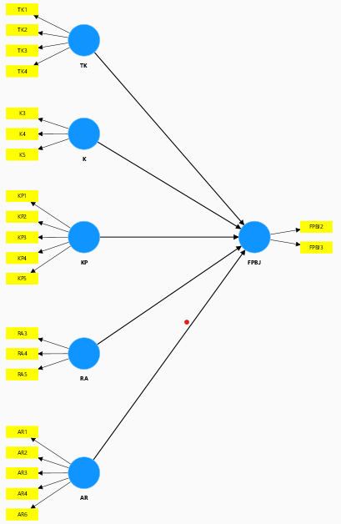

Loading Factors
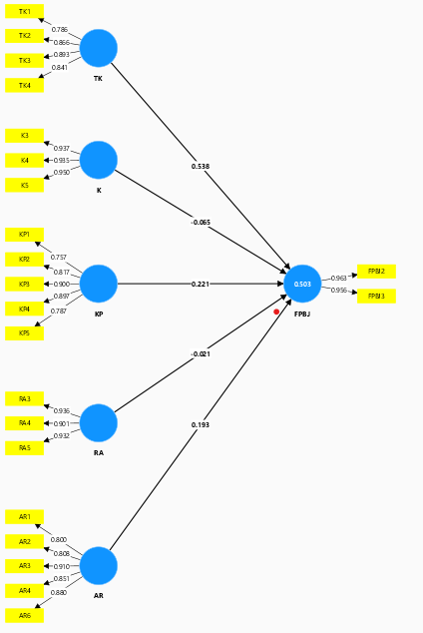
Outer Loadings
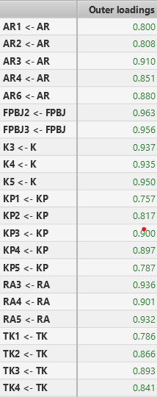
Construct Reliability and Validity
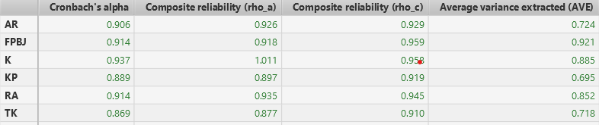
R-Square
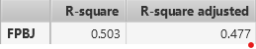

Discriminant Validity
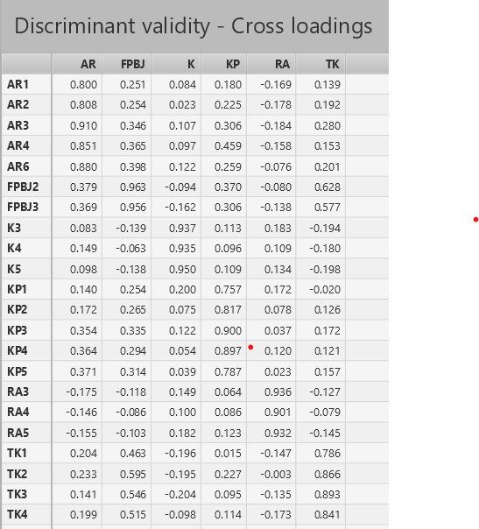

Bootsrapping
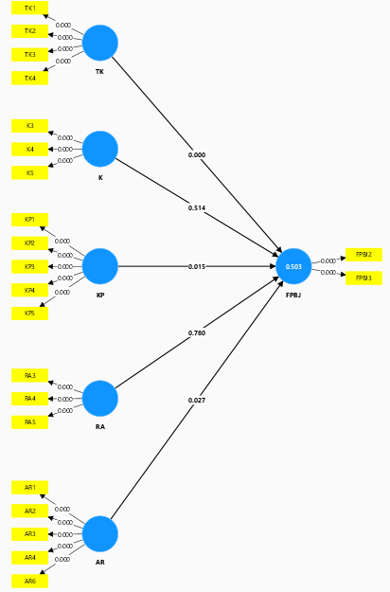
Path Coefficients
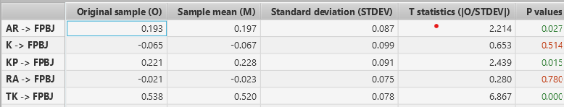

Appendix 5 Research Permit Letter
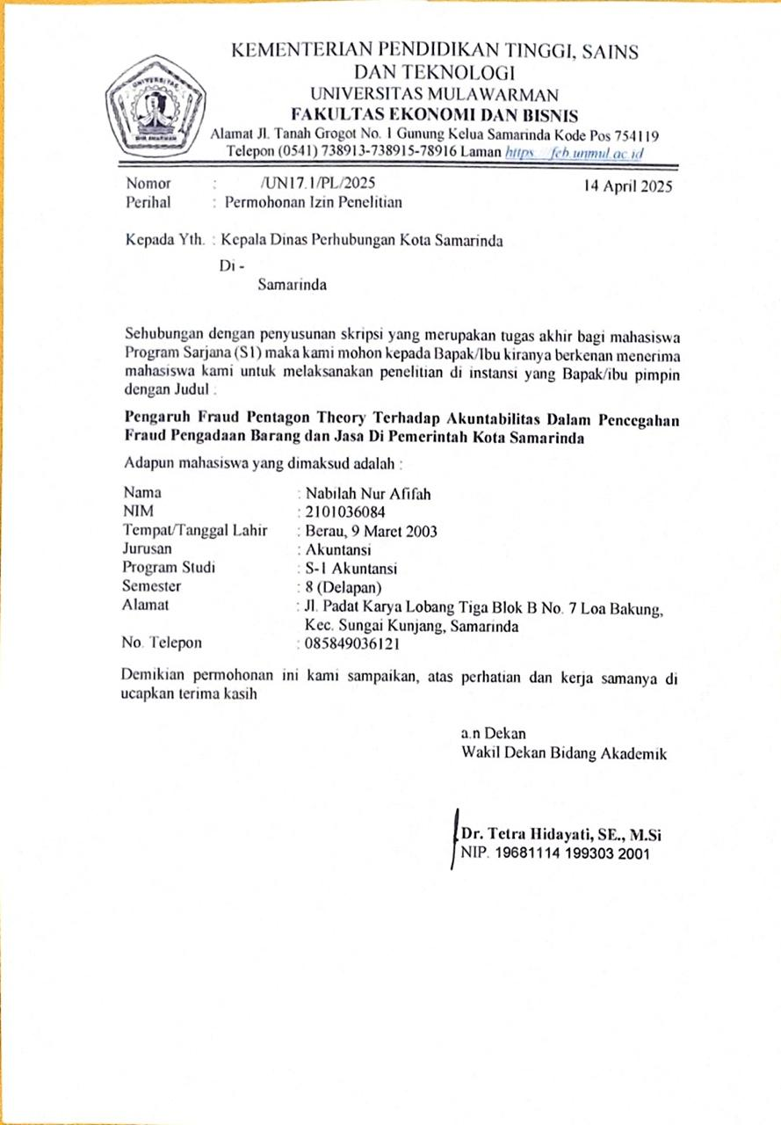

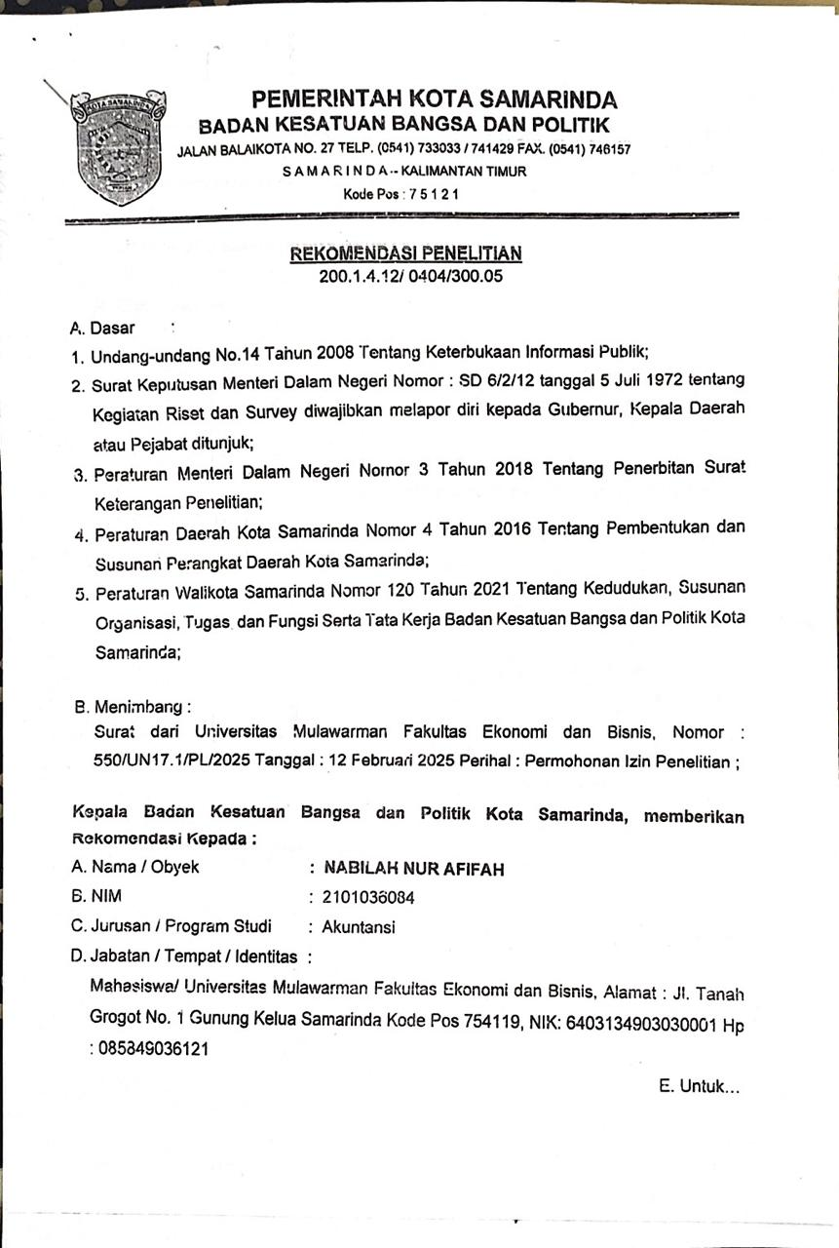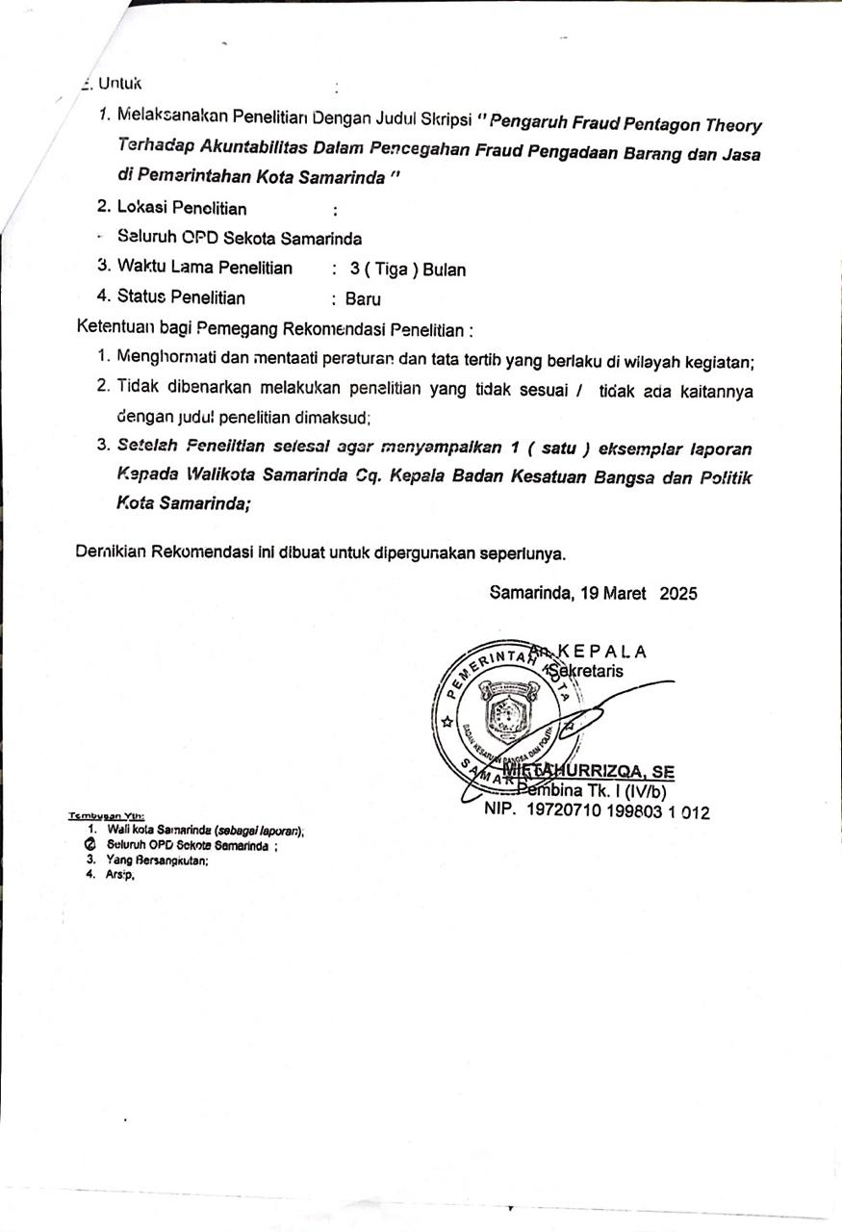
Appendix 6 Documentation

