THE EFFECT OF GREEN ACCOUNTING, CARBON EMISSION DISCLOSURE AND GREEN CAPITAL STRUCTURE ON FIRM VALUE WITH GREEN INTELLECTUAL CAPITAL AS A MODERATING VARIABLE

THESIS
Written to obtain a Bachelor's degree in Accounting



Written by:
RARASANTI EKA PURNAMASARI
2101036218
ACCOUNTING STUDY PROGRAM

FACULTY OF ECONOMICS AND BUSINESS
UNIVERSITAS MULAWARMAN
SAMARINDA
2025

APPROVAL PAGE
Research Title : The Effect of Green Accounting, Carbon Emission Disclosure and Green Capital Structure on Firm Value with Green Intellectual Capital as a Moderating Variable
Name : Rarasanti Eka Purnamasari
Student Number : 2101036218
Faculty : Economics and Business
Study Program : Bachelor of Accounting
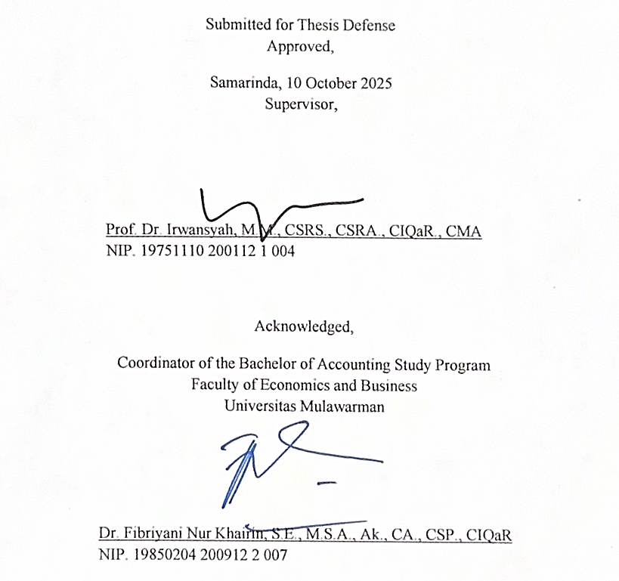
Acknowledged,
Coordinator of the Bachelor of Accounting Study Program
Faculty of Economics and Business
Universitas Mulawarman

Dr. Fibriyani Nur Khairin, S.E., M.S.A., Ak., CA., CSP., CIQaR NIP. 19850204 200912 2 007
Submitted for Thesis Defense
Approved,
Samarinda, 10 October 2025
Supervisor,

Prof. Dr. Irwansyah, M.M., CSRS., CSRA., CIQaR., CMA NIP. 19751110 200112 1 004

ABSTRACT
Rarasanti Eka Purnamasari, The Effect of Green Accounting, Carbon Emission Disclosure, and Green Capital Structure on Firm Value with Green Intellectual Capital as a Moderating Variable, supervised by Mr. Irwansyah. This study aims to examine the effect of green accounting, carbon emission disclosure, and green capital structure on firm value, as well as the role of green intellectual capital as a moderating variable in energy sector companies in Indonesia. This research is grounded in the importance of integrating environmental aspects into corporate reporting and financial structure to achieve social legitimacy and enhance firm value amid the growing awareness of sustainability and global regulations related to climate change. The research employs a quantitative approach on energy sector companies listed on the Indonesia Stock Exchange for the 2021–2024 period. Hypothesis testing was conducted using multiple linear regression analysis and moderated regression analysis (MRA). The results show that green accounting and green capital structure have a positive and significant effect on firm value, while carbon emission disclosure has a positive and insignificant effect on firm value. Additionally, green intellectual capital is proven to moderate the relationship between carbon emission disclosure on firm value, but does not moderate the effect of green accounting and green capital structure on firm value.
Keywords: Green Accounting, Carbon Emission Disclosure, Green Capital Structure, Green Intellectual Capital, Firm Value

STATEMENT OF THESIS AUTHENTICITY
I honestly state that in this Thesis manuscript there are no scientific works that have ever been submitted by others to obtain an academic degree in a university and there are no works or opinions that have been written or published by others, except those that are quoted in writing in this manuscript and mentioned in the source of the quotation and bibliography.
If it turns out that in this Thesis manuscript can be proven that there are elements of plagiarism, I am willing to cancel the Thesis and Bachelor's Degree on my behalf, and processed in accordance with applicable laws and regulations.


FOREWORD
Praise and thanks be to Allah SWT, the One Almighty God, for His abundant mercy and blessings, and peace and blessings be upon the Prophet Muhammad SAW, his family, companions, and all his followers. By His grace, the author has been able to complete a thesis entitled: “The Effect of Green Accounting, Carbon Emission Disclosure and Green Capital Structure on Firm Value with Green Intellectual Capital as a Moderating Variable.” This thesis was prepared as one of the requirements for obtaining a Bachelor of Accounting degree in the Accounting Study Program, Faculty of Economics and Business, Universitas Mulawarman.
In the process of writing this thesis, the author realizes that none of these achievements would have been possible without the help, guidance, prayers, and support of many people. Therefore, the author would like to express her sincere gratitude to:
- Prof. Dr. Ir. H. Abdunnur, M.Si., IPU., ASEAN Eng., Rector of Universitas Mulawarman.
- Dr. Zainal Abidin, SE., MM., Dean of the Faculty of Economics and Business, Universitas Mulawarman.
- Dr. Wulan lyhig Ratna Sari, SE., M.Si., CSP., Head of the Accounting Department, Faculty of Economics and Business, Universitas Mulawarman.
- Dr. Fibriyani Nur Khairin, SE., M.S.A., Ak., CA., CSP., CIQaR., Coordinator of the Accounting Study Program, Faculty of Economics and Business, Universitas Mulawarman.
- Prof. Dr. Irwansyah, M.M., CSRS., CSRA., CIQaR., CMA., as the thesis advisor who guided and devoted his time, energy, and thoughts sincerely and patiently in providing guidance, motivation, and advice for the completion of this thesis. The author expresses her deepest gratitude for the time, energy, and thoughts he has given, so that this thesis could be completed well.
- Mr. Rusliansyah, SE., M.Si., as the academic advisor during the study period who always monitored, provided direction and advice to the author.
- All lecturers at the Faculty of Economics and Business, Universitas Mulawarman, who have educated and equipped the author with knowledge, values of integrity, and extraordinary academic experience during the study period.
- My beloved father, Wijalistyo Dwi Purnawan, and my dear mother, Nurdiana Rahayu, who with love, prayers, and immeasurable sacrifice have been the pillars of strength for the author to reach this point. Thank you for your patience, moral and material support, and unwavering belief that kept me from giving up. Also, to my beloved younger sister, Annisa Shobirina Dwi Saraswati, thank you for your love and encouragement that always made me feel loved and supported.
- My entire extended family, who have given me their prayers, attention, and moral support throughout my academic journey, reminding me that I was never alone in this process, and whose unwavering love and encouragement have strengthened my determination to keep moving forward even in the most challenging times.
- My closest friends who have been there to share my joys and sorrows: Rumaisha, Asyifa, Ghania, Alysa, Amanda, and Nada. Thank you for the laughter, warm hugs, and prayers you have given me throughout this writing process.
- My friends during college: Alifa, Ona, Ayu, Aqilah, Mawara, and Hasya, thank you for being my comrades who strengthened each other amid the busy college activities and thesis process.
- My classmates from the 2021 KBI Accounting program, who have been part of a meaningful academic journey.
- My International Student Buddy besties: Al Ghazali, Aliefa, and Rizka, thank you for all the laughter, kindness, and for being part of the memories i'll cherish forever.
- The lecturers and staff of the International Office at Universitas Mulawarman, as well as my colleagues from the 2024 Suntropis International Summer School Community Service Program, who have provided extraordinary life experiences and new insights through this cross-border and cross-cultural program.
- All those who cannot be mentioned one by one, who have helped, encouraged, and contributed greatly to the process of writing this thesis.
The author acknowledges that this thesis is far from perfect. Therefore, constructive criticism and suggestions are greatly appreciated for the improvement of this work in the future. May this thesis be of benefit to readers and serve as a useful reference in the advancement of knowledge, particularly in the field of environmental accounting and sustainability.

Samarinda, 1 July 2025
Rarasanti Eka Purnamasari

TABLE OF CONTENTS
Pages
APPROVAL PAGE i
ABSTRACT ii
STATEMENT OF THESIS AUTHENTICITY iii
FOREWORD iv
TABLE OF CONTENTS viii
LIST OF TABLES xi
LIST OF FIGURES xii
LIST OF ABBREVIATIONS xiii
LIST OF APPENDICES xiv
CHAPTER I INTRODUCTION 15
1.1 Background 15
1.2 Problem Formulation 24
1.3 Research Objectives 25
1.4 Research Significance 26
CHAPTER II LITERATURE REVIEW 27
2.1 Theoretical Basis 27
2.1.1 Legitimacy Theory 27
2.1.2 Firm Value 28
2.1.3 Green Intellectual Capital 29
2.1.4 Green Accounting 31
2.1.5 Carbon Emission Disclosure 33
2.1.6 Green Capital Structure 34
2.2 Previous Research 36
2.3 Conceptual Framework 39
2.4 Research Hypothesis 41
2.4.1 The Effect of Green Accounting on Firm Value 41
2.4.2 The Effect of Carbon Emission Disclosure on Firm Value 41
2.4.3 The Effect of Green Capital Structure on Firm Value 42
2.4.4 The Effect of Green Accounting on Firm Value with Green Intellectual Capital as a Moderating Variable 43
2.4.5 The Effect of Carbon Emission Disclosure on Firm Value with Green Intellectual Capital as a Moderating Variable 43
2.4.6 The Effect of Green Capital Structure on Firm Value with Green Intellectual Capital as a Moderating Variable 44
2.5 Research Model 45
CHAPTER III RESEARCH METODOLOGY 46
3.1 Definitions 46
3.1.1 Dependent Variable 46
3.1.2 Independent Variable 46
3.1.3 Moderating Variable 49
3.2 Population and Sample 50
3.2.1 Population 50
3.2.2 Sample 52
3.3 Type and source of data 54
3.3.1 Type of Data 54
3.3.2 Source of Data 54
3.4 Data Collection Methods 55
3.5 Analysis Tools 55
3.5.1. Descriptive Statistics 55
3.5.2. Classical Assumption Test 56
3.5.3. Model Suitability Test (F Test) 57
3.5.4. Coefficient of Determination Test (R²) 58
3.5.5. Hypothesis Test (T Test) 58
3.5.6. Moderated Regression Analysis 58
CHAPTER IV RESULT AND DISCUSSION 61
4.1 Overview of the Research Object 61
4.2 Data Analysis Results 63
4.2.1 Descriptive Statistical Analysis 63
4.2.2. Classical Assumption Test 65
4.2.3. Model Suitability Test (F Test) 70
4.2.5. Multiple Linear Regression Analysis 72
4.2.6 Hypothesis Test (t Test) 75
4.3 Explanation of Research Results 78
4.3.1. The Effect of Green Accounting on Firm Value 78
4.3.2. The Effect of Carbon Emission Disclosure on Firm Value 79
4.3.3. The Effect of Green Capital Structure on Firm Value 81
4.3.4. The Effect of Green Intellectual Capital on Green Accounting on Firm Value 82
4.3.5. The Effect of Green Intellectual Capital on the Carbon Emission Disclosure Structure on Firm Value 84
4.3.6. The Effect of Green Intellectual Capital on Green Capital Structure on Firm Value 85
BAB V CLOSING 87
5.1 Conclusion 87
5.2 Research Limitations 88
5.3 Recommendations 89
BIBLIOGRAPHY 91
APPENDICES 97
TURNITIN SIMILARITY RESULTS 119
PROPOSAL SEMINAR CORRECTION SHEET 120
RESULT SEMINAR CORRECTION SHEET 121

LIST OF TABLES
Pages
Table 2.1 Indicators for the Company Performance Rating Program in Environmental Management (PROPER) 32
Table 2.2 Previous Research 36
Table 3.1 Carbon Emission Disclosure Items 47
Table 3.2 Green Intellectual Capital Indicator 49
Table 3.3 Detailed mapping of WRI’S energy sector categories to relevant IDX sectors 51
Table 3.4 Alignment between the IDX sector and the WRI energy sector 52
Table 3.5 Number of Research Samples 53
Table 4.1 List of Research Objects 62
Table 4.2 Descriptive Statistical Analysis Result 63
Table 4.3 Normality Test Results 65
Table 4.4 Multicollinearity Test Results 68
Table 4.5 Autocorrelation Test Results 70
Table 4.6 F Test Results 71
Table 4.7 Coefficient of Determination Test (R²) 72
Table 4.8 Multiple Linear Regression Analysis 73
Table 4.9 Hypothesis Test Model 1 75
Table 4.10 Hypothesis Test Model 2 77

LIST OF FIGURES
Pages
Figure 1.1 Graph of Carbon Emissions Increase in Indonesia 16
Figure 1.2 Carbon Emissions by Sector 23
Figure 2.1 Conceptual Framework 39
Figure 2.2 Research Model 45
Figure 4.1 Histogram Graph 66
Figure 4.2 Normal P-Plot Graph 67
Figure 4.3 Heteroscedasticity Test Results 69

LIST OF ABBREVIATIONS
CBAM Carbon Border Adjustment Mechanism
CED Carbon Emissions Disclosure
ESG Environmental, Social, and Governance
ETF Enhanced Transparency Framework
GA Green Accounting
GCS Green Capital Structure
GHC Green Human Capital
GIC Green Intellectual Capital
GRC Green Relational Capital
GSC Green Structural Capital
IPCC Intergovernmental Panel on Climate Change
NDC Nationally Determined Contributions
NOAA National Oceanic and Atmospheric Administration
PROPER Program Penilaian Peringkat Kinerja Perusahaan
UNFCCC United Nations Framework Convention on Climate Change
WRI World Research Institute

LIST OF APPENDICES
Pages
Appendix 1. Company Sample List 98
Appendix 2. Green Accounting Calculation Results 99
Appendix 3. Carbon Emission Disclosure Calculation Results 102
Appendix 4. Green Capital Structure Calculation Results4 104
Appendix 5. Firm Value Calculation Results 107
Appendix 6. Green Intellectual Capital Calculation Results 109
Appendix 7. Data Tabulation 111
Appendix 8. Descriptive Statistical Test Results9 113
Appendix 9. Normality Test Results 113
Appendix 10. Histogram Chart 114
Appendix 11. Normal Chart of P-Plot 114
Appendix 12. Multicollinearity Test Results 115
Appendix 13. Heteroskedasticity Test Results 115
Appendix 14. Autocorrelation Test Results 116
Appendix 15. F Test Results (Model Feasibility) 116
Appendix 16. Determination Coefficient Test Results (R²) 116
Appendix 17. Multiple Linear Regression Analysis Results 117
Appendix 18. t Test Results (Hypothesis Test) 117
Appendix 19. Moderated Regression Analysis Test Results 118

CHAPTER I

INTRODUCTION

1.1 Background
Global environmental issues are increasingly becoming a major concern worldwide, with impacts being felt in various sectors. In recent years, sustainability has become a major focus in the business world, especially amid growing awareness of the impact of climate change. According to the (World Meteorological Organization, 2024, the year 2024 was the warmest year on record, with global surface temperatures reaching about 1.55°C above pre-industrial levels (1850–1900). The Intergovernmental Panel on Climate Change reported that during the period 2011–2020, global surface temperatures were already about 1.1°C higher than in the pre-industrial era. This confirms the long-term warming trend, with 2011–2020 being the hottest decade since records began. Looking ahead, if greenhouse gas emissions are not significantly reduced, projections indicate that global temperatures could rise by around 2.1°C to 3°C by the end of the 21st century under an intermediate emissions pathway (SSP2-4.5), far exceeding the 1.5 °C limit recommended by scientists to minimize the impacts of climate change (IPCC, 2023)
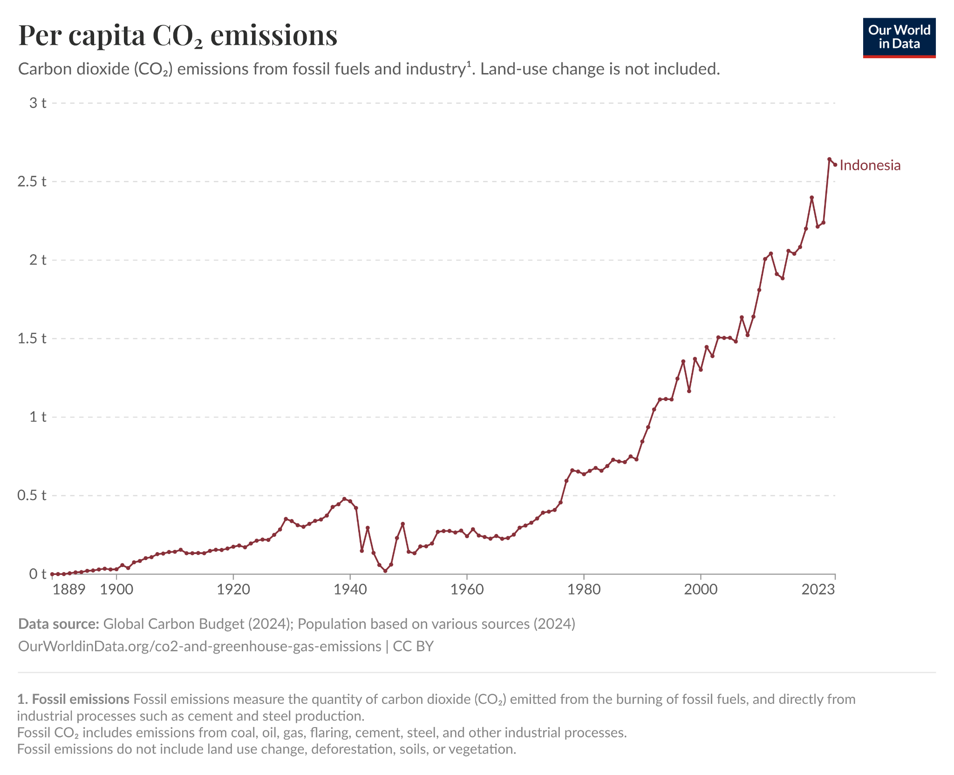
Based on data from (Our World in Data, 2024), Indonesia’s share of global CO₂ emissions has recently been around 1.5–2%. Regulatory mechanisms such as the EU’s Carbon Border Adjustment Mechanism (CBAM) are being implemented to ensure that imports reflect embedded carbon emissions, which places pressure on companies that export carbon-intensive goods. To prepare for these kinds of risks, companies are increasingly required to enhance their supply chain transparency and adopt environmental reporting practices, and there is growing investment interest in renewable energy and lower-carbon technologies.
Figure 1.1 Graph of Carbon Emissions Increase in Indonesia
Source: Our World in Data, 2024
Globally, regulations have been strengthened to ensure reporting and management of environmental impacts by countries. The United Nations Framework Convention on Climate Change (UNFCCC) through the 2015 Paris Agreement requires each country to prepare, submit, and update Nationally Determined Contributions (NDCs) every five years to reduce greenhouse gas emissions, with all parties having submitted at least their initial NDCs. The Enhanced Transparency Framework (ETF) under the Paris Agreement requires the submission of biennial transparency reports (BTR) starting in 2024 and external assessment through technical and multilateral means to monitor NDC progress. The Global Carbon Budget 2024 notes that CO₂ emissions from fossil fuels are expected to reach 37.4 gigatons in 2024, an increase of about 0.8% over the previous year. At the regional level, the European Union, through the European Green Deal, is strengthening mechanisms such as the EU Emissions Trading System (EU ETS), which requires certain facilities (companies in covered sectors) to obtain emission allowances so that their emissions remain within certain limits.
As business activity in Indonesia increases, public demand for products continues to grow. However, this increase also has a negative impact on the environment, particularly in the form of increased carbon emissions generated from various company operations. This situation increases pressure on companies to be more responsible for the environmental impact they cause in order to maintain business sustainability. In addition, pressure from stakeholders, both individuals and groups, is increasingly forcing companies to fulfill their social obligations and responsibilities.
Research by (Yunus et al., 2020) shows that companies facing pressure from stakeholders tend to increase their level of carbon emissions disclosure. This reflects the significant role of external oversight, particularly from regulators and investors, in promoting corporate environmental transparency. A study by (Widagdo et al., 2023) shows that companies that disclose their carbon emissions and demonstrate good environmental performance tend to have higher firm values. Therefore, optimizing firm value through disclosure and environmental strategies is becoming increasingly important in the face of global pressure on climate change issues.
Firm value represents the market's perception of the company's ability to create long-term economic value, as reflected in its share price, future cash flows, and strategic competitiveness. In recent years, non-financial aspects have gained increasing attention, particularly those related to corporate environmental and social responsibility. This is reflected in green accounting reporting, carbon emissions disclosure, and capital structures related to sustainability. Research by (Naseer et al., 2024) shows that companies with greater financial flexibility tend to be able to reduce climate risk, improve ESG performance, and ultimately achieve better firm value. This study emphasizes that financial flexibility through adaptive capital structures supports transparency and sustainability practices that appeal to investors focused on ESG criteria.
Green accounting is a tool that enables companies to manage and report environmental impacts financially by integrating environmental costs into financial reporting systems. This approach increases corporate transparency and accountability for operational activities that impact the environment, as well as increasing firm value (Albitar et al., 2020). Green accounting helps companies evaluate the environmental impact on firm value, ensuring that business decisions are not only profit-oriented but also sustainable. In line with the Nationally Determined Contributions (NDCs) and Paris Agreement targets, green accounting supports the creation of a holistic reporting system to encourage more environmentally friendly business transformation.
Research by (S. Khan & Gupta, 2023) shows that green accounting practices have a positive effect on corporate financial performance, which can ultimately increase firm value. A study by (Klaaßen et al., 2024) also found that companies that consistently improve climate transparency, particularly carbon emissions disclosure, tend to see an increase in market value and reputation. However, research by (Alaika & Firmansyah, 2024) on the palm oil industry in Indonesia reveals that green accounting practices actually have a negative impact on firm value due to the high cost of environmental compliance, while sustainability disclosure does not show a significant effect. These findings confirm that the effectiveness of green accounting on firm value can vary according to industry sector and geographical context.
Carbon emission disclosure is a key aspect in improving corporate transparency regarding the environmental impact of its operational activities. Carbon emission disclosure provides an overview of how companies manage environmental risks and demonstrates their commitment to sustainable business practices. Research by (Jiang et al., 2021) shows that voluntary carbon emission disclosure has a positive relationship with firm value. These findings indicate that transparency in carbon emission disclosure can increase investor confidence and ultimately increase firm value. However, the effectiveness of carbon emission disclosure on firm value can vary depending on the industry sector and geographical context. A study by (Kurnia et al., 2021) comparing manufacturing companies in Indonesia and Australia found that carbon emissions disclosure increased firm value in Indonesia but had no significant effect in Australia. This shows that factors such as implementation costs and investor perceptions of carbon emissions disclosure can influence its impact on firm value.
Capital structure refers to the composition of a company's funding, which consists of debt and equity, with the aim of minimizing the cost of capital while maximizing the value of the company (Myers & Majiuf, 1981). Structure plays an important role in determining the value of a company through financial efficiency and risk management. In the context of sustainability, the concept of green capital structure has emerged, which refers to corporate financing that supports environmentally friendly projects, such as green bonds or green financing. This approach not only considers capital cost efficiency, but also the environmental impact of financing decisions. Companies with a healthy capital structure are more flexible in supporting sustainability initiatives, thereby enhancing their competitiveness and reputation. Research by (Bui et al., 2023) shows that green capital structure has a significant positive effect on firm value, while a study by (Febrianti et al., 2024) finds that green capital structure actually has a negative impact on firm value.
Firm value is determined not only by profitability but also by sustainability aspects. A report (Morningstar, 2024) notes that ESG-based investment funds have experienced significant growth, confirming that firm value is influenced by transparency and sustainability practices implemented by companies. At the global level, regulations such as the European Union's Carbon Border Adjustment Mechanism (CBAM) encourage companies to increase the transparency of their carbon emissions in order to remain competitive in the international market. However, increased sustainability does not always correlate directly with an increase in firm value, indicating that other factors such as green intellectual capital can moderate this effect.
Green intellectual capital (GIC) is a sustainability-based intellectual asset that encompasses knowledge, technology, and human resource competencies in supporting environmentally friendly business practices. This concept is important for companies because it plays a role in driving green innovation, improving operational efficiency, and building a positive reputation that attracts environmentally conscious investors and consumers. A study by (Alnaim & Metwally, 2024) shows that GIC contributes positively to a company's environmental performance through the optimization of knowledge-based resources and environmentally friendly technologies. Although this study focuses on environmental performance, its implications show that the application of GIC also has the potential to increase the attractiveness of sustainability-oriented investors and support an increase in firm value.
In addition to contributing directly to firm value, Green Intellectual Capital (GIC) also has the potential to act as a moderating variable that strengthens the relationship between green accounting, carbon emission disclosure, and green capital structure with firm value. Companies with green-oriented human resources and intellectual assets tend to be more innovative and adaptive in responding to environmental regulations and market pressures. (Liu et al., 2022) empirically prove that GIC encourages green innovation, which is supported by the organization's ability to absorb environmental knowledge, establish collaborations with supply chain partners, and implement green supply chain integration that bridges the transformation of GIC into value-added innovation for the company.
The studies by (Kumar et al., 2025) and (Lee’ et al., 2020) emphasize that the effective implementation of green accounting is greatly influenced by GIC elements such as green human capital, green relational capital, and green structural capital, as these three aspects enable companies to integrate sustainability principles into their business processes and improve their environmental performance and firm value. The research by (Setiana & Arieftiara, 2023) found that GIC plays a significant role as a moderating variable that strengthens the relationship between green accounting and carbon emission disclosure on firm value. However, different results were found in (Jirakraisiri et al., 2021) and (Riyanti & Murwaningsari, 2023), which showed that GIC did not play a significant role as a moderating variable, and not all GIC elements strengthened the impact of sustainability, in some cases, they even weakened it. Therefore, this study was conducted to re-examine the role of GIC as a moderating variable with a newer period and approach in the context of energy sector companies in Indonesia.
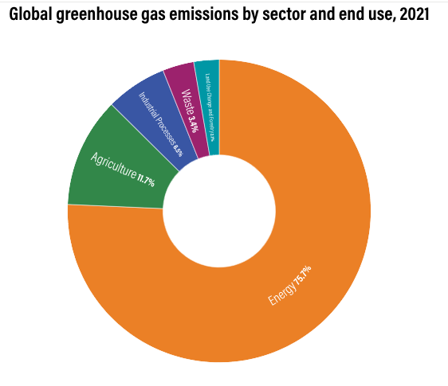
The energy sector contributes significantly to carbon emissions, making transparency in carbon disclosure, green accounting, and green capital structure crucial aspects. Investments in renewable energy projects and environmentally friendly technologies play an important role in companies' efforts to reduce their carbon footprint and improve the sustainability of their operations. The energy sector is a major contributor to global carbon emissions, with 75.7% of emissions coming from fossil-based activities, such as coal-fired power plants and oil and gas exploration (World Resources institute, 2024).

Gambar 2

Figure 1.2 Carbon Emissions by Sector
Source: World Resources Institute, 2024
According to the World Resources Institute (WRI), the energy sector is one of the main sectors that encompasses various activities related to energy production, distribution, and consumption. This sector not only includes power generation and fuel supply, but also involves various important subsectors such as Transportation and Logistics, Basic Materials, and other sectors that play a role in the overall energy supply chain. High greenhouse gas emissions indicate that the energy sector not only plays an important role in economic development but is also a major source of global environmental challenges. Thus, according to the World Resources Institute (WRI), the energy sector encompasses a broad spectrum of interrelated economic activities that play a crucial role in both supporting economic growth and addressing environmental issues, particularly those related to resource management and its impacts. Therefore, efficient energy management and the transition to clean energy sources are very important aspects of climate change mitigation efforts and the achievement of sustainable development goals.
Based on this urgency, researchers chose the energy sector as the object of study for the period 2021 to 2024. This period was deemed relevant because it coincided with the implementation of various new regulations that encouraged greater transparency in environmental management among energy sector businesses. In addition, the availability of data from companies annual reports and sustainability reports was an important supporting factor, as it reflected trends in increased carbon emissions disclosure, the implementation of green accounting, and capital structure management during that period.
Considering the background and availability of data, the author decided to conduct a study entitled: “The Effect of Green Accounting, Carbon Emission Disclosure and Green Capital Structure on Firm Value with Green Intellectual Capital as a Moderating Variable.” This study focused on companies engaged in the energy sector and listed on the Indonesia Stock Exchange, with an observation period from 2021 to 2024.

1.2 Problem Formulation
Based on the explanation provided in the background above, the problem formulation in this study is as follows:
- Does green accounting affect firm value?
- Does carbon emission disclosure affect firm value?
- Does green capital structure affect firm value?
- Can green intellectual capital moderate the relationship between green accounting on firm value?
- Can green intellectual capital moderate the relationship between carbon emission disclosure on firm value?
- Does green intellectual capital moderate the relationship between green capital structure on firm value?

1.3 Research Objectives
Based on the research questions presented above, the objectives of this study are:
- To determine and analyze the effect of green accounting on firm value.
- To determine and analyze the effect of carbon emission disclosure on firm value.
- To determine and analyze the effect of green capital structure on firm value.
- To identify and analyze the effect of green intellectual capital in moderating the relationship between green accounting on firm value.
- To identify and analyze the effect of green intellectual capital in moderating the relationship between carbon emission disclosure on firm value.
- To identify and analyze the effect of green intellectual capital in moderating the relationship between green capital structure on firm value.

1.4 Research Significance
The expected benefits of this research are as follows:
- For the Author
It is hoped that this research will provide an opportunity for the author to deepen their understanding of the topic discussed and serve as a means for the author to contribute academically by presenting the latest empirical evidence related to the dynamics of energy transition in Indonesia, which is still rarely discussed comprehensively.
- For Academics
This research is expected to enrich the literature on green accounting, carbon emissions disclosure, and green capital structure in the context of energy companies in emerging markets such as Indonesia.
3. For Practitioners
This research is expected to provide input in evaluating investment decisions, particularly regarding the influence of green accounting, carbon emissions disclosure, and green capital structure on company value. These findings are also expected to assist companies in formulating policies related to sustainability practices and the application of green intellectual capital, as well as providing guidance for stakeholders in making more appropriate decisions regarding environmental policies and corporate financial strategies.

CHAPTER II

LITERATURE REVIEW

2.1 Theoretical Basis

2.1.1 Legitimacy Theory
This theory is rooted in sociological thinking that developed in the 1970s, in which (Dowling & Pfeffer, 1975) argued that organizations need to adapt to social values in order to maintain legitimacy in society. This legitimacy is often referred to as a social license to operate, which is an unwritten permission from society for an entity to continue operating. This concept was further developed by (Suchman, 1995), who classified legitimacy into three types: pragmatic (based on stakeholder interests), moral (based on values and ethics), and cognitive (based on perceptions of the organization's acceptability within the social system).
This theory emphasizes that legitimacy is an important resource that must be maintained to ensure business continuity. In the context of sustainability, the legitimacy theory explains how companies respond to pressure from the community, regulators, and investors by demonstrating global policies such as the Paris Agreement and national regulations such as LHK Regulation No. 1 of 2021, which encourages carbon emission transparency.
The study by (Albitar et al., 2020) emphasizes that external pressures encourage companies to improve the quality of their environmental and ESG disclosures in order to maintain their reputation, minimize risk, and gain access to financial resources. Using legitimacy theory, the study explains that corporate compliance with social and environmental demands is key to maintaining legitimacy. In line with this, (H. Z. Khan et al., 2021) show that companies that are able to demonstrate compliance with social and environmental values tend to be more trusted by stakeholders and more attractive to investors. In this study, green intellectual capital is positioned as a factor that can strengthen the relationship between sustainability practices and corporate legitimacy, thereby ultimately contributing to an increase in firm value.
Based on legitimacy theory, companies must disclose their environmental responsibilities as a form of adaptation to evolving social expectations. As demands from the public, regulators, and investors for transparency and sustainability increase, companies that do not demonstrate a commitment to environmentally friendly practices risk losing the trust of stakeholders. Therefore, environmental disclosure is not only a regulatory obligation, but also a strategy to maintain legitimacy in order to ensure long-term business sustainability.

2.1.2 Firm Value
According to (Brigham & Houston, 2019), firm value is reflected in the price investors are willing to pay for the company as a whole, which also reflects expectations regarding the company's growth prospects and ability to generate profits in the future.
When the share price increases, the firm's value also increases, ultimately maximizing shareholder wealth. Firm value is also seen as an important indicator of managerial performance in managing resources to create added value for shareholders. In recent literature, non-financial factors such as sustainability disclosure, environmental performance, and green intellectual capital management are also beginning to be recognized as factors that influence firm value.
(Dincer et al., 2023) show that companies that actively disclose their social and environmental responsibilities receive positive market reactions that lead to an increase in firm value. This is in line with legitimacy theory, which emphasizes the importance of public acceptance and trust in maintaining the continuity of a company's operations. (Suchman, 1995) defines legitimacy as the perception that an entity's actions are considered consistent with prevailing norms and values. (Fernando et al., 2022) reinforce this finding by showing that proactive environmental strategies can attract institutional investors while increasing firm value. Thus, managing environmental aspects not only protects reputation but also becomes a real value creation strategy.
It can be concluded that a firm value is not only a representation of its financial performance, but also reflects the extent to which the company has succeeded in building social legitimacy. Companies that are able to balance economic performance and social responsibility tend to obtain higher market value and long-term trust from stakeholders.

2.1.3 Green Intellectual Capital
Green Intellectual Capital (GIC) is an extension of the concept of intellectual capital that emphasizes environmental sustainability. (Chen, 2008) explains that GIC consists of three main components: Green Human Capital (GHC), Green Structural Capital (GSC), and Green Relational Capital (GRC), which collectively reflect the knowledge, systems, and relationships of a company in supporting environmental and sustainability goals.
- Green Human Capital (GHC)
Green Human Capital reflects the capabilities, skills, awareness, and environmental values possessed by employees. (Yusliza et al., 2020) emphasize that GHC can be improved through environmental training, human resource empowerment, and the creation of a work environment that encourages green innovation.
- Green Structural Capital (GSC)
Green Structural Capital encompasses organizational structures, policies, procedures, technologies, and information systems that support environmental strategy management. (Benevene et al., 2021) assert that strong GSC accelerates the adoption of green technologies, improves operational systems, and strengthens the documentation and dissemination of sustainable knowledge.
- Green Relational Capital (GRC)
Green Relational Capital describes the quality of a company's relationships with external parties, including customers, regulators, business partners, and communities. (Alnaim & Metwally, 2024) found that good GRC strengthens a company's social legitimacy and reputation and significantly improves environmental performance, especially when supported by accurate Environmental Management Accounting (EMA) practices.
The concept of GIC is also closely related to the theory of legitimacy, which states that companies must conduct their activities in accordance with values and norms accepted by society in order to survive (Suchman, 1995). In this context, the application of Green Intellectual Capital becomes a corporate strategy to maintain or obtain legitimacy from the public, regulators, and investors. Commitment to GIC shows that companies are not only profit-oriented, but also responsible for the environment.
It can be concluded that Green Intellectual Capital is a crucial intangible asset in achieving corporate sustainability goals. Through GIC integration, companies are not only able to improve their environmental and financial performance, but also strengthen their legitimacy in the eyes of the public, which ultimately increases firm value and investor confidence.

2.1.4 Green Accounting
Green accounting is an accounting approach that integrates environmental aspects into the recording, measurement, and reporting of a company's economic activities. The aim is to present more comprehensive information, not only related to financial performance but also the environmental impact caused, while responding to demands for transparency from stakeholders (Albitar et al., 2020).
According to (Sundarasen et al., 2024), green accounting covers various aspects such as carbon emission measurement, energy efficiency, waste management, and sustainability reporting. The application of this practice in the public and private sectors has been proven to improve the quality of environmental reporting, support long-term strategic decision-making, and contribute to the achievement of the Sustainable Development Goals (SDGs). From the perspective of legitimacy theory (Suchman, 1995), green accounting serves as a corporate strategy to obtain and maintain social legitimacy. Through transparent and responsible environmental reporting, companies can demonstrate compliance with social values and norms, as well as strengthen their image in the eyes of regulators, the public, and investors.
In Indonesia, the implementation of green accounting is reflected in the Company Performance Rating Program (PROPER) initiated by the Ministry of Environment and Forestry (KLHK). PROPER assesses company performance based on compliance with environmental regulations and the implementation of voluntary sustainability initiatives. Companies that achieve a Gold or Green rating generally have more transparent environmental reporting systems and demonstrate a high commitment to reducing environmental impact. Conversely, a Red or Black rating indicates low environmental compliance and potential financial burdens due to sanctions and restoration costs.
Table 2.1 Indicators for the Company Performance Rating Program in Environmental Management (PROPER)1
Rank | Descriptions
Gold | The company consistently demonstrates excellence in its production processes and services, while conducting its business in an ethical and socially responsible manner. In addition, the company is committed to environmental excellence by implementing sustainable production and service practices, and integrating social responsibility into every aspect of its operations.
Green | The company has managed the environment with standards that exceed regulatory requirements (beyond compliance) through the implementation of an effective environmental management system. In addition, the company also optimizes the efficient use of resources and carries out its social responsibilities well, reflecting its commitment to sustainability and concern for the environment and society.
Blue | The company has implemented environmental management in accordance with applicable laws and regulations, ensuring compliance with the standards set in its operations.
Red | The company has made efforts to manage the environment, but has not yet fully complied with applicable laws and regulations.
Black | Imposed on parties who, in the course of their business or activities, have intentionally or negligently caused environmental pollution or damage, violated applicable laws and regulations, and failed to comply with the administrative sanctions that have been imposed.
Source: Report on the Company Performance Assessment Program in Environmental Management (PROPER), 2018, Ministry of Environment and Forestry (Processed by researchers, 2025)

2.1.5 Carbon Emission Disclosure
Carbon emission disclosure is a form of non-financial disclosure that conveys information related to greenhouse gas (GHG) emissions generated from company activities, including the amount of emissions, sources of emissions, reduction targets, and climate change mitigation policies.
This practice is becoming increasingly important in response to demands for transparency from regulators, investors, and the public. The Intergovernmental Panel on Climate Change (IPCC, 2023) report emphasizes the importance of transparency and accountability in GHG emissions reporting as part of global efforts to reduce the impact of climate change. In the context of companies, carbon emissions disclosure reflects their commitment to climate change mitigation.
According to (Karim et al., 2021), carbon disclosure plays an important role in identifying and managing environmental risks faced by companies, while also increasing stakeholder trust. A high level of disclosure not only reflects a company's commitment to sustainability practices, but also strengthens its competitive position in the market. This is reinforced by (Moussa & Elmarzouky, 2024), who found that carbon disclosure contributes to reducing market uncertainty through increased transparency of sustainability information. Furthermore, this practice also encourages corporate accountability in achieving long-term environmental goals, making carbon emissions disclosure a strategic instrument for companies to maintain legitimacy and competitiveness amid global sustainability demands.
From the perspective of legitimacy theory, disclosure of environmental information, including carbon emissions, is a form of corporate adaptation to social expectations. Companies seek to demonstrate that their activities are in line with societal values and norms in order to obtain and maintain institutional legitimacy, particularly in the eyes of regulators and the public (Suchman, 1995).
In Indonesia, regulations such as Financial Services Authority Regulation (PJOK) No. 51/PJOK.03/2017 on the Implementation of Sustainable Finance encourage companies to include environmental information in their annual reports. This provision is a concrete step in promoting transparency and accountability for carbon emissions, while strengthening corporate sustainability governance. Thus, carbon emission disclosure not only serves as a means of reporting environmental responsibility, but also becomes part of a company's strategy in creating sustainable value, strengthening public trust, and responding to market and regulatory expectations for corporate sustainability.

2.1.6 Green Capital Structure
Green capital structure is a corporate capital structure approach that supports the financing of environmentally friendly and sustainable business activities. This concept encompasses a combination of internal and external funding directed toward green projects, such as renewable energy investments, energy efficiency, sustainable transportation, and waste management.
Green capital structure emphasizes that capital management is not only aimed at optimizing financial value but also at fulfilling the company's social and environmental responsibilities. (Zhou & Fan, 2023) assert that the implementation of a green capital structure can increase competitiveness and reputation, as well as facilitate access to low-cost financing. In addition, companies with a green capital structure also tend to be more adaptive in facing regulatory pressures and stakeholder demands related to sustainability.
In line with this, (Fu et al., 2023) emphasize that the implementation of green corporate finance is a key element in achieving global climate targets and carbon neutrality. In this context, the financial sector has an important role in accelerating the transition to a sustainable economy. (Zairis et al., 2024) add that the successful integration of environmental, social, and governance (ESG) factors into investment decisions will direct capital flows toward economic activities that have a positive impact on the environment and society.
From the perspective of legitimacy theory (Suchman, 1995), green capital structure is viewed as a corporate strategy to obtain and maintain social legitimacy. By actively allocating capital to sustainable projects, companies demonstrate alignment with community values and stakeholder expectations regarding environmental responsibility.
In Indonesia, the commitment to green financing is reflected in the issuance of Financial Services Authority Regulation (POJK) No. 60/POJK.04/2017 concerning the Issuance and Requirements of Environmentally Friendly Debt Securities (Green Bonds). This regulation encourages companies to issue debt securities whose proceeds are used for environmentally friendly projects. In addition, the government is also actively issuing green sukuk to finance strategic projects such as renewable energy and waste management, marking progress in the national green finance ecosystem. Thus, green capital structure not only functions as a financing framework, but also as a strategic instrument in achieving sustainability, strengthening legitimacy, and increasing firm value in the eyes of the market and stakeholders.

2.2 Previous Research
Table 2.2 Previous Research2
No. | Author and Research Title | Research Sample | Result
1. | Tri Astuti & Nurmala Ahmar (2025) Effects of green intellectual capital, green accounting, and green innovation on firm value: The moderating role of return on assets | This study uses data from SRI-KEHATI index companies listed on the Indonesia Stock Exchange. | The results of this study indicate that green accounting and green intellectual capital have a positive and significant effect on firm value before and after being moderated by ROA. Meanwhile, green innovation has a positive and insignificant effect on firm value and a negative and insignificant effect on firm value after being moderated by ROA.
Continued on the next page

Table 2.2 Table Continuation
2. | Wenni Anggita, Ari Agung Nugroho dan Suhaidar (2022) Carbon Emission Disclosure and Green Accounting Practices on the Firm Value | This study uses data from consumer goods companies listed on the Indonesia Stock Exchange (IDX) for the period 2020-2021. | The results of this study indicate that carbon emission disclosure has no effect on firm value, while green accounting practices has a positive and significant effect on firm value.
3. | Siti Hailatul Fikriyah dan Rahma Wiyanti (2023) The Effect of Environmental Performance and Green Accounting on Firm Value | This study uses data from SRI-KEHATI index companies listed on the Indonesia Stock Exchange. | The results of this study indicate that green accounting and environmental performance have a positive and significant effect on firm value.
4. | Vitalis Ari Widianingsih dan Agustinus Kismet Nugroho Jati (2024) Implementation of Green Accounting, Intellectual Capital and Environmental Performance on Company Value Mediated by Financial Performance | This study uses data from mining companies listed on the Indonesia Stock Exchange (IDX) for the period 2020-2021. | The results of this study indicate that green accounting and intellectual capital have a negative and insignificant effect on firm value before and after being moderated by financial performance. Meanwhile, environmental performance has a negative and insignificant effect on firm value and a positive and significant effect on firm value after being moderated by business strategy.
5. | Wang & Juo (2021) An environmental policy of green intellectual capital: green innovation strategy for performance sustainability | This study uses manufacturing companies in Taiwan. | Green Intellectual Capital has a positive and significant effect on innovation and company performance, and can strengthen the influence of sustainability practices on firm value.
Continued on the next page

Table 2.2 Table Continuation
6. | Albitar et al. (2020) ESG disclosure and firm performance before and after IR | This study uses public companies in Europe that implement integrated reporting. | The results of this study indicate that environmental accounting improves transparency and sustainable performance.
7. | Anandita Setiana and Dianwicaksih Arieftiara (2024) Carbon Emission Disclosure and Green Intellectual Capital: The Effect on Firm Value | This study uses data from companies that received PROPER ratings on the Indonesia Stock Exchange (IDX) for the 2019-2022 period. | The results of the study indicate that carbon emissions disclosure, environmental performance, and green accounting have a positive and not significant effect on firm value.
8. | Rilla Gantino, Endang Ruswanti dan Agung Mulyo Widodo (2023) Green Accounting and Intellectual Capital Effect on the Firm Value Moderated by Business Strategy | This study uses data from companies in the Automotive and Components and Consumer Goods sectors listed on the Indonesia Stock Exchange. | The results of this study indicate that green accounting has a positive and significant effect on firm value, and has a negative and insignificant effect on firm value after being moderated by business strategy. Meanwhile, intellectual capital has a positive and significant effect on firm value before and after being moderated by business strategy.
9. | Zhou & Fan (2023) Does green capital structure contribute to firm development? | This study uses companies in China with green project financing. | Green capital structure strengthens a company's reputation and improves access to financing, which has a positive impact on firm value.
10. | Theresya, Elsa dan Natasya Cindy (2024) The Effect of Capital Structure on Firm Value with Profitability as Variable Mediator | This study uses data from mining companies listed on the Indonesia Stock Exchange (IDX) for the period 2020-2021. | The results show that capital structure has a positive and significant effect on firm value, and profitability mediates the effect of capital structure on firm value.
Source: Previous research (Processed by Author, 2025)

2.3 Conceptual Framework
The conceptual framework in this study describes the relationships and interactions between the main concepts and related concepts associated with the issues under investigation. This framework is based on the theory that forms the basis of the study. The purpose of this conceptual framework is to analyze the relationship between legitimacy theory and the influence of green accounting, carbon emission disclosure, and green capital structure on firm value, with green intellectual capital as a moderating variable.
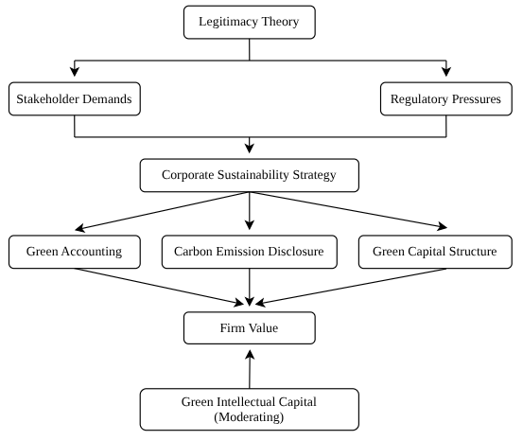
The conceptual framework in this study is presented as follows:
Figure 2.1 Conceptual Framework 3
Source: Processed by Author, 2025
Firm value is influenced by the implementation of corporate sustainability strategies that are shaped by both stakeholder demands and regulatory pressures, in line with the legitimacy theory. Companies that seek to maintain legitimacy are encouraged to adopt sustainability-oriented practices such as green accounting, carbon emission disclosure, and green capital structure. Green accounting ensures that environmental aspects are integrated into financial reporting, thereby enhancing transparency and accountability. Carbon emission disclosure reflects a company’s commitment to reducing its environmental footprint and addressing climate change, while green capital structure demonstrates the integration of environmentally friendly financing and investment decisions into corporate strategies. These three practices are expected to have a direct impact on firm value by improving investor confidence, strengthening corporate reputation, and ensuring long-term financial sustainability.
Furthermore, green intellectual capital acts as a moderating variable, reinforcing the relationship between the independent variables and firm value. The presence of green intellectual capital, which encompasses the knowledge, capabilities, and innovation of human resources in managing sustainability, is expected to enhance the effectiveness of green practices in creating firm value. Thus, the conceptual framework provides a comprehensive perspective on how corporate sustainability initiatives, supported by intellectual capital, can strengthen the legitimacy of firms and ultimately increase their value.

2.4 Research Hypothesis

2.4.1 The Effect of Green Accounting on Firm Value
Legitimacy Theory explains that the sustainability of a company depends on its ability to operate in accordance with social norms and expectations. In this case, green accounting plays an important role in demonstrating corporate environmental responsibility through the measurement and reporting of environmental impacts in financial statements. The application of green accounting can increase transparency, build a positive image in the eyes of investors, and ultimately contribute to an increase in company value.
Research by (Xie et al., 2022) found that green innovation and environmental disclosure significantly increase firm value, especially in heavily polluting companies in China. In line with this, (Utomo et al., 2020) showed that environmental performance and environmental disclosure in non-financial companies in Indonesia have a positive effect on firm value. These findings emphasize the importance of integrating environmental aspects into reporting and accounting to build legitimacy and increase long-term value.
H1: Green accounting has a positive effect on firm value

2.4.2 The Effect of Carbon Emission Disclosure on Firm Value
Carbon emission disclosure is a form of non-financial disclosure that demonstrates a company's commitment to managing and reducing greenhouse gas emissions. Based on legitimacy theory, companies that transparently report their emissions will be more trusted by the public, investors, and regulators because they are considered socially and environmentally responsible. (Huang et al., 2022) found that the quality of carbon disclosure has a significant positive effect on the firm value of public companies in China. The higher the quality and transparency of disclosure, the greater the positive perception of investors towards the company's performance and long-term prospects. In line with this, (Lee & Cho, 2021) in a study in Korea showed that active and structured carbon emission disclosure can increase firm value, even when emission levels are high. These findings confirm that transparency serves as a positive signal for sustainability-oriented investors.
H2: Carbon emission disclosure has a positive effect on firm value

2.4.3 The Effect of Green Capital Structure on Firm Value
Green capital structure is an important aspect of financial decision-making that supports the financing of environmentally friendly and sustainable business activities. Companies with a stable and green-oriented capital structure tend to gain greater trust from shareholders, creditors, and the public. This trust strengthens the company's legitimacy and position in the market, which ultimately increases the company's value.
(Zhou & Fan, 2023) show that green capital structure has a significant impact on company development, especially when combined with technological innovation to support carbon peaking targets. In line with this, (Tang & Zhang, 2020) found that the issuance of green bonds as part of a green financing strategy can increase shareholder value, confirming that sustainability-based financing decisions provide real economic benefits for companies.
H3: Green capital structure has a positive effect on firm value

2.4.4 The Effect of Green Accounting on Firm Value with Green Intellectual Capital as a Moderating Variable
Green Intellectual Capital (GIC) encompasses the knowledge, skills, and organizational structures that support sustainability practices. GIC strengthens the implementation of green accounting by providing human resources, information systems, and organizational culture that support transparency and social responsibility towards the environment. As a moderating variable, GIC is expected to strengthen the positive relationship between green accounting and firm value, as green intellectual capabilities enable companies to convert environmental accounting data into measurable and marketable sustainability strategies.
(Alnaim & Metwally, 2024) found that GIC contributes positively to environmental performance and creates competitive advantage when synergized with environmental accounting and reporting practices. This supports the assumption that GIC can strengthen the influence of green accounting on firm value.
H4: Green Intellectual Capital strengthens the influence of Green Accounting on firm value

2.4.5 The Effect of Carbon Emission Disclosure on Firm Value with Green Intellectual Capital as a Moderating Variable
Carbon emission disclosure is a key strategy for companies to gain legitimacy by revealing information related to carbon emissions and mitigation measures taken. However, this transparency will be more meaningful if it is supported by strong Green Intellectual Capital (GIC). The existence of GIC allows carbon emission disclosure to be viewed not only as regulatory compliance, but also as a strategy to create a positive environmental impact that strengthens the legitimacy and firm value. (Hakki et al., 2024) found that energy sector companies that combine environmentally friendly practices with strategic carbon disclosure have higher firm value. These findings support the assumption that GIC can strengthen the influence of carbon emission disclosure on market perception and firm value.
H5: Green Intellectual Capital strengthens the influence of Carbon Emission Disclosure on firm value

2.4.6 The Effect of Green Capital Structure on Firm Value with Green Intellectual Capital as a Moderating Variable
An optimal green capital structure reflects a sustainable financial strategy that supports risk management and long-term value creation. However, its effectiveness is greatly influenced by the company's internal capabilities. This is where Green Intellectual Capital (GIC) plays an important role, as GIC strengthens organizational capabilities through human resource development, managerial systems, and strategic relationships with stakeholders. Companies with high levels of GIC are better able to manage green capital structure strategically, drive environmental innovation, and increase legitimacy in the eyes of the market.
(Yusliza et al., 2020) prove that GIC, which includes green human capital, green structural capital, and green relational capital has a significant effect on sustainability performance. These findings support the argument that GIC not only has a direct effect, but can also strengthen the influence of green capital structure on firm value.
H6: Green Intellectual Capital strengthens the influence of Green Capital Structure on firm value

2.5 Research Model
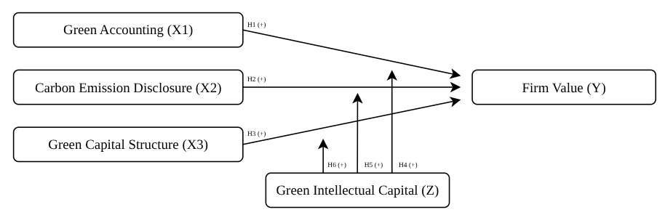
Research approach based on hypothesis development as described:
Figure 2.2 Research Model 4
Source: Processed by Author, 2025

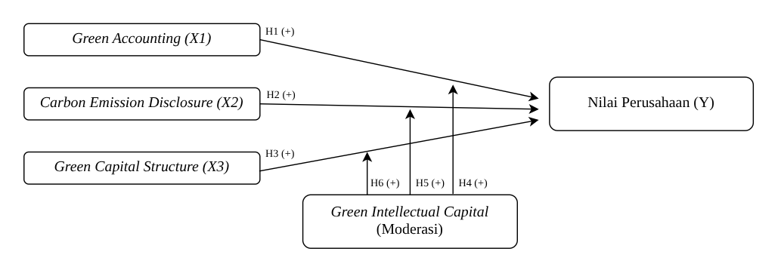
CHAPTER III

RESEARCH METODOLOGY

3.1 Definitions
Based on the problem formulation and theoretical framework described above, the operational definitions for each variable in this study are as follows:

3.1.1 Dependent Variable
The dependent variable in this study is firm value, which reflects the performance and quality of the firm in providing returns to shareholders, as reflected in its share price. In this study, firm value is measured using Tobin's Q (James Tobin, 1969), a method commonly used to assess the value of a firm. The formula for calculating Tobin's Q can be explained as follows:

${Tobin}^{'}s Q=\frac{MVE + Total Debt}{Total Assets}$……………………...………………………..3.1

3.1.2 Independent Variable

Green Accounting
Green accounting is the first independent variable in this study. Green accounting is an accounting concept that incorporates environmental aspects into a company's accounting system, whether in the form of recording assets, costs, revenues, or liabilities related to environmental activities. Green accounting aims to reflect the environmental impact of a company's operational activities and support sustainability-oriented decision-making.
In this study, green accounting is measured using the proportion of environmental costs to a company's financial performance. The measurement is carried out using the ratio between the total environmental costs incurred by the company and its net profit after tax (Ivan Adyaksana & Vitta Adhivinna, 2022).

$$GA=\frac{Environmental Cost}{Net Profit After Tax} x 100\%……………....................3.2$$

Carbon Emission Disclosure
The second independent variable in this study is carbon emission disclosure, which is the extent to which companies report information about greenhouse gas emissions generated from their operational activities. Transparency in this case is very important because it can shape stakeholders' perceptions of the company's commitment to environmental protection and sustainability.
In this study, CED was measured using a list of disclosure indicators developed by (Bae Choi et al., 2013) consisting of 18 items grouped into five main categories. Each item was assessed equally based on whether it was disclosed in the company's annual report or sustainability report. The higher the disclosure score, the greater the company's level of engagement in carbon reporting and accountability for climate change.
Table 3.1 Carbon Emission Disclosure Items
Category | Code | Description
Climate change: risks and opportunities | CC1 | Disclosure of climate-related risks and actions.
Climate change: risks and opportunities | CC2 | Explanation of financial or business impacts of climate change.
GHG emissions accounting | GHG1 | Description of the methodology used to calculate GHG emissions (e.g. GHG protocol of ISO)
GHG emissions accounting | GHG2 | Information on third-party verification of GHG data.
GHG emissions accounting | GHG3 | Total GHG emissions (in CO2-e metric tons).
GHG emissions accounting | GHG4 | Disclosure of emissions by scope (Scope 1, 2, 3).
GHG emissions accounting | GHG5 | Disclosure of GHG emissions by sources (e.g. energy, coal, fuel, electricity, etc.)
GHG emissions accounting | GHG6 | Disclosure of GHG emissions by facility or segment.
GHG emissions accounting | GHG7 | Comparison of GHG emissions with previous years.
Energy consumption accounting | EC1 | Disclosure of total energy consumed.
Energy consumption accounting | EC2 | Disclosure of renewable energy usage.
Energy consumption accounting | EC3 | Disclosure of energy consumption by type, facility of segment.
GHG reduction and cost | RC1 | Detail of plans or strategies to reduce GHG emissions.
GHG reduction and cost | RC2 | Targets or goals for emission reduction.
GHG reduction and cost | RC3 | Actual reductions achieved and associated costs/savings.
GHG reduction and cost | RC4 | Cost of future emissions factored into capital expenditure planning
Carbon emission accountability | ACC1 | Identification of climate strategy leadership.
Carbon emission accountability | ACC2 | Mechanism for reviewing climate performance.
Source: Choi et al., 2013

$CED=\frac{Total Items Disclosed}{Maximum Total Score}$ x 100%...............................................................3.3

Green Capital Structure
The third independent variable in this study is green capital structure, which is the proportion of funds raised by companies and specifically allocated for environmental protection purposes. This structure reflects the company's financial orientation towards environmentally friendly sustainable development. In this study, green capital structure is measured using the ratio between environmental project financing and the company's shareholder equity, as developed by (Zhou & Fan, 2023).

$GCS=\frac{Net Green Financing}{Total Equity}$...............................................................................3.4

3.1.3 Moderating Variable
The moderating variable used in this study is Green Intellectual Capital (GIC), which is an intellectual capital concept that focuses on environmental sustainability. GIC consists of three main elements: Green Human Capital (GHC), Green Structural Capital (GSC), and Green Relational Capital (GRC), each of which plays a role in creating sustainability-based competitive advantage. In this study, Green Intellectual Capital (GIC) is measured using indicators developed by (Chang & Chen, 2012).
Table 3.2 Green Intellectual Capital Indicator 4
Category | Code | Description
Green Human Capital (GHC) | GHC1 | Employees demonstrate strong productivity and contribution toward environmental protection.
Green Human Capital (GHC) | GHC2 | Employees have sufficient knowledge and skills in environmental management.
Green Human Capital (GHC) | GHC3 | Employees provide environmentally friendly products and services.
Green Human Capital (GHC) | GHC4 | Teams work collaboratively on environmental initiatives.
Green Human Capital (GHC) | GHC5 | Managers support employees in achieving environmental goals.
Green Structural Capital (GSC) | GSC1 | The company has an effective environmental management system.
Green Structural Capital (GSC) | GSC2 | The company generates profit from its environmental protection activities.
Green Structural Capital (GSC) | GSC3 | The company invests in environmental R&D in proportion to its overall operations.
Green Structural Capital (GSC) | GSC4 | The company engages in innovation related to environmental protection.
Green Structural Capital (GSC) | GSC5 | The company allocates funding to develop environmental protection facilities.
Green Structural Capital (GSC) | GSC6 | The company has a knowledge management system that facilitates learning and sharing of environmental practices.
Green Relational Capital (GRC) | GRC1 | The company designs products and services that align with customers’ environmental preferences.
Green Relational Capital (GRC) | GRC2 | The company maintains stable cooperative relationships with suppliers and clients regarding environmental efforts.
Green Relational Capital (GRC) | GRC3 | The company engages in long-term partnerships for environmental collaboration.
Source: Chen dan Chang, 2012

$$GIC=\frac{Total Items Disclosed}{Maximum Total Score} x 100\%......................................3.5$$

3.2 Population and Sample

3.2.1 Population
This study uses companies operating in the energy sector as its research population. The determination of the energy sector in this study adopts the conceptual approach of the Sectoral Decarbonization Approach (SDA), which emphasizes that sector classification in the context of climate change mitigation should not be based solely on formal categorization, such as sector classification on the Indonesia Stock Exchange (IDX), but should also consider actual activities and sectoral emission intensity (Science Based Targets Initiative, 2015).
Based on data developed by the World Resources Institute (WRI), the energy sector is the largest contributor to global greenhouse gas emissions, accounting for approximately 73.2% of total carbon emissions. Therefore, this study expands the scope of the energy sector while still referring to the principle of sectoral functionality in SDA. This means that in addition to companies that are formally classified in the energy sector on the IDX, this study also includes companies from other sectors such as Basic Materials, Industrials, Infrastructure, and Transportation & Logistics, which have high energy consumption intensity and substantial emission contributions.
Thus, the approach used does not limit the energy sector to administrative classifications, but also includes sub-sectors that are operationally relevant and significant in the context of decarbonization. To support this classification, the following is presented:
Table 3.3 Detailed mapping of WRI’S energy sector categories to relevant IDX sectors 5
No. | WRI | IDX
1 | Electricity and Heat: 29.7% | Energy → Electricity and Heat Companies
1 | Electricity and Heat: 29.7% | Infrastructure → Sub Sector Utilities
1 | Electricity and Heat: 29.7% | Basic Materials → Industry iron and steel, chemicals, non-metallic minerals
1 | Electricity and Heat: 29.7% | Industrials → High energy consumption in operations, production of equipment for the energy and mining sectors
2 | Transportation: 13.7% | Energy → fuel for transportation
2 | Transportation: 13.7% | Transportation and Logistics
2 | Transportation: 13.7% | Infrastructure → Airlines, shipping, railways
3 | Manufacturing and Construction: 12.7% | Energy → Mining and quarrying
3 | Manufacturing and Construction: 12.7% | Basic Materials → Iron and steel, chemicals, non-metallic minerals, pulp and paper
4 | Buildings: 6.6% | Properties & Real Estate → Residential and commercial property developers
4 | Buildings: 6.6% | Infrastructure → Building utilities
5 | Fugitive Emissions: 6.6% | Energy → Fuel
6 | Other Fuel Combustion: 4.4% | Energy → Fuel
Source: Data processed by Author, 2025
Table 3.4 Alignment between the IDX sector and the WRI energy sector 6
BEI sectors | Included in the WRI energy sector? | Description
Energy | Yes | Production and distribution of electricity, oil, gas, coal
Transportation & Logistics | Yes | Direct emissions from fuel combustion
Basic Materials | Yes | High energy consumption and emissions from industry processes
Industrials | Partly Yes | Energy use for production
Infrastructure | Partly Yes | Utilitas seperti listrik dan gas
Properties & Real Estate | No | Included in “Building energy use,” but not an energy producer
Source: Data processed by Author, 2025
The tables above are used as a basis in the process of classifying and selecting companies to be included in the research sample.

3.2.2 Sample
This study uses the purposive sampling method in selecting samples. This technique is carried out by setting certain criteria so that the selected samples are in line with the research objectives. One of these criteria is sector classification based on functional contribution to carbon emissions. This approach refers to the Sectoral Decarbonization Approach (SDA) framework developed by the Science Based Targets initiative (SBTi), which emphasizes that setting targets and grouping sectors for sustainability issues should be based on emission intensity levels and actual sectoral roles, rather than solely on formal stock market classifications. The criteria used in sample selection are as follows:
- The company is listed in the ESG Quality 45 Index (ESGQ-KEHATI) during the observation period of 2021–2024
- Companies have main activities relevant to the energy sector based on the functional approach of the World Resources Institute (WRI)
- Companies publish complete annual reports and sustainability reports for the reporting period 2021–2024
Table 3.5 Number of Research Samples 7
No. | Criteria | Total
1. | Companies listed in the ESG Quality 45 (ESGQ-KEHATI) index | 45
2. | Companies listed in the ESGQ-KEHATI index that do not have core activities related to the energy sector according to the WRI approach | (29)
3. | Companies with core activities relevant to the energy sector based on the functional approach of the World Resources Institute (WRI) | 16
4. | Companies that published annual reports and sustainability reports completely during the reporting period 2021-2024 | 16
Total companies |  | 16
Number of samples (16 x 4 years) |  | 64
Source: Data processed by Author, 2025
The determination of the sample size in this study was based on the approach proposed by (Joseph F. Hair JR., 2010), which suggests that studies using regression analysis should have a minimum sample size of 10-20 times the number of independent variables. In this study, there are three independent variables (Green Accounting, Carbon Emission Disclosure, and Capital Structure), one moderating variable (Green Intellectual Capital), and one dependent variable (Firm Value). Thus, the total number of independent variables (independent + moderating) in this study is 4. Based on the guidelines (Joseph F. Hair JR., 2010), the recommended minimum sample size is 40 samples (10 × 4). In this study, the sample size used was 64 samples, which means that the number has met the specified sample standard and is considered adequate for the analysis performed.

3.3 Type and source of data

3.3.1 Type of Data
This study is a quantitative study that uses a positivist approach in analyzing data. A quantitative approach was chosen because this study focuses on testing hypotheses based on numeric data that is analyzed statistically. This study was conducted on a predetermined population and sample, with the aim of measuring the relationship between the variables under study. In its analysis, this study uses a ratio scale. The ratio scale is applied in measuring the variables of Green Accounting, Carbon Emission Disclosure, Capital Structure, and Green Intellectual Capital to obtain more objective and measurable results.

3.3.2 Source of Data
This study uses secondary data obtained from various official sources. The main data for the ESG Quality 45 (ESGQ-KEHATI) index is sourced from the Indonesia Stock Exchange (IDX) through its official website (https://www.idx.co.id). The selection of ESGQ-KEHATI was based on the consideration that this index reflects companies with high sustainability (Environmental, Social, and Governance/ESG) performance and strong financial fundamentals. ESGQ-KEHATI is the result of a collaboration between the Indonesia Stock Exchange (IDX) and the KEHATI Foundation, with companies selected based on strict and objective ESG criteria.
The data collected includes annual reports and sustainability reports of companies relevant to the energy sector based on WRI's functional approach. In addition, this study also uses PROPER ranking data from the official website of the Ministry of Environment and Forestry (KLHK).

3.4 Data Collection Methods
The data collection method used in this study was non-participant observation, in which the researcher was not directly involved in the activities of the company being studied. Instead, data was collected by searching for and recording information from various sources, such as financial reports and sustainability reports obtained from relevant official websites.

3.5 Analysis Tools

3.5.1. Descriptive Statistics
Descriptive statistics are used to provide an overview of the characteristics of research data. This analysis includes the maximum value, minimum value, mean, and standard deviation of each research variable. The purpose of this analysis is to provide an informative summary of the data before further testing is conducted.

3.5.2. Classical Assumption Test
Classical assumption tests are conducted to ensure that the regression model meets the basic assumptions and produces valid and unbiased estimates. The types of classical assumption tests used in this study include:
1. Normality Test
The normality test aims to determine whether the data in this study is normally distributed. The test is conducted using the Kolmogorov-Smirnov (K-S) test with the following criteria:
- If the significance value (Sig.) < 0.05, then the data is not normally distributed.
- If the significance value (Sig.) > 0.05, then the data is normally distributed.
2. Multicollinearity Test
This test is conducted to see if there is a high linear relationship between independent variables. The test is conducted by looking at the Tolerance and Variance Inflation Factor (VIF) values, with the following criteria:
- If the Tolerance value is < 0.10 and VIF is > 10, then multicollinearity occurs.
- If the Tolerance value is > 0.10 and VIF is < 10, then there is no multicollinearity.
3. Heteroscedasticity Test
The heteroscedasticity test aims to determine whether there are differences in residual variance between observations in the regression model. A good regression model does not experience heteroscedasticity. The test is conducted by looking at the scatter plot between the residuals and the independent variables. If there is a certain pattern in the scatter plot, it indicates heteroscedasticity, whereas if the points are scattered randomly, there is no heteroscedasticity.
4. Autocorrelation Test
The autocorrelation test aims to determine whether there is a correlation between the residuals in the regression model. The test is conducted using the Durbin-Watson (DW Test), with the following criteria:
- If the Durbin-Watson (DW) value > upper limit value (du), then there is no autocorrelation.
- If the Durbin-Watson (DW) value < lower limit value (dl), then there is positive autocorrelation.
- If the DW value is between dl and du, then the results cannot be conclusively determined.

3.5.3. Model Suitability Test (F Test)
The F test is performed to test the significance of the regression model as a whole, in order to determine whether the independent variables collectively influence the dependent variable. The criteria for this test are as follows:
a. If the significance value (Sig.) is < 0.05, then the regression model is suitable for used
b. If the significance value (Sig.) is > 0.05, then the regression model is not suitable for use.

3.5.4. Coefficient of Determination Test (R²)
The coefficient of determination test (R²) is used to measure the extent to which the independent variables in the model can explain the dependent variable. The R² value ranges from 0 to 1, where the closer it is to 1, the greater the ability of the independent variables to explain the variability of the dependent variable.

3.5.5. Hypothesis Test (T Test)
The T-test is conducted to test the effect of each independent variable on the dependent variable partially. The criteria for the T-test are as follows:
- If the significance value (Sig.) < 0.05, then the hypothesis is accepted (the independent variable has a significant effect on the dependent variable).
- If the significance value (Sig.) > 0.05, then the hypothesis is rejected (the independent variable does not significantly affect the dependent variable).

3.5.6. Moderated Regression Analysis
This study uses the Moderated Regression Analysis (MRA) method to test the moderating effect of the Green Intellectual Capital (GIC) variable on the relationship between the independent and dependent variables. This method involves the interaction between the independent variable and the moderating variable in the regression equation, which can be formulated as follows:

$Y : α+β^{1}X^{1}+β^{2}X^{2}+β^{3}X^{3}+β^{4}M+β^{5}\left(X^{1}*M\right)+β^{6}\left(X^{2}*M\right)+β^{7}\left(X^{3}*M\right)$+ e……………………………………..……………….3.6

Explanation:
Y = Firm Value
⍺ = Constant
X₁ = Green Accounting
X₂ = Carbon Emission Disclosure
X₃ = Green Capital Structure
M = Green Intellectual Capital (Moderating Variable)
β₁ = Regression Coefficient for X₁
β₂ = Regression Coefficient for X₂
β₃ = Regression Coefficient for X₃
β₄ = Moderating Variable Coefficient
β₅ = Regression Coefficient for X₁
β₆ = Regression Coefficient for X₂
β₇ = Regression Coefficient for X₃
e = Error
With a significance value of 5%, the moderating variable is said to have an effect on the relationship between the independent variable and the dependent variable if:
1. If the significance value is > 0.05, it can be concluded that the hypothesis is rejected, meaning that the moderating variable (Z) has no effect on the relationship between the independent variable (X) and the dependent variable (Y).
2. If the significance value is < 0.05, it can be concluded that the hypothesis is accepted, meaning that the moderating variable (Z) has a significant effect on the relationship between the independent variable (X) and the dependent variable (Y).
Moderating variables can be classified into four categories, as follows:
- Pure Moderator
If the β₄ coefficient is not significant, but the β₅, β₆, and β₇ coefficients are significant, then the moderating variable is classified as a pure moderator. As a pure moderator, the moderating variable moderates the relationship between the independent variable and the dependent variable, and interacts with the independent variable without becoming an independent variable.
2. Quasi Moderator
If coefficients β₄, β₅, β₆, and β₇ are significant, then the moderating variable is classified as a quasi moderator. As a quasi moderator, the moderating variable moderates the relationship between the independent variable and the dependent variable, interacts with the independent variable, and also becomes an independent variable.
3. Homologiser Moderator
If the coefficients β₄ , β₅ , β₆ , and β₇ are declared insignificant, then the moderator variable is classified as a potential moderator. As a potential moderator, the moderator variable has the potential to become a moderator variable.
4. Predictor Moderator
If the coefficient β₄ is significant, but the coefficients β₅, β₆, and β₇ are insignificant, then the moderator variable is classified as a moderator predictor. As a moderator predictor, the moderator variable only becomes a predictor (independent) variable in the regression mode.

CHAPTER IV

RESULT AND DISCUSSION

4.1 Overview of the Research Object
This study aims to obtain empirical evidence regarding the influence of green accounting, carbon emission disclosure, and green capital structure on firm value, with green intellectual capital as a moderating variable. The analysis method used is multiple linear regression, as this study involves more than one independent variable. The data used in this study were obtained from annual reports and sustainability reports published by each company.
The objects in this study are companies that carry out activities in the energy sector, which are determined based on the emissions-based functional approach from the World Resources Institute (WRI). This approach was chosen because it provides a more comprehensive picture of companies that directly or indirectly contribute significantly to carbon emissions. This is in line with the Sectoral Decarbonization Approach (SDA) framework from the Science Based Targets initiative (SBTi), which emphasizes the importance of grouping sectors based on emission intensity and actual role in sustainability issues, rather than solely based on formal stock exchange classifications.
The population in this study consists of companies included in the ESG Quality 45 Index (ESGQ-KEHATI) for the period 2021 to 2024. This index was chosen because it consists of companies that are considered to have good sustainability performance and strong financial fundamentals, making it suitable for the research focus on green accounting practices and carbon emissions disclosure. Of the total 45 companies in the ESGQ-KEHATI index, 29 companies did not have main activities relevant to the energy sector according to the WRI approach and were therefore excluded from the sample. Thus, there were 16 companies that met all the criteria and were used as the research sample.
Table 4.1 List of Research Objects 8 Table 8
No. | Code | Company Name
1. | AKRA | AKR Corporindo Tbk.
2. | ANTM | Aneka Tambang Tbk.
3. | ASII | Astra International Tbk.
4. | AVIA | Avia Avian Tbk.
5. | BIRD | Blue Bird Tbk.
6. | ELSA | Elnusa Tbk.
7. | ESSA | ESSA Industries Indonesia Tbk.
8. | INCO | Vale Indonesia Tbk.
9. | INTP | Indocement Tunggal Prakarsa Tbk.
10. | JSMR | Jasa Marga (Persero) Tbk.
11. | MTEL | Dayamitra Telekomunikasi Tbk.
12. | PGEO | Pertamina Geothermal Energy Tbk.
13. | POWR | Cikarang Listrindo Tbk.
14. | SMGR | Semen Indonesia (Persero) Tbk.
15. | TLKM | Telkom Indonesia (Persero) Tbk
16. | UNTR | United Tractors Tbk.
Source: Data processed by Author, 2025

4.2 Data Analysis Results

4.2.1 Descriptive Statistical Analysis
Descriptive statistics aim to provide an overview of the research data that can be seen through the mean, standard deviation, maximum value, and minimum value. The following table shows the descriptive statistical analysis in this study:
Table 4.2 Descriptive Statistical Analysis Result 9
Descriptive Statistics
 | N | Minimum | Maximum | Mean | Std. Deviation
Green Accounting | 64 | 0.00 | 0.04 | 0.0052 | 0.00637
Carbon Emission Disclosure | 64 | 0.44 | 0.94 | 0.7273 | 0.15168
Green Capital Structure | 64 | 0.00 | 0.00 | 0.0005 | 0.00125
Firm Value | 64 | 0.11 | 0.85 | 0.4380 | 0.16423
Green Intellectual Capital | 64 | 0.43 | 0.86 | 0.6685 | 0.10700
Valid N (listwise) | 64
Source: Data processed by SPSS 30, 2025
Table 4.2 presents the results of descriptive statistical analysis of five research variables consisting of Green Accounting, Carbon Emission Disclosure, Green Capital Structure, Firm Value, and Green Intellectual Capital. The data were obtained from 64 observation samples (N = 64).
- Green Accounting
This variable has a minimum value of 0.00042 and a maximum value of 0.04262, with a mean value of 0.0052 and a standard deviation of 0.0064. This indicates that, in general, companies have a low level of expenditure or reporting related to green accounting, with a relatively small data distribution.
- Carbon Emission Disclosure
This variable has a minimum value of 0.44 and a maximum value of 0.94, with an average of 0.7273 and a standard deviation of 0.1517. The fairly high average indicates that most companies have disclosed their carbon emissions quite intensively, although there are still variations between companies.
- Green Capital Structure
The green capital structure variable has a minimum value of 0.00001 and a maximum of 0.00856, with an average value of 0.0006 and a standard deviation of 0.0013. This very small average value indicates that the proportion of green financing in the capital structure of companies is still limited and has not become common practice.
- Firm Value
The firm value variable ranges from 0.11 to 0.85, with an average of 0.4380 and a standard deviation of 0.1642. This indicates that there is considerable variation between companies in terms of their market value or financial performance.
- Green Intellectual Capital
This variable has a minimum value of 0.43 and a maximum of 0.86, with an average value of 0.6686 and a standard deviation of 0.1070. This average indicates that most companies have a moderate to high level of Green Intellectual Capital, reflecting the capacity of knowledge-based resources that support sustainability.

4.2.2. Classical Assumption Test
1. Normality Test
A normality test was conducted to determine whether the residual data from the regression model was normally distributed. This test is important because one of the basic assumptions in classical linear regression analysis is that the residuals must be normally distributed. In this study, the normality test was conducted using the One-Sample Kolmogorov-Smirnov Test method.
Table 4.3 Normality Test Results 10 Table 10
One-Sample Kolmogorov-Smirnov Test
 |  | Unstandardized Residual
N |  | 64
Normal Parameters^{a,b} | Mean | 0.0000000
Normal Parameters^{a,b} | Std. Deviation | 0.09933663
Most Extreme Differences | Absolute | 0.074
Most Extreme Differences | Positive | 0.074
Most Extreme Differences | Negative | -0.061
Test Statistic |  | 0.074
Asymp. Sig. (2-tailed) |  | 0.200^{c}
a. Test distribution is Normal.
b. Calculated from data.
c. Lilliefors Significance Correction.

Source: Data processed by SPSS 30, 2025
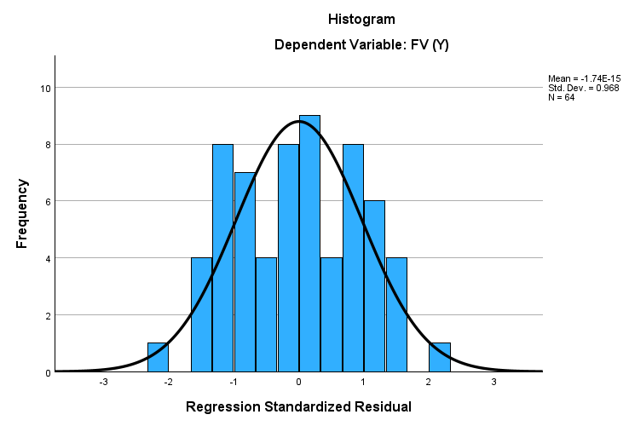
Based on Table 4.3, it is known that the Asymp. Sig. (2-tailed) value of the Kolmogorov-Smirnov test is 0.200, which is greater than the significance value of 0.05. This indicates that the residuals in the regression model are normally distributed, so it can be concluded that the model meets the assumption of normality. Thus, the regression model is suitable for use in further testing.
Figure 4.1 Histogram Graph 5
Source: Data processed by SPSS 30, 2025

Gambar 5

The histogram of standardized residuals shows a distribution pattern resembling a normal curve (bell-shaped curve), with a peak in the middle and symmetry to the left and right. This reinforces the results of the previous normality test, which showed that the regression model residuals are normally distributed.

Gambar 6
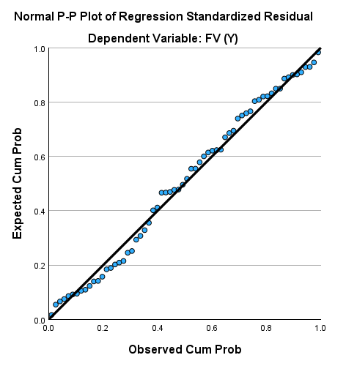

Figure 4.2 Normal P-Plot Graph 6
Source: Data processed by SPSS 30, 2025

The Normal P-P Plot graph shows that the residual points are scattered close to the diagonal line, indicating that the residuals are normally distributed. The closer the points are to the line, the stronger the assumption of normality is fulfilled. Thus, it can be concluded that the regression model has fulfilled the assumption of residual normality.
2. Multicollinearity Test
The multicollinearity test is performed to determine whether there is a high correlation between the independent variables in the regression model. High multicollinearity can cause distortion in the estimation of regression coefficients. The indicators used in this test are the Tolerance and Variance Inflation Factor (VIF) values with decision making criteria. If the Tolerance value is > 0.10 and VIF is <10, then there is no multicollinearity, and if Tolerance is <0.10 and VIF is >10, then there is an indication of multicollinearity.
Table 4.4 Multicollinearity Test Results 11
Coefficients
Model |  | Collinearity Statistics
 |  | Tolerance | VIF
1 | Green Accounting | 0.804 | 1.244
1 | Carbon Emission Disclosure | 0.749 | 1.335
1 | Green Capital Structure | 0.802 | 1.248
1 | Green Intellectual Capital | 0.759 | 1.318
a. Dependent Variable: Firm Value
Source: Data processed by SPSS 30, 2025
Based on Table 4.4, all independent variables in this study have a Tolerance value above 0.10 and a VIF value below 10, namely, Green Accounting has a Tolerance of 0.804 and a VIF of 1.244, Carbon Emission Disclosure has a Tolerance of 0.749 and a VIF of 1.335, Green Capital Structure has a Tolerance of 0.802 and a VIF of 1.248, and Green Intellectual Capital has a Tolerance of 0.759 and a VIF of 1.318.
Thus, it can be concluded that there is no multicollinearity between the independent variables in this regression model, so the model is suitable for further testing.
3. Heteroscedasticity Test
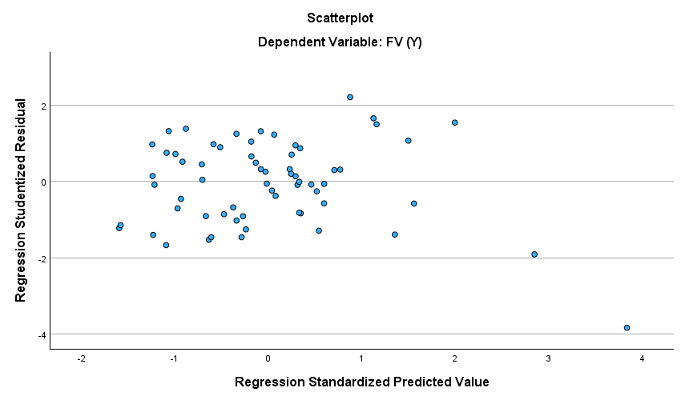
A heteroscedasticity test was conducted to determine whether there was variance inequality of the residuals across all predictor values in the regression model. One way to detect heteroscedasticity is to use a scatterplot between the standardized residual values (standardized residual) and the standardized predicted values (standardized predicted value).
Gam Based on Figure 4.3, it can be seen that the residual points are scattered randomly above and below the zero axis without forming any particular pattern, such as a converging or diverging pattern. This indicates that the residual variance is constant for all predicted values. Thus, it can be concluded that there is no heteroscedasticity in the regression model, so that the model meets the assumption of homoscedasticity and is suitable for further analysis.
Figure 4.3 Heteroscedasticity Test Results 7
Source: Data processed by SPSS 30, 2025
4. Autocorrelation Test
An autocorrelation test is performed to determine whether there is a correlation between the residuals in one observation and the residuals in other observations. Autocorrelation can cause a violation of classical regression assumptions, especially in time series data, although this test can still be used as an additional check on cross-sectional data. One method used to detect autocorrelation is the Durbin-Watson Test, with the criteria being that if the Durbin-Watson value is close to 2, there is no autocorrelation; if the value is close to 0, there is positive autocorrelation; and if the value is close to 4, there is negative autocorrelation.
Table 4.5 Autocorrelation Test Results 12
Model Summary^{b}
Model | R | R Square | Adjusted R Square | Std. Error of the Estimate | Durbin-  Watson
1 | 0.846ª | 0.716 | 0.691 | 0.09162 | 1.655
a. Predictors: (Constant), Green Intellectual Capital, Green Accounting, Carbon Emission disclosure, Green Capital Structure
b. Dependent Variable: Firm Value
Source: Data processed by SPSS 30, 2025
Based on Table 4.5, the Durbin-Watson value is 1.655, which is within the range of 1.5–2.5. Therefore, it can be concluded that there is no autocorrelation in this regression model. Thus, the regression model meets the assumption of autocorrelation freedom and is suitable for further testing.

4.2.3. Model Suitability Test (F Test)
The F test or simultaneous test is conducted to determine whether all independent variables included in the regression model collectively have a significant effect on the dependent variable. This test is part of the ANOVA (Analysis of Variance) analysis in linear regression with the following decision criteria:
- If the significance value (Sig.) < 0.05, then the regression model is suitable for use because the independent variables simultaneously have a significant effect on the dependent variable.
- If the significance value (Sig.) > 0.05, then the regression model is not suitable for use.
Table 4.6 F Test Results 13 13
ANOVAª
Model |  | Sum of Squares | df | Mean Square | F | Sig.
1 | Regression | 1,078 | 4 | 0.269 | 25.567 | <0.001^{b}
1 | Residual | 0.622 | 59 | 0.011
1 | Total | 1.699 | 63
a. Dependent Variable: Firm Value
b. Predictors: (Constant), Green Accounting, Carbon Emission Disclosure, Green Capital Structure
Source: Data processed by SPSS 30, 2025
Based on Table 4.6, it is known that the F value is 25.567 with a significance value of <0.001. This value is less than 0.05, which means that simultaneously, the variables of Green Accounting, Carbon Emission Disclosure, and Green Capital Structure have a significant effect on Firm Value. Thus, it can be concluded that the regression model used in this study is suitable for further testing because it meets the model validity simultaneously.
4.2.4. Coefficient of Determination (R²) Test
The coefficient of determination test is used to measure the extent to which the regression model can explain the variation of the dependent variable. The coefficient of determination (R²) value ranges from 0 to 1. The higher the R² value, the better the regression model is at explaining the dependent variable.

Table 4.7 Coefficient of Determination Test (R²) 14
Model Summary
Model | R | R Square | Adjusted R Square | Std. Error of the Estimate
1 | 0.846ª | 0.716 | 0.691 | 0.09162
a. Predictors: (Constant), Green Intellectual Capital, Green Accounting, Carbon Emission Disclosure, Green Capital Structure, X1M, X2M, X3M
b. Dependent Variable: Firm Value
Source: Data processed by SPSS 30, 2025
Based on Table 4.7, the R Square value obtained is 0.716, which means that 71.6% of the variation in firm value (FV) can be explained by the independent variables in this model, namely green accounting (X1), carbon emission disclosure (X2), green capital structure (X3), and the moderating variable of green intellectual capital (Z). Thus, this regression model has a fairly strong predictive ability, because more than half of the variation in firm value can be explained by these variables. Meanwhile, the remaining 28.4% (100% - 71.6%) is explained by other factors not included in the model, such as external factors, macroeconomic conditions, government policies, company reputation, and others.

4.2.5. Multiple Linear Regression Analysis
The analytical approach in this study uses multiple linear regression with the Moderated Regression Analysis (MRA) technique. This test aims to determine the correlation between the independent variables and the dependent variables and to see the possibility of a moderating effect.

Table 4.8 Multiple Linear Regression Analysis 15
Coefficients
Model |  | Unstandardized Coefficients |  | Standardized Coefficients
 |  | B | Std. Error | Beta
1 | (Constant) | 0.118 | 0.074
1 | GA | 15.352 | 2.563 | 0.596
1 | CED | 0.129 | 0.098 | 0.119
1 | GCS | 29.999 | 12.988 | 0.230
1 | X1M | 45.058 | 50.509 | 1.177
1 | X2M | -1.075 | 0.305 | -0.991
1 | X3M | -62.230 | 295.648 | -0.328
a. Dependent Variable: Firm Value
Source: Data processed by SPSS 30, 2025
A constant value of 0.118 indicates a positive parameter
1. Green Accounting
The green accounting variable has a regression coefficient value of 15.352. This indicates that every 1 unit increase in green accounting will decrease the firm value by 15.352 units, assuming other variables remain constant. The standard coefficient (Beta) of 0.596 indicates a strong influence. Thus, green accounting has a positive effect on firm value.
2. Carbon Emission Disclosure
The carbon emission disclosure variable has a regression coefficient value of 0.129. This indicates that a 1-unit increase in carbon emission disclosure will increase firm value by 0.129 units, assuming other variables remain constant. In other words, CED has a positive effect on firm value.
3. Green Capital Structure
The environmental-based social responsibility variable has a coefficient value of 29.999, indicating a positive effect on firm value. This means that every 1-unit increase in GCS is estimated to increase firm value by 29.999 units.
4. Green Intellectual Capital in Moderating Green Accounting on Firm Value
The interaction between green accounting and green intellectual capital has a regression coefficient value of 45.058. This shows that green intellectual capital strengthens the effect of green accounting on firm value by 45.058, although its significance value (Sig. = 0.376) indicates that it is not significant.
5. Green Intellectual Capital in moderating Carbon Emission Disclosure on Firm Value
The interaction between carbon emission disclosure and green intellectual capital has a regression coefficient value of -1.075. This means that every 1 unit increase in this interaction actually decreases firm value by 1.075, with other variables held constant. This interaction is significant (Sig. < 0.001), so that green intellectual capital moderates the relationship between CED and firm value.
6. Green Intellectual Capital in moderating Green Capital Structure on Firm Value
The interaction between green capital structure and green intellectual capital has a regression coefficient of -62.230. This indicates that an increase in this interaction will actually decrease firm value by 62.230 units, with other variables held constant. However, the significance value of 0.834 > 0.05, which means it is not significant.

4.2.6 Hypothesis Test (t Test)
The t-test is used to test the partial effect of each independent variable on the dependent variable on the dependent variable (Firm Value), assuming that other variables are held constant with decision making criteria. If the Sig. (p-value) <0.05, then the independent variable has a significant effect on the dependent variable and if the Sig. value (p-value) >0.05, then the independent variable has no significant effect.
Table 4.9 Hypothesis Test Model 1 16 16
Coefficients
Model |  | Unstandardized Coefficients |  | Standardized Coefficients | t | Sig.
 |  | B | Std. Error | Beta | t | Sig.
1 | (Constant) | 0.248 | 0.075 |  | 3.314 | 0.002
1 | GA | 15.352 | 2.563 | 0.596 | 5.989 | <0.001
1 | CED | 0.129 | 0.098 | 0.119 | 1.321 | 0.191
1 | GCS | 29.999 | 12..988 | 0.230 | 2.310 | 0.024
a. Dependent Variable: Firm Value
Source: Data processed by SPSS 30, 2025
Based on the results of the t-test for model 1 in Table 4.9, it is known that:
1. Green Accounting
Green accounting has a positive and significant effect on firm value, The green accounting variable has a significance value of < 0.001, which is smaller than the significance level of 0.05. This indicates that green accounting has a significant effect on firm value. The B coefficient value is 15.352 and is positive, which means that the higher the green accounting practices carried out by the company, the higher the firm value.
2. Carbon Emission Disclosure
Carbon emission disclosure has a positive and insignificant effect on firm value. The carbon emission disclosure variable has a significance value of 0.191, which is greater than 0.05. Therefore, it can be concluded that carbon emission disclosure does not have a significant effect on firm value. Although the B coefficient value of 0.129 indicates a positive direction of influence, the effect is not statistically significant.
3. Green Capital Structure
Green capital structure has a positive and significant effect on firm value. The green capital structure variable has a significance value of 0.024, which is less than 0.05. This indicates that green capital structure has a significant effect on firm value. The B coefficient is 29.999 and has a positive value, which means that the higher the proportion of a company's green capital structure, the higher the company's value tends to be.

Table 4.10 Hypothesis Test Model 2 17Table 17
Coefficients
Model |  | Unstandardized Coefficients |  | Standardized Coefficients | t | Sig.
 |  | B | Std. Error | Beta | t | Sig.
1 | (Constant) | 0.118 | 0.074 |  | 1.601 | 0.115
1 | GA | -15.436 | 33.922 | -0.599 | -0.455 | 0.651
1 | CED | 1.044 | 0.252 | 0.964 | 4.146 | <0.001
1 | GCS | 72.341 | 202.116 | 0.555 | 0.358 | 0.722
1 | X1M | 45.058 | 50.509 | 1.177 | 0.892 | 0.376
1 | X2M | -1.075 | 0.305 | -0.991 | -3.531 | <0.001
1 | X3M | -62.230 | 295.648 | -0.328 | -0.210 | 0.834
a. Dependent Variable: Firm Value
Source: Data processed by SPSS 30, 2025
Moderated Regression Analysis (MRA) was conducted to determine whether the moderating variable, namely Green Intellectual Capital (GIC), was able to moderate the relationship between the independent variables (Green Accounting, Carbon Emission Disclosure, and Green Capital Structure) and the dependent variable, namely Firm Value.
Based on the results of the t-test for model 2 in Table 4.10, it is known that:
1. Green Intellectual Capital cannot moderate the relationship between green accounting and firm value. This is indicated by a significance value (Sig.) of 0.376 > 0.05, which means it is not significant. Thus, green intellectual capital acts as a homologizer moderator or potential moderator.
2. Green Intellectual Capital can moderate the relationship between carbon emission disclosure and firm value. This is indicated by a significance value (Sig.) of <0.001, which means it is significant. Thus, green intellectual capital acts as a pure moderator.
3. Green Intellectual Capital cannot moderate the relationship between green capital structure and firm value. This is indicated by a significance value (Sig.) of 0.834 > 0.05, which means it is not significant. Thus, green intellectual capital acts as a homologizer moderator or potential moderator.

4.3 Explanation of Research Results

4.3.1. The Effect of Green Accounting on Firm Value
Based on the t-test results in Table 4.9, the t-value for the Green Accounting variable is 5.989 > t-table 1.66235, with a significance value < 0.001 < 0.05. This indicates that Hypothesis 1 (H1) is accepted, so it can be concluded that Green Accounting has a positive and significant effect on firm value.
These results support Legitimacy Theory, which states that corporate sustainability is highly dependent on its ability to operate in accordance with social norms and public expectations. In this context, the application of Green Accounting is one way for companies to demonstrate their environmental responsibility through transparent reporting and measurement of environmental impacts. Thus, companies can build a positive image and gain the trust of investors and other stakeholders, which ultimately increases the company's market value.
Based on the research data, most energy companies in the research sample have demonstrated efforts to implement green accounting through recording environmental costs, investing in clean technology, and reporting environmental aspects in their sustainability reports. These companies are also active in responding to demands for transparency from stakeholders, including regulators, investors, and the public, given that the energy sector is one of the industries with the greatest environmental impact. The availability of environmental cost data and emission mitigation activities disclosed in annual reports or sustainability reports shows that companies are beginning to recognize the importance of environmental reporting as part of their business strategy and not merely as a matter of compliance.
These findings are in line with research by (Xie et al., 2022), which shows that strategic environmental reporting and green innovation have a significant impact on firm value, especially in heavily polluting industries. Furthermore, these results are also reinforced by (Utomo et al., 2020), who state that environmental disclosure has a positive effect on the firm value of non-financial companies in Indonesia. This confirms that integrating environmental aspects into the accounting reporting system is a legitimacy strategy that contributes to increasing firm value in the long term.

4.3.2. The Effect of Carbon Emission Disclosure on Firm Value
The second hypothesis test shows that the Carbon Emission Disclosure (CED) variable has a positive but insignificant effect on firm value, with a significance value of 0.191 > 0.05 and a t-value of 1.321 < 1.66235. Therefore, Hypothesis 2 (H2) is rejected.
This result is not in line with Legitimacy Theory, which states that environmental transparency can increase public, regulatory, and investor trust and legitimacy in a company. In this context, carbon emission disclosure should be a positive signal of a company's environmental responsibility, which can ultimately increase the company's market value.
However, based on observations of the research data, carbon emissions disclosure by energy sector companies in Indonesia is still very limited in terms of both quantity and quality. Most companies only disclose normative and general information, such as statements of commitment to the environment or involvement in CSR programs, without accompanying quantitative data, emission reduction targets, or clear calculation methodologies. Some companies do not even explicitly mention total carbon emissions in their sustainability reports, so the transparency that should be the basis for legitimacy has not been optimally achieved.
In addition, regulations related to carbon emissions reporting in Indonesia are still voluntary, as stipulated in Presidential Regulation No. 98 of 2021, which has not been equipped with an integrated reporting system or strict sanctions for non-compliance. This has led many companies to only make minimal and symbolic disclosures, merely to meet the basic expectations of stakeholders, rather than as part of a business strategy integrated with the company's long-term goals.
These results are in line with the research by (Hardiyansah & Agustini, 2020) and (Mirza Aulia et al., 2024), which also reported that CED has not had a significant impact on firm value in Indonesia, as it is still voluntary and limited in nature. Both studies highlight that without strong regulatory incentives and standardized reporting standards, carbon emissions disclosure tends to have no material influence on market and investor perceptions. Thus, although in theory CED should be able to increase firm value, weak and inconsistent implementation in the field is the main factor explaining the insignificant results in this study.

4.3.3. The Effect of Green Capital Structure on Firm Value
Based on the t-test results in Table 4.9, the t-value for Green Capital Structure is 2.310 > t-table 1.66235, with a significance value of 0.024 < 0.05. Therefore, it can be concluded that Hypothesis 3 (H3) is accepted, meaning that Green Capital Structure has a positive and significant effect on firm value.
This result is consistent with Legitimacy Theory, as environmentally-based financing decisions show that companies are responsible not only economically, but also socially and ecologically. Green capital structure demonstrates a commitment to sustainability and can increase the trust of investors, creditors, and the public. With this increased legitimacy, the company's reputation and firm value also increase.
From a review of the research data, it was found that several energy sector companies in the sample have begun to finance environmentally friendly projects through instruments such as green bonds, green loans, or internal fund allocations for energy efficiency and clean technology. Although it is still not evenly distributed across all companies, this financing practice shows an awareness of integrating sustainability aspects into financial decisions. This is reflected in the company's sustainability reports and annual reports, which list renewable energy projects, resource efficiency, or environmental management systems that are specifically funded.
In addition, pressure from global stakeholders and commitment to Environmental, Social, and Governance (ESG) principles are increasingly encouraging companies to develop capital structures that support green projects. Institutional investors, especially those from abroad, are also showing greater interest in companies with environmentally-oriented financing profiles, providing market incentives for companies to switch to green capital structures.
These findings are in line with research by (Zhou & Fan, 2023), which states that green capital structures drive company growth, and (Tang & Zhang, 2020), which found that green financing strategies such as green bonds can increase shareholder value. Thus, financial structures that support environmentally friendly practices have been proven to provide tangible economic benefits, not only in the context of compliance, but also as a value added strategy for companies.

4.3.4. The Effect of Green Intellectual Capital on Green Accounting on Firm Value
The interaction test results between Green Accounting × Green Intellectual Capital (X1M) show a significance value of 0.376 > 0.05 with a t-value of 0.892 < 1.66235, thus rejecting Hypothesis 4 (H4). This means that Green Intellectual Capital (GIC) cannot significantly moderate the relationship between Green Accounting and firm value.
According to Legitimacy Theory, companies are expected to align their operations with social norms and stakeholder expectations to gain legitimacy and enhance firm value. In theory, GIC which encompasses environmental human capital, structural capital, and relational capital should reinforce the implementation of Green Accounting by providing competencies, systems, and organizational mechanisms that ensure high-quality environmental reporting. With stronger GIC, Green Accounting practices would be more credible and perceived as a genuine effort to address environmental issues, thereby strengthening legitimacy in the eyes of stakeholders and positively influencing firm value.
However, based on observations of the research data, the implementation of GIC in Indonesian energy sector companies remains limited and not systematically disclosed. Many companies fail to highlight competencies in environmental management, integrated reporting systems, or partnerships with stakeholders that could enhance the impact of Green Accounting. As a result, investors and markets find it difficult to evaluate the role of GIC, given its intangible nature, measurement challenges, and minimal formal disclosure.
These findings align with (Martínez-Falcó et al., 2025), who emphasize that GIC tends to be more effective as a mediating variable rather than as a moderator. This study confirms that without systemic integration into managerial and operational practices, GIC cannot effectively strengthen the relationship between Green Accounting and firm value. In the context of legitimacy, this suggests that GIC has not yet been leveraged as a strategic instrument to reinforce the credibility of environmental accounting, thereby limiting its ability to contribute to sustained legitimacy and firm value creation.

4.3.5. The Effect of Green Intellectual Capital on the Carbon Emission Disclosure Structure on Firm Value
Based on the t-test results in Table 4.10, the t-value for the interaction between Carbon Emission Disclosure (CED) and Green Intellectual Capital (GIC) is -3.531, with a significance value of < 0.001. Therefore, Hypothesis 5 (H5) is accepted, indicating that GIC significantly moderates the effect of CED on firm value.
Interestingly, the coefficient is negative, suggesting that while GIC moderates the relationship, the effect does not necessarily strengthen it. Within the lens of Legitimacy Theory, disclosure of environmental information should build trust and enhance legitimacy if it is backed by credible internal resources such as skilled human capital, reliable reporting systems, and organizational structures that support sustainability. When disclosure is supported by strong GIC, it signals genuine environmental responsibility and fosters legitimacy in the market. Conversely, when disclosures are not backed by robust GIC, stakeholders may interpret them as symbolic gestures or even greenwashing, which undermines legitimacy and decreases firm value.
The research data reveal that many energy sector companies disclose carbon emissions in sustainability reports, but these disclosures are often narrative, general, and lack quantitative rigor. In the absence of adequate GIC such as trained sustainability experts, integrated carbon management systems, or systematic data reporting such disclosures appear less credible to investors. This explains the negative moderating effect: disclosures made without substantive internal capabilities may reduce rather than enhance legitimacy.
These findings are consistent with (Hakki et al., 2024), who argue that the combination of substantive environmental practices and transparent disclosure is what generates legitimacy and boosts firm value. The results of this study confirm that GIC is crucial in transforming environmental disclosure into a credible legitimacy strategy. Therefore, to achieve positive value creation, carbon emission disclosure must be accompanied by strong GIC that supports transparency with real capabilities and measurable results.

4.3.6. The Effect of Green Intellectual Capital on Green Capital Structure on Firm Value
The interaction test results between Green Capital Structure × Green Intellectual Capital (X3M) produced a significance value of 0.834 > 0.05 and a t-count of -0.210 < 1.66235, indicating that Hypothesis 6 (H6) was rejected. This means that GIC does not significantly moderate the relationship between Green Capital Structure and firm value.
From the perspective of Legitimacy Theory, financing decisions that integrate environmental considerations such as issuing green bonds or allocating funds for renewable energy should enhance legitimacy when they are supported by internal intellectual capital. GIC is theoretically expected to strengthen this relationship by ensuring that green financing is embedded within broader sustainability strategies, managed by competent human resources, and transparently reported through robust systems. With such support, green financing would not only serve as compliance but also as a credibility-building mechanism, reinforcing legitimacy and improving firm value.
Nevertheless, the findings indicate that the role of GIC in this relationship is not yet significant. Research data show that GIC practices, such as environmental training, sustainability-oriented knowledge management, or decision-making systems for green financing, are not consistently disclosed by energy companies in Indonesia. Furthermore, weak institutional frameworks for intangible asset reporting make it difficult for stakeholders to recognize and evaluate the contribution of GIC in financing strategies. As a result, the moderating role of GIC in this relationship remains unrecognized in the market.
This conclusion is in line with (Zhang & Wang, 2023), who found that environmental information disclosure impacts sustainable growth only when supported by tangible internal structures and systems. Similarly, (Benevene et al., 2021), highlight that in developing countries, GIC has not consistently moderated the link between sustainability strategy and firm performance due to weak recognition and disclosure of intangible assets. In the context of legitimacy, this study reinforces that GIC can only enhance the credibility of green financing when it is systematically integrated into internal processes and transparently communicated. Without these elements, its potential to strengthen the legitimacy derived from Green Capital Structure remains limited.

BAB V

CLOSING

5.1 Conclusion
After analyzing, obtaining, and discussing the results from the previous chapters, the conclusion of this study is as follows:
- Green Accounting has a positive and significant effect on the firm value of energy sector companies listed on the Indonesia Stock Exchange for the period 2021–2024. This shows that measuring and reporting environmental impacts through green accounting practices can increase investors' positive perceptions of companies.
- Carbon Emission Disclosure has a positive but insignificant effect on firm value. This shows that although carbon emission disclosure is important as a form of environmental transparency, this information is not yet fully considered relevant or impactful by investors in increasing a firm's market value.
- Green Capital Structure has a positive and significant effect on firm value. An environmentally friendly capital structure oriented towards sustainable financing can increase the legitimacy and trust of stakeholders in the firm, which ultimately has an impact on firm value.
- Green Intellectual Capital cannot moderate the influence of Green Accounting on firm value. Despite its potential as a strategic intangible resource, GIC has not made a significant moderating contribution in strengthening the relationship between environmental reporting and firm market value. Thus, GIC acts as a homologizer moderator or potential moderator.
- Green Intellectual Capital can moderate the effect of Carbon Emission Disclosure on firm value. This indicates that the green intellectual capabilities possessed by the company can strengthen the relationship between carbon emission disclosure and an increase in firm value. Thus, GIC acts as a pure moderator.
- Green Intellectual Capital cannot moderate the influence of Green Capital Structure on firm value. This shows that even though green capital structure has a positive influence on firm value, the existence of GIC has not been able to strengthen this influence. In this case, GIC again acts as a homologizer moderator or potential moderator.

5.2 Research Limitations
- Research Object Limitations
This study only focuses on energy sector companies included in the ESG Quality 45 (ESGQ-KEHATI) index during the 2021–2024 period. Thus, the results of this study cannot be generalized to all industrial sectors in Indonesia.
2. Time and Period Limitations
The research time frame is limited to only four years (2021–2024), so it may not be able to describe long-term trends in the relationship between green accounting, carbon emission disclosure, green capital structure, and firm value.

5.3 Recommendations
1. For the Government
The government is expected to strengthen regulations related to environmental reporting, particularly carbon emission disclosure and green accounting practices, so that they become standardized obligations rather than voluntary measures. This will increase corporate accountability and transparency in supporting the transition to a green economy.
The government can also expand fiscal and non-fiscal incentives for companies that implement green capital structure, such as tax deductions for green projects or special interest rates on green bonds.
2. For Companies
Companies need to improve the integration of sustainability aspects into their business strategies through the comprehensive implementation of green accounting and the presentation of transparent information in their annual reports and sustainability reports.
Strengthening green intellectual capital is important to reinforce the link between environmental initiatives and firm value. Companies are advised to develop environmentally friendly human resource training, sustainable innovation, and collaborate with relevant stakeholders. Companies can also begin to strategically develop a financing structure that supports environmentally friendly activities (green capital structure) to maintain long-term legitimacy in the eyes of the market and regulators.

3. For Investors
Investors can consider disclosures on green accounting, carbon emissions, and green financing structures as important factors in their investment decisions. These three factors reflect a company's environmental risk management and long-term orientation. Assessing green intellectual capital is also important as it can be an indicator of a company's readiness to face sustainability challenges, as well as opportunities to create economic and social value.
4. For Further Research
Further research should expand the scope of industrial sectors and extend the observation period to obtain more general and comprehensive results. The addition of control variables such as company size, profitability, and type of ownership can help further explain the relationship between variables in the context of firm value.

BIBLIOGRAPHY
A General Equilibrium Approach To. (n.d.). https://about.jstor.org/terms
Alaika, A. A., & Firmansyah, A. (2024). Unveiling The Impact of Green Accounting and Sustainability Disclosure On The Firm Value. Journal of Governance Risk Management Compliance and Sustainability, 4(2), 64–78. https://doi.org/10.31098/jgrcs.v4i2.2436
Albitar, K., Hussainey, K., Kolade, N., & Gerged, A. M. (2020). ESG disclosure and firm performance before and after IR: The moderating role of governance mechanisms. International Journal of Accounting and Information Management, 28(3), 429–444. https://doi.org/10.1108/IJAIM-09-2019-0108
Alnaim, M., & Metwally, A. B. M. (2024). Green Intellectual Capital and Corporate Environmental Performance: Does Environmental Management Accounting Matter? Administrative Sciences, 14(12). https://doi.org/10.3390/admsci14120311
Bae Choi, B., Lee, D., & Psaros, J. (2013). An analysis of Australian company carbon emission disclosures. Pacific Accounting Review, 25(1), 58–79. https://doi.org/10.1108/01140581311318968
Benevene, P., Buonomo, I., Kong, E., Pansini, M., & Farnese, M. L. (2021). Management of green intellectual capital: Evidence-based literature review and future directions. In Sustainability (Switzerland) (Vol. 13, Issue 15). MDPI AG. https://doi.org/10.3390/su13158349
Brigham, E. F. ., & Houston, J. F. . (2019). Fundamentals of financial management. Cengage.
Bui, T. N., Nguyen, X. H., & Pham, K. T. (2023). The Effect of Capital Structure on Firm Value: A Study of Companies Listed on the Vietnamese Stock Market. International Journal of Financial Studies, 11(3). https://doi.org/10.3390/ijfs11030100
Calvin, K., Dasgupta, D., Krinner, G., Mukherji, A., Thorne, P. W., Trisos, C., Romero, J., Aldunce, P., Barrett, K., Blanco, G., Cheung, W. W. L., Connors, S., Denton, F., Diongue-Niang, A., Dodman, D., Garschagen, M., Geden, O., Hayward, B., Jones, C., … Ha, M. (2023). IPCC, 2023: Climate Change 2023: Synthesis Report. Contribution of Working Groups I, II and III to the Sixth Assessment Report of the Intergovernmental Panel on Climate Change [Core Writing Team, H. Lee and J. Romero (eds.)]. IPCC, Geneva, Switzerland. (P. Arias, M. Bustamante, I. Elgizouli, G. Flato, M. Howden, C. Méndez-Vallejo, J. J. Pereira, R. Pichs-Madruga, S. K. Rose, Y. Saheb, R. Sánchez Rodríguez, D. Ürge-Vorsatz, C. Xiao, N. Yassaa, J. Romero, J. Kim, E. F. Haites, Y. Jung, R. Stavins, … C. Péan, Eds.). https://doi.org/10.59327/IPCC/AR6-9789291691647
Chang, C. H., & Chen, Y. S. (2012). The determinants of green intellectual capital. Management Decision, 50(1), 74–94. https://doi.org/10.1108/00251741211194886
Chen, Y. S. (2008). The positive effect of green intellectual capital on competitive advantages of firms. Journal of Business Ethics, 77(3), 271–286. https://doi.org/10.1007/s10551-006-9349-1
Dincer, B., Keskin, A. İ., & Dincer, C. (2023). Nexus between Sustainability Reporting and Firm Performance: Considering Industry Groups, Accounting, and Market Measures. Sustainability (Switzerland), 15(7). https://doi.org/10.3390/su15075849
Dowling, J., & Pfeffer, J. (1975). Pacific Sociological Association Organizational Legitimacy: Social Values and Organizational Behavior. In Source: The Pacific Sociological Review (Vol. 18, Issue 1).
Febrianti, S., Giriati, Malini, H., & Wendy. (2024). Determinants of Capital Structure and the Effect on Firm Value: Evidence from Indonesia. Asian Journal of Economics, Business and Accounting, 24(6), 407–421. https://doi.org/10.9734/ajeba/2024/v24i61370
Fernando, C. S., Sharfman, M. P., Uysal, V. B., Harper, J., Jandik, T., Kacperczyk, M., Kang, B., Krüger, P., Nejadmalayeri, A., Petersen, M., Rao, R., Smith, C., Sulaeman, J., Zhou, Y., & Zou, H. (2009). Corporate Environmental Policy and Shareholder Value: Following the Smart Money.
Fu, C., Lu, L., & Pirabi, M. (2023). Advancing green finance: a review of sustainable development. Digital Economy and Sustainable Development, 1(1). https://doi.org/10.1007/s44265-023-00020-3
Global Carbon Project. (2025). The Global Carbon Budget. https://globalcarbonbudget.org/faqs/
Hakki, T. W., Akwila, K., & Jurjanta, P. (2024). The Effect of Carbon Management Accounting, Competitive Business Strategic and Carbon Emission Disclosure on Company Performance Moderated by Green Intellectual Capital. https://doi.org/10.38035/jafm.v5i5
Hardiyansah, M., & Agustini, A. T. (2020). Analysis Of Carbon Emissions Disclosure And Firm Value: Type Of Industry As A Moderating Model. INTERNATIONAL JOURNAL OF SCIENTIFIC & TECHNOLOGY RESEARCH, 9, 2. www.ijstr.org
Huang, L., Ji, X., Niu, T., & Ou, W. (2025). The Impact of Carbon Information Disclosure Quality on Enterprise Value: Evidence from Chinese Listed Companies. Sustainability (Switzerland), 17(2). https://doi.org/10.3390/su17020402
Intergovernmental Panel on Climate Change. (2023). AR6 Synthesis Report: Climate Change. https://www.ipcc.ch/report/ar6/syr/
Ivan Adyaksana, R., & Vitta Adhivinna, V. (2022). Does Environmental Information Disclosure Mediate the Effect of Environmental Cost on Environmental Performance? KnE Social Sciences. https://doi.org/10.18502/kss.v7i14.12024
Jiang, Y., Luo, L., Xu, J. F., & Shao, X. R. (2021). The value relevance of corporate voluntary carbon disclosure: Evidence from the United States and BRIC countries. Journal of Contemporary Accounting and Economics, 17(3). https://doi.org/10.1016/j.jcae.2021.100279
Jirakraisiri, J., Badir, Y. F., & Frank, B. (2021). Translating green strategic intent into green process innovation performance: the role of green intellectual capital. Journal of Intellectual Capital, 22(7), 43–67. https://doi.org/10.1108/JIC-08-2020-0277
Karim, A. E., Albitar, K., & Elmarzouky, M. (2021). A novel measure of corporate carbon emission disclosure, the effect of capital expenditures and corporate governance. Journal of Environmental Management, 290. https://doi.org/10.1016/j.jenvman.2021.112581
Khan, H. Z., Bose, S., Sheehy, B., & Quazi, A. (2021). Green banking disclosure, firm value and the moderating role of a contextual factor: Evidence from a distinctive regulatory setting. Business Strategy and the Environment, 30(8), 3651–3670. https://doi.org/10.1002/bse.2832
Khan, S., & Gupta, S. (2023). The interplay of sustainability, corporate green accounting and firm financial performance: a meta-analytical investigation. Sustainability Accounting, Management and Policy Journal, 15(5), 1038–1066. https://doi.org/10.1108/SAMPJ-01-2022-0016/FULL/XML
Klaaßen, L., Lohmüller, C., & Steffen, B. (2024). Assessing corporate climate action: Corporate climate policies and company-level emission reductions. PLOS Climate, 3(11). https://doi.org/10.1371/journal.pclm.0000458
Kumar, J., Rani, V., Rani, M., & Rani, G. (2025). Linking green intellectual capital and firm performance through green innovation and environmental performance in small and medium-sized enterprises. Journal of Intellectual Capital, 26(3), 670–690. https://doi.org/10.1108/JIC-10-2024-0345/FULL/XML
Kurnia, P., Emrinaldi Nur, D. P., & Putra, A. A. (2021). Carbon emission disclosure and firm value: A study of manufacturing firms in Indonesia and Australia. International Journal of Energy Economics and Policy, 11(2), 83–87. https://doi.org/10.32479/ijeep.10730
Lee’, H. Y., Liu, C. F., Yain, Y. S., & Lin, C. H. (2020). Intellectual capital for green accounting in agribusiness. International Food and Agribusiness Management Review, 23(4), 759–765. https://doi.org/10.22434/IFAMR2020.0028
Lee, J. H., & Cho, J. H. (2021). Firm-value effects of carbon emissions and carbon disclosures—evidence from korea. International Journal of Environmental Research and Public Health, 18(22). https://doi.org/10.3390/ijerph182212166
Liu, D., Yu, X., Huang, M., Yang, S., Isa, S. M., & Hu, M. (2022). The Effects of Green Intellectual Capital on Green Innovation: A Green Supply Chain Integration Perspective. Frontiers in Psychology, 13. https://doi.org/10.3389/fpsyg.2022.830716
Martínez-Falcó, J., Sánchez-García, E., Marco-Lajara, B., & Visser, G. (2025). The Influence of Green Intellectual Capital on Competitive Advantage: A Mediation Analysis in Spanish Wineries. Journal of the Knowledge Economy. https://doi.org/10.1007/s13132-025-02811-9
Mirza Aulia, A., Noer, U., & Safitri, C. (2024). The Impact of Carbon Emission Disclosure on Firm Value. In Journal of Environmental Economics and Sustainability (Vol. 1, Issue 3). https://economics.pubmedia.id/index.php/jees
Morningstar. (2024). ESG Investing Trends: A Qualitative Look Into Investor Perception. https://www.morningstar.com/views/esg-investing-trends
Moussa, A. S., & Elmarzouky, M. (2024). Sustainability Reporting and Market Uncertainty: The Moderating Effect of Carbon Disclosure. Sustainability (Switzerland) , 16(13). https://doi.org/10.3390/su16135290
Myers, S. C., & Majiuf, N. S. (1981). CORPORATE FINANCING AND INVESTMENT DECISIONS WHEN FIRMS HAVE INFORMATION THE INVESTORS DO NOT HAVE.
Naseer, M. M., Khan, M. A., Bagh, T., Guo, Y., & Zhu, X. (2024). Firm climate change risk and financial flexibility: Drivers of ESG performance and firm value. Borsa Istanbul Review, 24(1), 106–117. https://doi.org/10.1016/j.bir.2023.11.003
National Oceanic and Atmospheric Administration. (2024). Climate change: Global temperature. https://www.climate.gov/news-features/understanding-climate/climate-change-global-temperature
Our World in Data. (2024). CO₂ and Greenhouse Gas Emissions. https://ourworldindata.org/co2-and-greenhouse-gas-emissions
Riyanti, Y. E., & Murwaningsari, E. (2023). CORPORATE GOVERNANCE ROLE AS MODERATING GREEN INTELLECTUAL CAPITAL AND GREEN ACCOUNTING INFLUENCE ON SUSTAINABLE FINANCE IMPLEMENTATION. http://devotion.greenvest.co.id
SECTORAL DECARBONIZATION APPROACH (SDA): A method for setting corporate emission reduction targets in line with climate science. (2015).
Setiana, A., & Arieftiara, D. (2023). CARBON EMISSION DISCLOSURE AND GREEN INTELLECTUAL CAPITAL: THE EFFECT ON FIRM VALUE.
Suchman, M. C. (1995). MANAGING LEGITIMACY: STRATEGIC AND INSTITUTIONAL APPROACHES. In Management Review (Vol. 20, Issue 3).
Sundarasen, S., Rajagopalan, U., & Alsmady, A. A. (2024). Environmental Accounting and Sustainability: A Meta-Synthesis. In Sustainability (Switzerland) (Vol. 16, Issue 21). Multidisciplinary Digital Publishing Institute (MDPI). https://doi.org/10.3390/su16219341
Tang, D. Y., & Zhang, Y. (2020). Do shareholders benefit from green bonds? Journal of Corporate Finance, 61. https://doi.org/10.1016/j.jcorpfin.2018.12.001
Utomo, M. N., Rahayu, S., Kaujan, K., & Irwandi, S. A. (2020). Environmental performance, environmental disclosure, and firm value: empirical study of non-financial companies at Indonesia Stock Exchange. Green Finance, 2(1), 100–113. https://doi.org/10.3934/GF.2020006
Widagdo, A. K., Ika, S. R., Neni, M. F., Hasthoro, H. A., & Widiawati. (2023). Does carbon emission disclosure and environmental performance increase firm value? Evidence from highly emitted industry in Indonesia. E3S Web of Conferences, 467. https://doi.org/10.1051/e3sconf/202346704002
World Greenhouse Gas Emissions by Sector | World Resources Institute. (2024). https://www.wri.org/data/world-greenhouse-gas-emissions-sector-2021-sunburst-chart
Xie, Z., Wang, J., & Zhao, G. (2022). Impact of Green Innovation on Firm Value: Evidence From Listed Companies in China’s Heavy Pollution Industries. Frontiers in Energy Research, 9. https://doi.org/10.3389/fenrg.2021.806926
Yunus, S., Elijido-Ten, E. O., & Abhayawansa, S. (2020). Impact of stakeholder pressure on the adoption of carbon management strategies: Evidence from Australia. Sustainability Accounting, Management and Policy Journal, 11(7), 1189–1212. https://doi.org/10.1108/SAMPJ-04-2019-0135
Yusliza, M. Y., Yong, J. Y., Tanveer, M. I., Ramayah, T., Noor Faezah, J., & Muhammad, Z. (2020). A structural model of the impact of green intellectual capital on sustainable performance. Journal of Cleaner Production, 249. https://doi.org/10.1016/j.jclepro.2019.119334
Zairis, G., Liargovas, P., & Apostolopoulos, N. (2024). Sustainable Finance and ESG Importance: A Systematic Literature Review and Research Agenda. In Sustainability (Switzerland) (Vol. 16, Issue 7). Multidisciplinary Digital Publishing Institute (MDPI). https://doi.org/10.3390/su16072878
Zhang, J., & Wang, M. (2023). Does environmental information disclosure drive corporate sustainable growth? A new insight into U-shaped relationship. Frontiers in Ecology and Evolution, 11. https://doi.org/10.3389/fevo.2023.1189052
Zhou, M., & Fan, R. (2023). The Impact of Green Capital Structure on Enterprise Development and the Regulation of Technological Innovation under Carbon Peaking. Sustainability (Switzerland), 15(7). https://doi.org/10.3390/su15075743

APPENDICES

Appendix 1. Company Sample List
No | Code | Name | Indeks
1 | AKRA | AKR Corporindo Tbk. | ESG Q KEHATI
2 | ANTM | Aneka Tambang Tbk. | ESG Q KEHATI
3 | ASII | Astra International Tbk. | ESG Q KEHATI
4 | AVIA | Avia Avian Tbk. | ESG Q KEHATI
5 | BIRD | Blue Bird Tbk. | ESG Q KEHATI
6 | ELSA | Elnusa Tbk. | ESG Q KEHATI
7 | ESSA | ESSA Industries Indonesia Tbk. | ESG Q KEHATI
8 | INCO | Vale Indonesia Tbk. | ESG Q KEHATI
9 | INTP | Indocement Tunggal Prakarsa Tbk. | ESG Q KEHATI
10 | JSMR | Jasa Marga (Persero) Tbk. | ESG Q KEHATI
11 | MTEL | Dayamitra Telekomunikasi Tbk. | ESG Q KEHATI
12 | PGEO | Pertamina Geothermal Energy Tbk. | ESG Q KEHATI
13 | POWR | Cikarang Listrindo Tbk. | ESG Q KEHATI
14 | SMGR | Semen Indonesia (Persero) Tbk. | ESG Q KEHATI
15 | TLKM | Telkom Indonesia (Persero) Tbk | ESG Q KEHATI
16 | UNTR | United Tractors Tbk. | ESG Q KEHATI

Appendix 2. Green Accounting Calculation Results
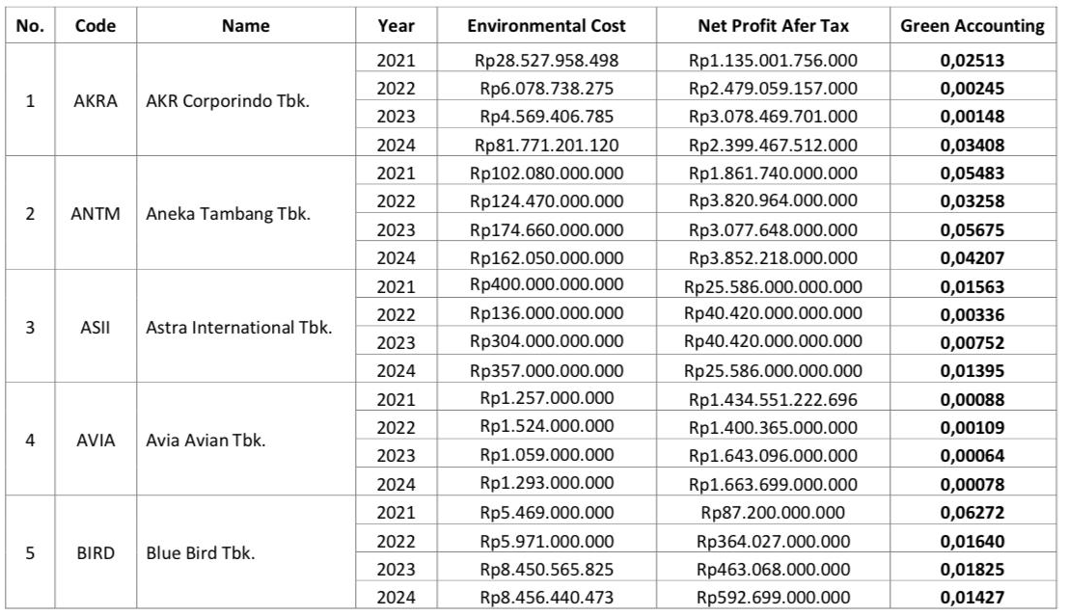
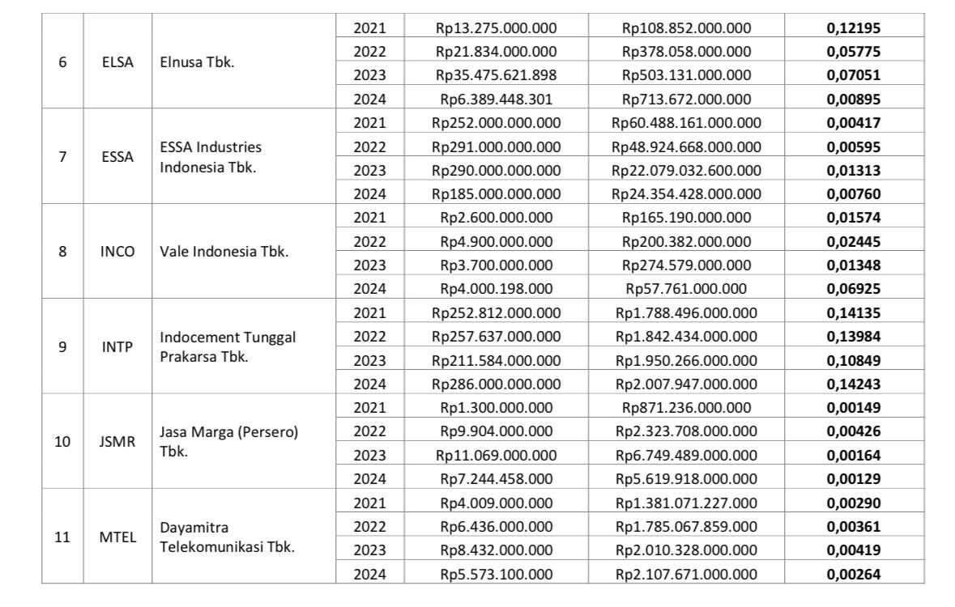
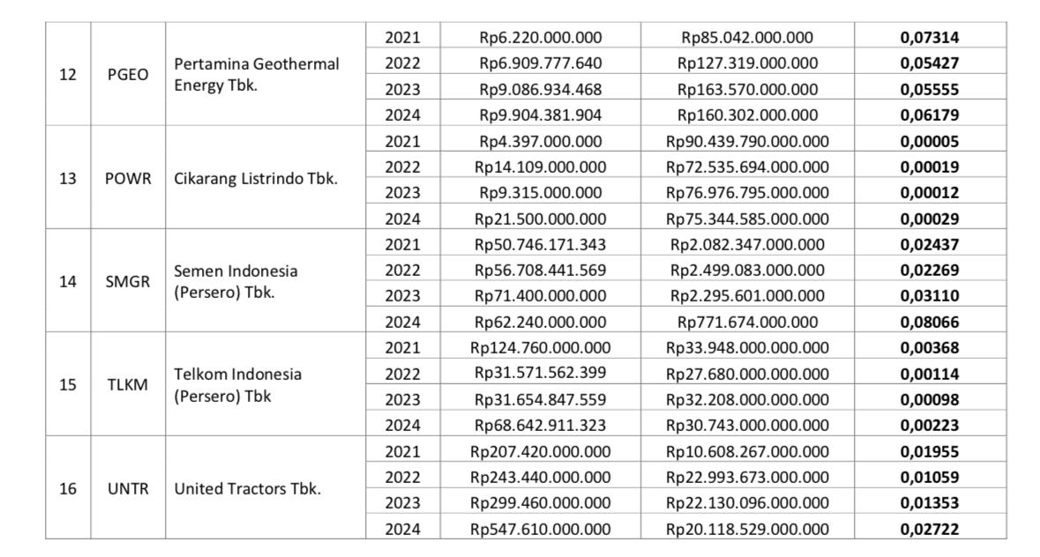

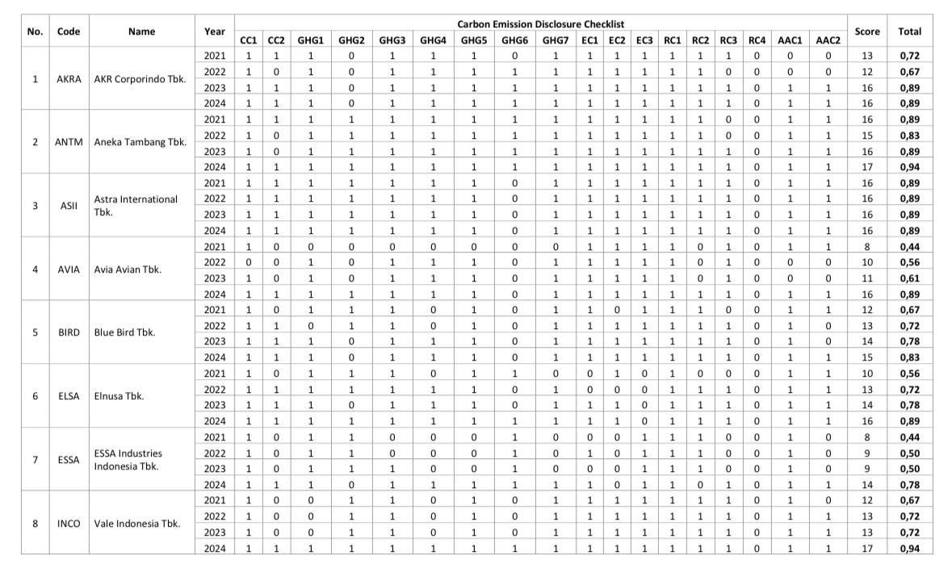
3Appendix 3. Carbon Emission Disclosure Calculation Results
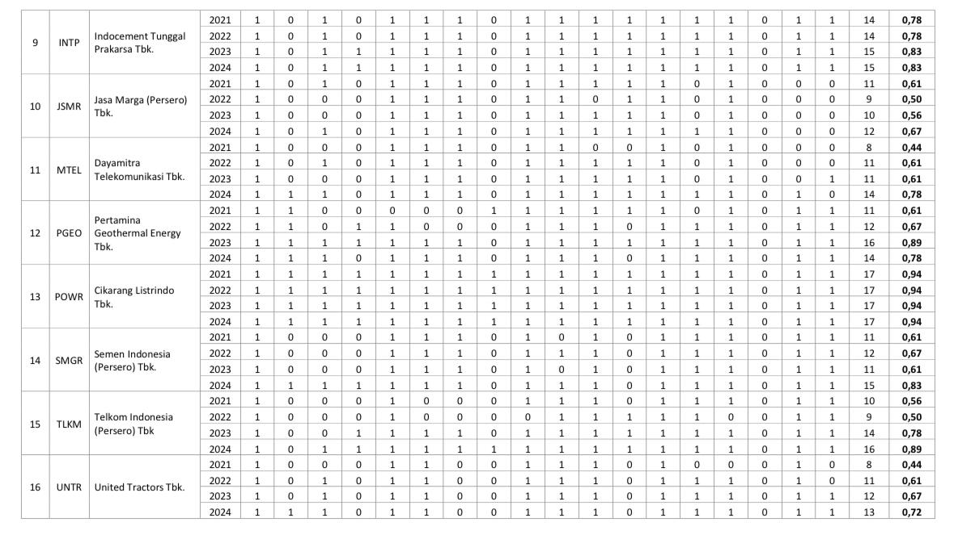

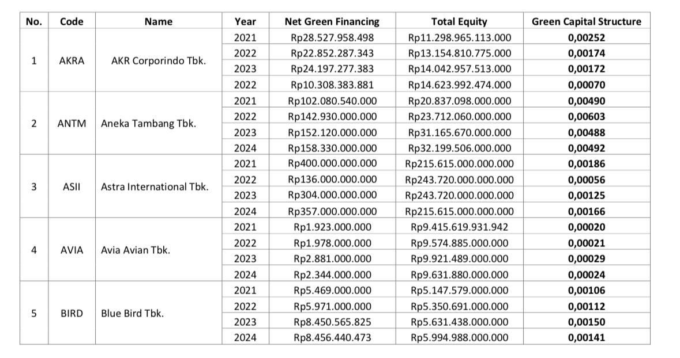
Appendix 4. Green Capital Structure Calculation Results4

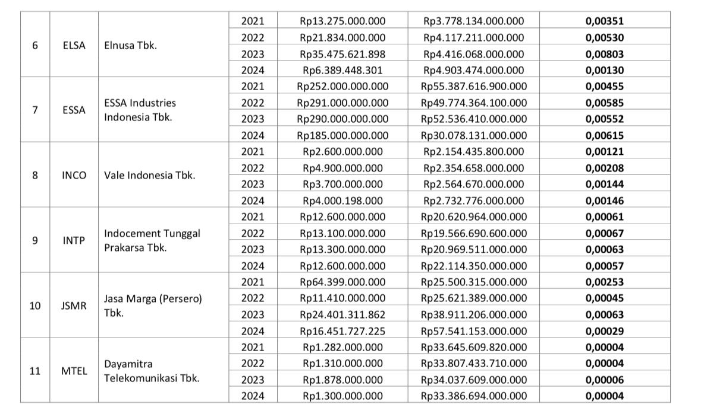
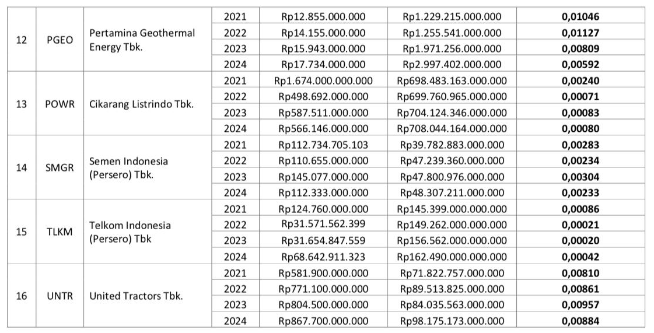

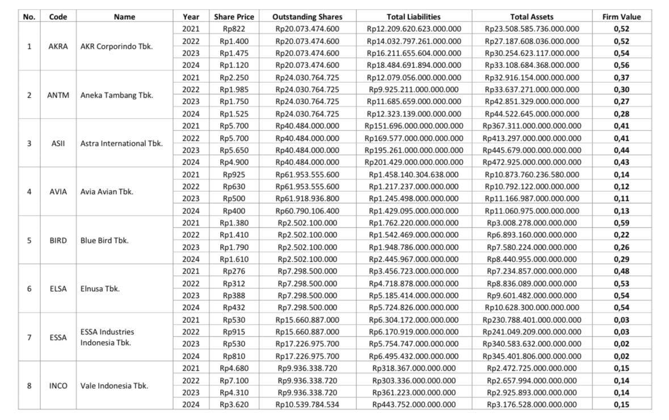
Appendix 5. Firm Value Calculation Results
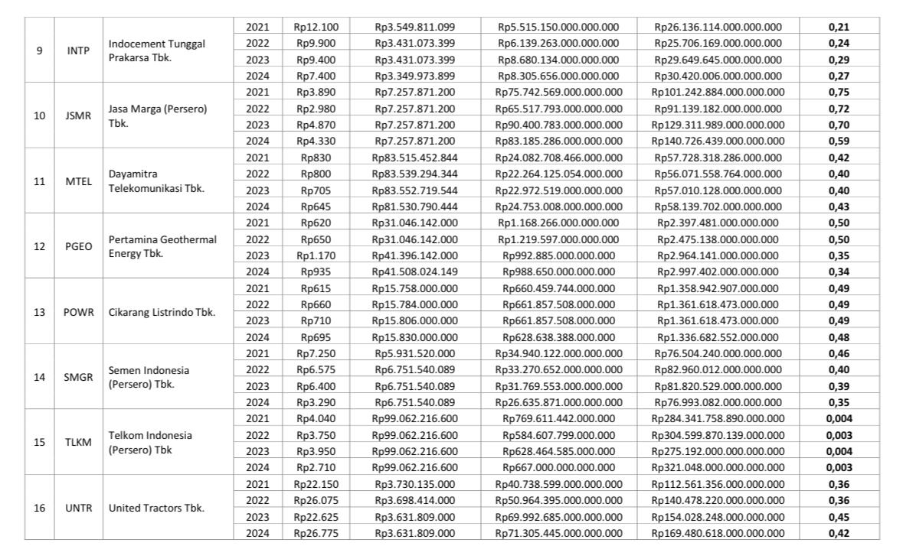
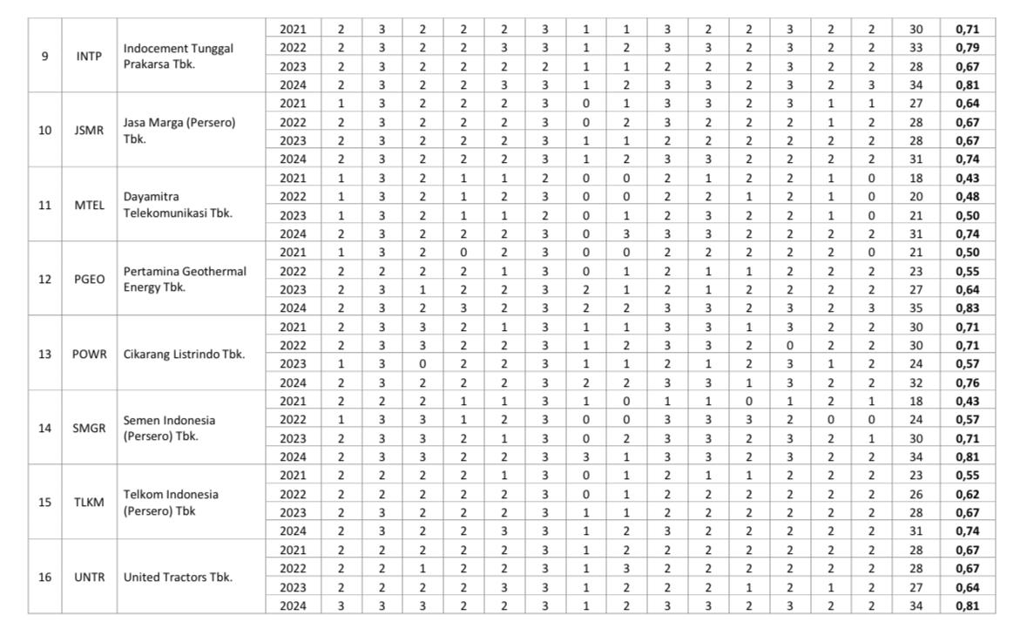
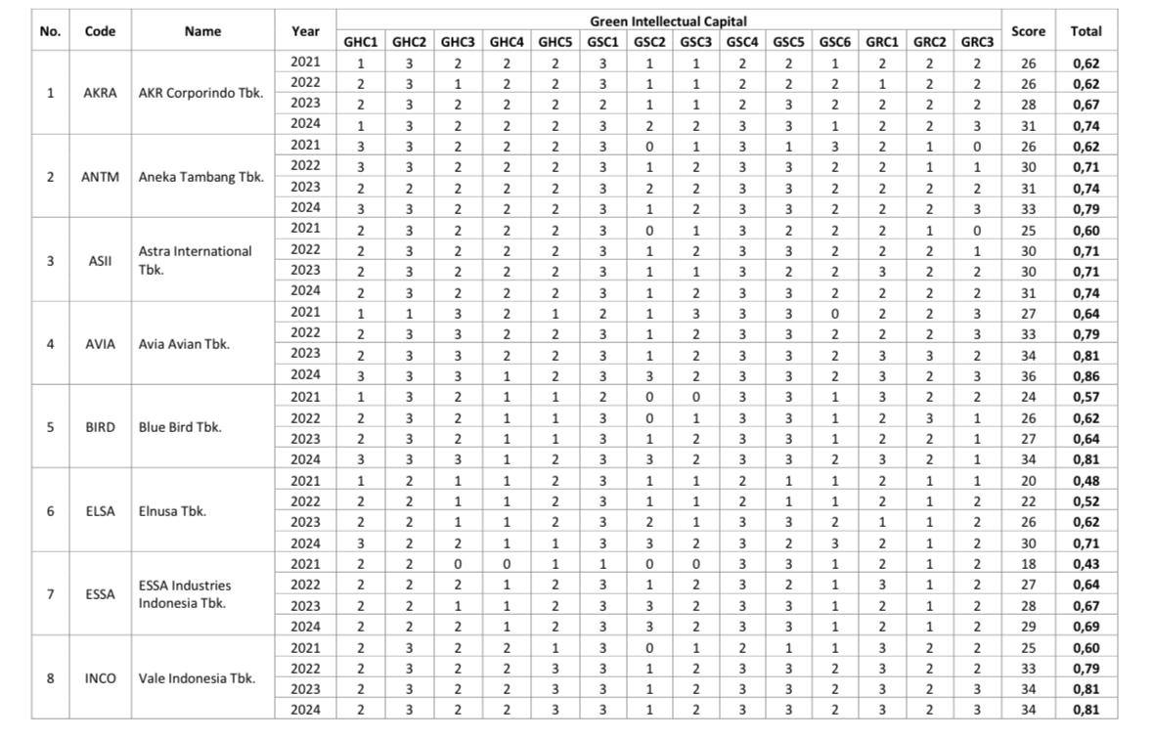
Appendix 6. Green Intellectual Capital Calculation Results
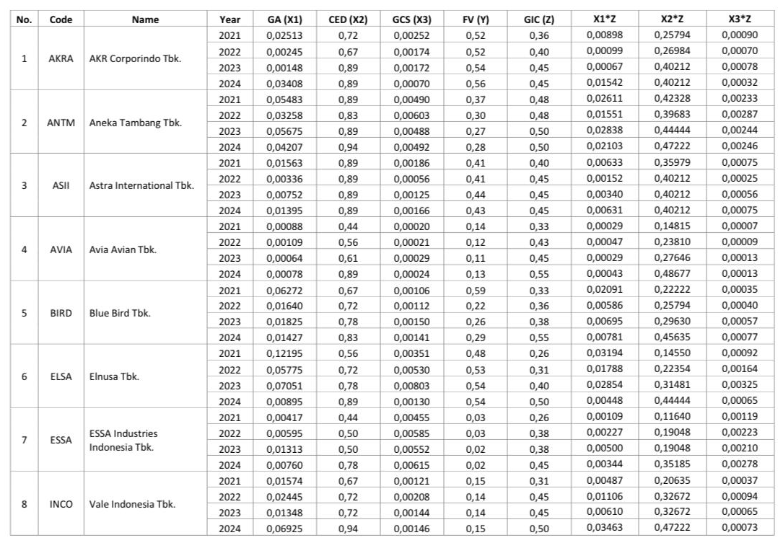
Appendix 7. Data Tabulation
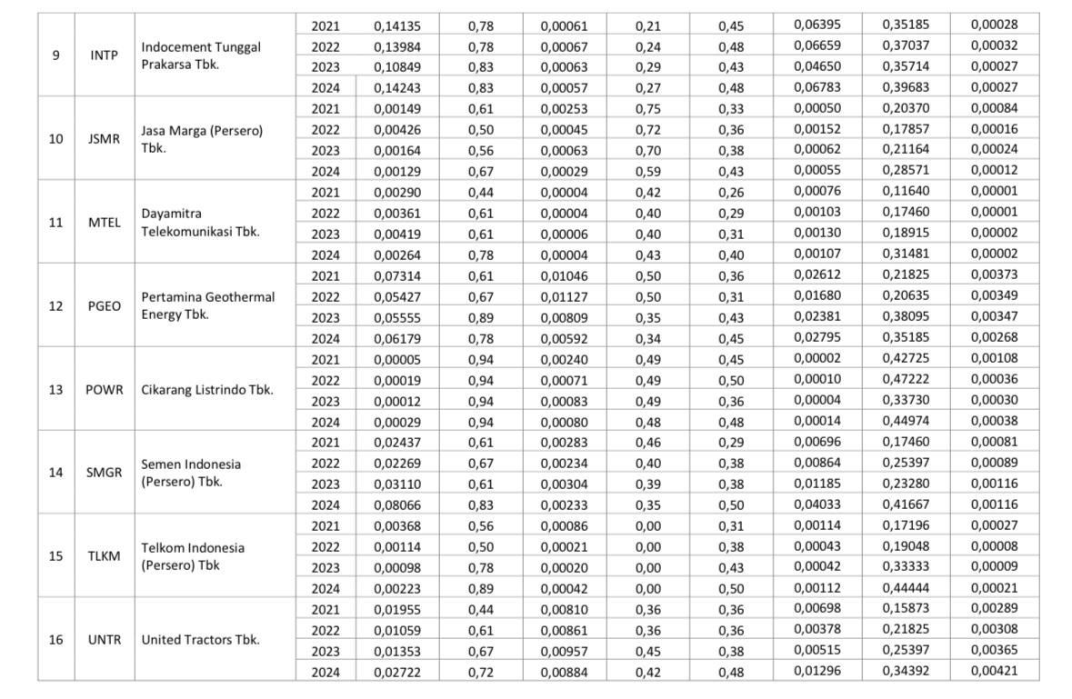
Appendix 8. Descriptive Statistical Test Results9
Descriptive Statistics
 | N | Minimum | Maximum | Mean | Std. Deviation
Green Accounting | 64 | 0.00 | 0.04 | 0.0052 | 0.00637
Carbon Emission Disclosure | 64 | 0.44 | 0.94 | 0.7273 | 0.15168
Green Capital Structure | 64 | 0.00 | 0.00 | 0.0005 | 0.00125
Firm Value | 64 | 0.11 | 0.85 | 0.4380 | 0.16423
Green Intellectual Capital | 64 | 0.43 | 0.86 | 0.6685 | 0.10700
Valid N (listwise) | 64
10

Appendix 9. Normality Test Results
One-Sample Kolmogorov-Smirnov Test
 |  | Unstandardized Residual
N |  | 64
Normal Parameters^{a,b} | Mean | 0.0000000
Normal Parameters^{a,b} | Std. Deviation | 0.09933663
Most Extreme Differences | Absolute | 0.074
Most Extreme Differences | Positive | 0.074
Most Extreme Differences | Negative | -0.061
Test Statistic |  | 0.074
Asymp. Sig. (2-tailed) |  | 0.200^{c}
a. Test distribution is Normal.
b. Calculated from data.
c. Lilliefors Significance Correction.

Appendix 10. Histogram Chart

Appendix 11. Normal Chart of P-Plot

Appendix 12. Multicollinearity Test Results
Coefficientsª
Model |  | Collinearity Statistics
 |  | Tolerance | VIF
1 | Green Accounting | 0.804 | 1.244
1 | Carbon Emission Disclosure | 0.749 | 1.355
1 | Green Capital Structure | 0.802 | 1.248
1 | Green Intellectual Capital | 0.759 | 1.318
a. Dependent Variable: Firm Value

Appendix 13. Heteroskedasticity Test Results

Appendix 14. Autocorrelation Test Results
Model Summary^{b}
Model | R | R Square | Adjusted R Square | Std. Error of the Estimate | Durbin-  Watson
1 | 0.846ª | 0.716 | 0.691 | 0.09162 | 1.655
a. Predictors: (Constant), Green Intellectual Capital, Green Accounting, Carbon Emission disclosure, Green Capital Structure
b. Dependent Variable: Firm Value

Appendix 15. F Test Results (Model Feasibility)
ANOVAª
Model |  | Sum of Squares | Df | Mean Square | F | Sig.
1 | Regression | 1.078 | 4 | 0.269 | 25.567 | <0.001^{b}
1 | Residual | 0.622 | 59 | 0.011
1 | Total | 1.699 | 63
a. Dependent Variable: Firm Value
b. Predictors: (Constant), Green Intellectual Capital, Green Accounting, Carbon Emission Disclosure, Green Capital Structure

Appendix 16. Determination Coefficient Test Results (R²)
Model Summary
Model | R | R Square | Adjusted R Square | Std. Error of the Estimate
1 | 0.846ª | 0.716 | 0.691 | 0.09162
a. Predictors: (Constant), Green Intellectual Capital, Green Accounting, Carbon Emission Disclosure, Green Capital Structure, X1M, X2M, X3M
b. Dependent Variable: Firm Value

Appendix 17. Multiple Linear Regression Analysis Results
Coefficientsª
Model |  | Unstandardized Coefficients |  | Standardized Coefficients
 |  | B | Std. Error | Beta
1 | (Constant) | 0.118 | 0.074
1 | GA | -15.436 | 33.922 | -0.599
1 | CED | 1.044 | 0.252 | 0.964
1 | GCS | 72.341 | 202.116 | 0.555
1 | X1M | 45.058 | 50.509 | 1.177
1 | X2M | -1.075 | 0.305 | -0.991
1 | X3M | -62.230 | 295.648 | -0.328
a. Dependent Variable: Firm Value

Appendix 18. t Test Results (Hypothesis Test)
Coefficientsª
Model |  | Unstandardized Coefficients |  | Standardized Coefficients | t | Sig.
 |  | B | Std. Error | Beta | t | Sig.
1 | (Constant) | 0.248 | 0.075 |  | 3.314 | 0.002
1 | GA | 15.352 | 2.563 | 0.596 | 5.989 | <0.001
1 | CED | 0.129 | 0.098 | 0.119 | 1.321 | 0.191
1 | GCS | 29.999 | 12.988 | 0.230 | 2.310 | 0.024
a. Dependent Variable: Firm Value

Appendix 19. Moderated Regression Analysis Test Results
Coefficientsª
Model |  | Unstandardized Coefficients |  | Standardized Coefficients | t | Sig.
 |  | B | Std. Error | Beta | t | Sig.
1 | (Constant) | 0.118 | 0.074 |  | 1.601 | 0.115
1 | GA | -15.436 | 33.922 | -0.599 | -0.455 | 0.651
1 | CED | 1.044 | 0.252 | 0.964 | 4.146 | <0.001
1 | GCS | 72.341 | 202.116 | 0.555 | 0.358 | 0.722
1 | GIC | 45.058 | 50.509 | 1.177 | 0.892 | 0.376
1 | X1M | -1.075 | 0.305 | -0.991 | -3.531 | <0.001
1 | X2M | -62.230 | 295.648 | -0.328 | -0.210 | 0.834
1 | X3M | 0.118 | 0.074 | -0.599 | 1.601 | 0.115
a. Dependent Variable: Firm Value

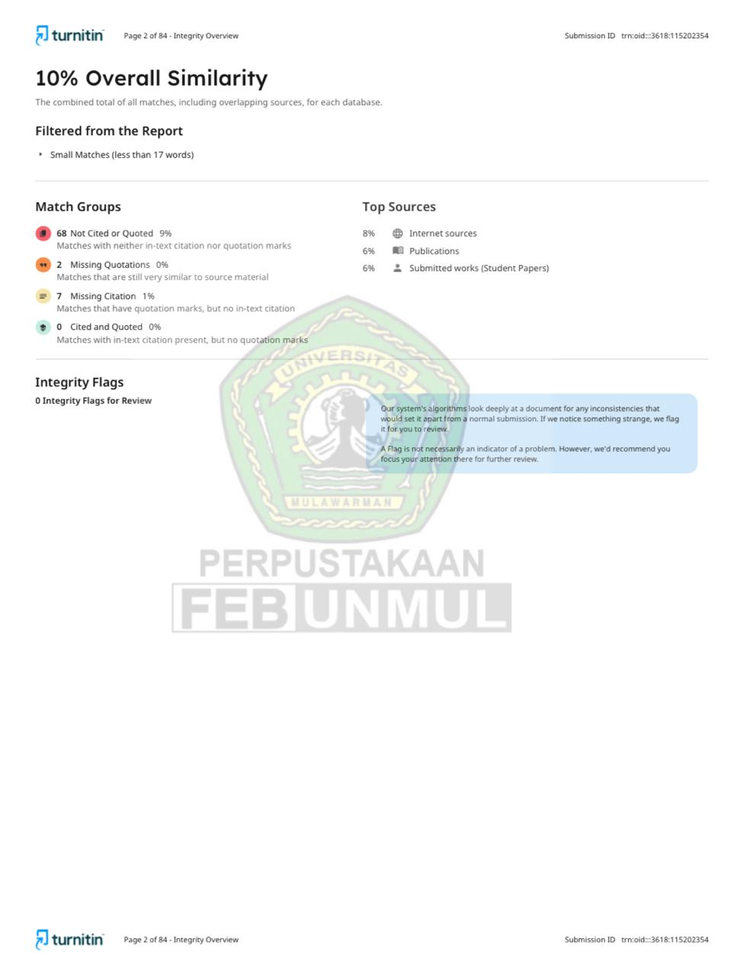
TURNITIN SIMILARITY RESULTS


PROPOSAL SEMINAR CORRECTION SHEET


RESULT SEMINAR CORRECTION SHEET

