PREPARATION OF FINANCIAL STATEMENTS IN COMPLIANCE WITH ISAK 35 OF NURUL ILMI MOSQUE

TITLE
SKRIPSI
UNTUK SEMINAR HASIL



Oleh:
GALVIN YAHYA RUSADI
2201036066
S-1 AKUNTANSI

FAKULTAS EKONOMI DAN BISNIS
UNIVERSITAS MULAWARMAN
SAMARINDA
2026

HALAMAN PENGESAHAN
Judul Penelitian | : | Preparation Of Financial Statements In Compliance With ISAK 35 Of Nurul Ilmi Mosque
Nama Mahasiswa | : | Galvin Yahya Rusadi
NIM | : | 2201036066
Fakultas | : | Ekonomi dan Bisnis
Program Studi | : | S1 – Akuntansi

Diajukan untuk Seminar Hasil

Menyetujui,
Samarinda, 9 Maret 2026
Pembimbing

Dr. Fibriyani Nur Khairin, SE.,M.S.A.,Ak.,CA.,CSP.,CIQaR
NIP. 19850204 200912 2 007

Mengetahui,
Koordinator Program Studi S1 Akuntansi
Fakultas Ekonomi dan Bisnis Universitas Mulawarman

Dr. Fibriyani Nur Khairin, SE.,M.S.A.,Ak.,CA.,CSP.,CIQaR
NIP. 19850204 200912 2 007

ABSTRAK
Galvin Yahya Rusadi, preparation of financial statements in compliance with isak 35 of nurul ilmi mosque. Dibimbing oleh Ibu Fibriyani nur khairin. Penelitian ini bertujuan untuk mengkonstruksi kesesuaian laporan keuangan masjid dengan standar akuntansi yang berlaku, yaitu ISAK 35 tentang penyajian laporan keuangan entitas nonlaba. Penelitian ini dilatarbelakangi oleh masih banyaknya masjid yang menyusun laporan keuangan secara sederhana dan belum mengikuti standar akuntansi yang berlaku. Penelitian ini menggunakan pendekatan kualitatif dengan metode studi kasus. Teknik pengumpulan data dilakukan melalui wawancara dengan pengurus masjid, dokumentasi laporan keuangan yang tersedia, serta observasi terhadap proses pencatatan keuangan yang dilakukan oleh pengelola masjid. Hasil penelitian menunjukkan bahwa pencatatan keuangan Masjid Nurul Ilmi masih berupa catatan sederhana yang hanya mencatat arus kas masuk dan kas keluar tanpa menggunakan akun-akun akuntansi yang sistematis. Selama periode penelitian tercatat sebanyak 984 transaksi yang belum disusun dalam bentuk laporan keuangan sesuai standar. Oleh karena itu, penelitian ini melakukan rekonstruksi laporan keuangan menjadi laporan yang sesuai dengan ISAK 35 yang meliputi laporan posisi keuangan, laporan perubahan aset neto, laporan arus kas, dan catatan atas laporan keuangan.

Kata Kunci: ISAK 35, laporan keuangan masjid, entitas nonlaba, akuntabilitas,

ABSTRACT
Galvin Yahya Rusadi, preparation of financial statements in compliance with ISAK 35 of Nurul Ilmi Mosque. Supervised by Mrs. Fibriyani Nur Khairin. This study aims to construct the conformity of mosque financial statements with applicable accounting standards, namely ISAK 35 concerning the presentation of financial statements of non-profit entities. This study was motivated by the fact that many mosques still prepare financial statements in a simple manner and do not follow applicable accounting standards. This study uses a qualitative approach with a case study method. Data collection techniques were carried out through interviews with mosque administrators, documentation of available financial reports, and observation of the financial recording process carried out by mosque managers. The results of the study show that the financial records of the Nurul Ilmi Mosque are still in the form of simple records that only record cash inflows and outflows without using systematic accounting accounts. During the research period, there were 984 transactions that had not been compiled into financial statements in accordance with standards. Therefore, this study reconstructed the financial statements into statements that comply with ISAK 35, which include a statement of financial position, a statement of changes in net assets, a cash flow statement, and notes to the financial statements.

Keywords: ISAK 35, mosque financial statements, non-profit entities, accountability,

KATA PENGANTAR
Puji Syukur Kehadirat Allah SWT, Tuhan Yang Maha Esa, yang telah memberikan segala karunia dan limpahan rahmatnya, serta junjungan kita Nabi Muhammad SAW sebagai panutan kita, yang akhirnya penulis dapat menyelesaikan skripsi yang berjudul “Pengaruh Intensutas Modal, Profitabilitas dan Leverage terhadap Agresivitas Pajak dengan Ukuran Perusahaan sebagai Variabel Moderasi”. Skripsi ini disusun sebagai suatu persyaratan untuk memperoleh gelar Sarjana pada program studi Akuntansi, Fakultas Ekonomi dan Bisnis Universitas Mulawarman.
Penulis menyadari bahwa selama proses penyusunan skripsi ini tidak dapat diselesaikan tanpa bantuan dan dukungan dari berbagai pihak. Oleh karena itu, penulis menyampaikan terima kasih yang sebesar-besarnya kepada:
- Bapak Prof. Dr. Ir. H. Abdunnur, M.Si., IPU., ASEAN Eng. selaku rektor Universitas Mulawarman.
- Bapak Dr. Zainal Abidin, SE., M.M. selaku Dekan Fakultas Ekonomi dan Bisnis Universitas Mulawarman.
- Ibu Dr. Wulan Iyhig Ratna Sari, SE.,M.Si.,CSP selaku Ketua Jurusan Akuntansi Fakultas Ekonomi dan Bisnis Universitas Mulawarman Samarinda.
- Ibu Dr. Fibriyani Nur Khairin, SE.,M.S.A.,Ak.,CA.,CSP.,CIQaR selaku Koordinator Program Studi Akuntansi Fakultas Ekonomi dan Bisnis Universitas Mulawarman Samarinda. Dan sebagai dosen pembimbing yang telah memberikan banyak bantuan kepada penulis baik dalam bimbingan skripsi maupun diluar bimbingan skripsi selama masa perkuliahan
- Ibu Dr Hj. Yana Ulfah, S.E., M.Si.,Ak. Selaku Dosen Penasehat Akademik yang telah membantu penulis dalam memberikan arahan terkait pembelajaran dan nasehat selama perkuliahan
- Seluruh Dosen Fakultas Ekonomi dan Bisnis Universitas Mulawarman khususnya Dosen pengampu mata kuliah Jurusan Akuntansi selama masa studi penulis yang telah memberikan banyak ilmu dan masukan kepada penulis.
- Seluruh Staf Akademik, Staf Kemahasiswaan dan Staf Jurusan Akuntansi Fakultas Ekonomi dan Bisnis Universitas Mulawarman yang turut membantu dalam proses administrasi selama masa perkuliahan.
- Teristimewa kepada kedua orang tua penulis yaitu Bapak Taram dan Ibu siti Aminah, kedua orang tua yang sangat berjasa dalam hidup penulis, terima kasih telah menjadi orangtua yang selalu memberikan kasih sayang tanpa batas, pengorbanan yang tulus, dan doa yang tak pernah putus. Segala kebaikan dan keteguhan hati yang diberikan menjadi sumber motivasi terbesar bagi penulis.
- Kepada Saudara kandung penulis yaitu Adam, Alm kak upi dan kak Amel yang selalu memberikan banyak dukungan material maupun moral dan nasehat kepada penulis selama menempuh perkuliahan. Ucapan terima kasih juga penulis sampaikan kepada keluarga besar yang senantiasa mendoakan dengan tulus.
- Kepada teman-teman d’ewe yaitu Hasin , Aldo, Boni, Husein dan Yosua yang menemani penulis selama masa perkuliahan dan bertukar pikiran baik tugas maupun hal lain diluar perkuliahan serta memberikan banyak dukungan kepada penulis.
- Kepada teman-teman perkuliahan yaitu Delila, Vera, Dhea, Loma, Denisa, Ikke, Nuril, Ayu, Nadia yang telah menemani, membantu dan mengisi hari-hari penulis selama masa perkuliahan berlangsung.
- Kepada seluruh teman-teman KBI angkatan 2022 yang berbagi semangat selama masa perkuliahan berlangsung.
- Kepada seluruh teman-teman Narsistik saya too hot to handle, terutama nana dan fajrial yang telah menemani kegiatan organisasi dan pertemanan penulis
- Kepada Sherelsa Dayekng yang telah menemani perjalanan penulis dan membantu menjadi pribadi yang lebih baik
Akhir kata penulis menyadari bahwa tidak ada yang sempurna, penulis masih melakukan kesalahan dalam penyusunan skripsi. Oleh karena itu, penulis meminta maaf yang sedalam-dalamnya atas kesalahan yang dilakukan penulis.
Penulis berharap semoga skripsi ini dapat bermanfaat bagi pembaca dan dapat dijadikan referensi demi pengembangan kearah yang lebih baik. Penulis berharap skripsi ini dapat berguna bagi pembacanya.

TABLE OF CONTENTS
TITLE i
HALAMAN PENGESAHAN ii
ABSTRAK iii
ABSTRACT iv
KATA PENGANTAR v
TABLE OF CONTENTS viii
LIST OF TABLES xi
LIST OF FIGURE xii
LIST OF ABBREVIATIONS xiii
TABLE OF APPENDIX xiv
CHAPTER I INTRODUCTION 1
1.1 Background 1
1.2 Problem Formulation 4
1.3 Reseach Objectives 4
1.4 Benefits of Research 4
CHAPTER II LITERATURE REVIEW 6
2.1 Non Profit Organizations 6
2.2 Accountability 7
2.3 Transparency 8
2.4 ISAK 35 9
2.4.1. Statement of financial position 10
2.4.2. Statement of comprehensive income 13
2.4.3. Statement of changes in net assets 16
2.4.4. Statement of cash flow 18
2.4.5. Notes to the financial statements 21
2.5 Previous Research Table 21
2.6 Framework of thinking 23
CHAPTER III METHODOLOGY 24
3.1 Type of Research 24
3.2 Research Focus 25
3.3 Research Informants 25
3.4 Data Collection Techniques 26
3.5 Data Analysis Techniques 27
CHAPTER IV RESULTS AND DISCUSSION 29
4.1 Description of the Financial Report of Nurul Ilmi Mosque 29
4.2 Reconstruction of Financial Reporting 31
4.2.1 Reconstruction of the Entry Journal 31
4.2.2 Preperation Of General Ledger 33
4.2.3 Preparation of the Asset Register 34
4.3 Reconstruction of Financial Statements Based on ISAK 35 37
4.3.1 Comprehensive Income Statement 37
4.3.2 Cash Flow Statement 41
4.3.3 Change in Net Assets Statement 44
4.3.4 Balance Sheet Statement 45
4.3.5 Notes To The Financial Statements 48
CHAPTER V CONCLUTIONS AND SUGGESTIONS 49
5.1 Conclusions 49
5.2 Suggestions 49
5.3 Research Limitations 50
BIBLIOGRAPHY 51
APPENDIX 54

LIST OF TABLES
Table 2. 1 Previous Research 21
Table 3. 1 Research Informant 25

LIST OF FIGURE
Figure 2. 1 Form of Financial Statement Position A 11
Figure 2. 2 Form of Comprehensive Income Statement A 14
Figure 2. 3 Form of Comprehensive Income Statement B 15
Figure 2. 4 Form of changes in net assets statement 17
Figure 2. 5 Form of cash flow statement (direct method) 19
Figure 2. 6 Form of cash flow statement (undirect method) 20
Figure 2. 7 framework of thinking 23
Figure 4. 1 Mosque Financial Report 30
Figure 4. 2 Account Receiveable Adjustment 32
Figure 4. 3 Reconstructed Entry Journal 33
Figure 4. 4 Reconstructed General Ledger 34
Figure 4. 5 Asset List 36
Figure 4. 6 Asset List Per 31 Desember 2024 37
Figure 4. 7 comprehensive income Statement 40
Figure 4. 8 Cash Flow Statement 43
Figure 4. 9 Change in Net Assets Statement 45
Figure 4. 10 Balance Sheet Statement 47

LIST OF ABBREVIATIONS
ISAK 35 Interpretasi Standar Akuntansi Keuangan 35
PSAK 45 Pernyataan Standar Akuntansi Keuangan 45
NPO Non Profit Organizations
DSAK Dewan Standar Akuntansi
IAI Ikatan Akuntan Indonesia

TABLE OF APPENDIX
Appendix 1 Request for financial report data 55
Appendix 2 Mosque financial report 55
Appendix 3 Additional Information About Mosque Financial Report 56
Appendix 4 Preparation of the financial report of the Nurul Ilmi Mosque 56

CHAPTER I
INTRODUCTION

Background
The mosque, called a "masjid" in Arabic, occupies a central place in Islamic civilization. Historically, it has served not only as a place of worship, but also as a hub for community activities, education, political discussions, and social welfare. According to Utaberta et al. (2015), "the mosque served many purposes: it acted as an Islamic community center, a place of worship, a place of political discussion, religious instruction and it was also an educational center". This multi-functionality underscores the essential nature of mosques beyond their religious dimension.
Contemporary mosques continue to play a crucial social role. Research indicates that they serve as vital community centers that support social welfare, promote civic engagement, and foster social cohesion, particularly within Muslim minority communities (Peucker, 2017). However, the civic and educational functions of mosques are not always fully utilized. A study conducted in Sri Lanka by Mim (2018) revealed that in some contexts, mosque engagement in broader community development activities remains minimal, primarily because mosques are perceived narrowly as houses of worship rather than community centers.
Moreover, mosques can be understood as part of the broader public sector, particularly in their role as nonprofit religious organizations serving community needs. As nonprofit entities, mosques manage resources entrusted to them by the public,
Including donations, grants, and other voluntary contributions. According to Dyah Prameswari et al. (2025) mosques operate to achieve specific objectives without the expectation of profit and are responsible for managing resources obtained from the community with sincerity, transparency, and accountability.
Religious organizations such as mosques for Islam use public funds as a source of funding in the form of donations, contributions, and other forms of financial assistance obtained from the public (Asdar et al., 2014). From a managerial perspective, a mosque is a public sector organization that operates as a non-profit entity. It carries out its activities by managing resources that are voluntarily and sincerely contributed by the community, such as zakat, waqf, infaq, and alms (Siskawati et al., 2016). These diverse sources of funding are generally used to finance the mosque's routine operational needs, such as electricity, water, and religious activities, while also serving as a financial resource that can support the development of the mosque's social and religious functions in the community.
Mosques as non-profit organizations often face obstacles in financial reporting practices. Many mosques do not yet have adequate recording systems, so the financial reports they compile tend to be simple and do not meet accounting standards. As shown in research by Siregar et al. (2023), the financial of Al-Ikhlas Mosque still uses simple bookkeeping (only income and expenses) and has not compiled detailed financial reports in accordance with Interpretasi Standar Akuntansi Keuangan (ISAK) 35. Another study in Bengkulu by asmarita et al. (2022) also found that several mosques have not compiled financial reports in accordance with Pernyataan Standar Akuntansi Keuangan (PSAK) No. 45, so their transparency and accountability are still limited. This situation limits the transparency and accountability of fund management, even though congregations and the community have the right to know how the funds they have donated are being used. Research shows that there are still mosques that are unable to present financial reports in accordance with accountability and transparency indicators, so that the information conveyed to congregations is not optimal.
ISAK 35 is an accounting standard that regulates the presentation of financial statements of non-profit entities, including religious organizations such as mosques. ISAK 35 provides guidelines for non-profit entities to prepare financial statements consisting of a statement of financial position, a statement of comprehensive income or statement of activities, a statement of change in assets, a cash flow statement, and notes to the financial statements. The application of ISAK 35 brings various benefits, including increased transparency, accountability, of financial statements.
Since 1997, non-profit organizations have been regulated by PSAK 45. However, starting in 2019, PSAK 45 was replaced by ISAK 35. With the issuance of this new regulation, non-profit organizations prepare their financial statements in accordance with ISAK 35. However, the emergence of this new regulation has been difficult for non-profit organizations to implement because many non-profit organizations do not have a background in accounting, making it difficult to implement (Purba & Siregar, 2021)
The Nurul Ilmi Mosque in Samarinda is an interesting case study in the context of mosque financial reporting, as it currently functions as a center for religious and social activities with complete facilities. The mosque has a representative administrative office, a large parking area that is rented out commercially, and also provides education for children in the form of playgroups. These conditions make fincial reporting at the Nurul Ilmi Mosque increasingly complex, requiring the implementation of transparent and accountable accounting standards. This study focuses on the financial reporting practices of the Nurul Ilmi Mosque in Samarinda and employs a qualitative case study approach to explore accountability and transparency based on ISAK 35 standards.

Problem Formulation
- The mosque's financial statements do not comply with ISAK 35 standards.

Reseach Objectives
- To construct the conformity of mosque financial reports with ISAK 35 standards.

Benefits of Research
In conducting this research, the researcher hopes that it will provide benefits to interested parties, both theoretical and practical benefits:

- Theoretical Benefits
This study is expected to contribute to the development of accounting literature, particularly in the area of non-profit accounting standards. By analyzing mosque financial reporting, this research enriches the understanding of how non-profit entities, especially religious institutions, can apply accounting standards to enhance financial transparency and accountability. Furthermore, the findings may serve as a reference for future studies on the implementation of ISAK 35 in other non-profit organizations.
- Practical Benefits
The results of this study are expected to provide valuable insights for mosque administrators in improving their financial reporting systems. The research can guide mosque accounting process to align their reporting practices with ISAK 35, thereby increasing the trust of congregants and donors. In addition, the findings may also serve as input for regulators and related institutions in promoting the wider adoption of ISAK 35 within religious organizations, ultimately supporting better governance and accountability in managing public funds.

CHAPTER II
LITERATURE REVIEW
- Non Profit Organizations
Non-profit organizations (npos) are entities whose existence is aimed at carrying out social missions and serving the community, not at making a profit. Therefore, the success of an NPO is not measured by the amount of financial profit, but by the extent to which the organization is able to achieve its social goals. The sustainability and legitimacy of npos are highly dependent on the level of accountability and transparency demonstrated in financial reporting practices, especially in financial reporting Ortega-Rodríguez et al. (2020), through a systematic literature review, emphasize that transparency is an essential element in the accountability of non-profit organizations. Transparency is seen as the foundation for building public trust and an important instrument for supporting the achievement of sustainable development goals, including efforts to prevent corruption and improve organizational governance. Dewan Standar Akuntansi Keuangan Ikatan Akuntan Indonesia (DSAK IAI) considers that the main difference between non-profit entities and profit-oriented business entities is the way non-profit entities obtain resources from resource providers who do not expect repayment or economic benefits comparable to the amount of resources provided.
Mosque accounting is a systematic process of recording and managing a mosque's financial activities. Guided by established principles and standards, it ensures the production of accurate and reliable financial information for the organization. According to Ibrahim (2018) The accounting practices for religious organizations, including mosques, are fundamentally designed to serve their congregation. This "public" comprises the members and followers of the faith. For a mosque, this means its accounting is accountable to the global Muslim community in a broad sense, and more directly to the local community it serves.
- Accountability
Accountability means responsibility or a state that must be accounted for. Public accountability is the obligation of the trustee (agent) to provide accountability, present, report, and disclose all activities and actions that are his responsibility to the principal who has the right and authority to request such accountability (Mardiasmo, 2021). According to Damin & Mustaqim (2021) Accountability is defined as the responsibility to manage resources and carry out the activities of a reporting entity that has been entrusted with these tasks, in order to achieve the predetermined objectives within a specific period.
Accountability is fundamental concepts that are key requirements in public sector financial accounting process, including in the application of reporting standards such as ISAK 35. Accountability is generally understood as an organization's obligation to be responsible for its actions and use of managed resources, as well as being able to explain its performance to interested parties (Wicaksono, 2021) Furthermore, accountability not only functions as a control mechanism, but also as a means of measuring the effectiveness and efficiency of an organization's performance so that the results of financial reporting can be accounted for objectively and transparently.
- Transparency
Transparency can also be defined as openness. According to (Mardiasmo, 2021) transparency is built upon the principle of freedom to access information, particularly information related to public interests that should be readily available to those who need it. In the context of financial reporting, transparency enables mosque administrators to provide clear and accessible information, thereby fostering public trust and encouraging the community to continue contributing funds for the mosque’s activities.
Transparency is a crucial aspect in building effective accountability, especially in public financial reporting. The principle of transparency requires organizations to provide easy, honest, and complete access to information related to financial implementation, and accountability (Amalia, 2021). Information that is open and accessible to the public and other stakeholders encourages increased public trust and participation in the oversight of financial management, thereby minimizing the risk of budget misuse (Rusrina, 2021). In addition, transparency also serves as a tool to prevent corruption by increasing the risks and penalties for irresponsible actors, while strengthening the norms of integrity in government administration.
- ISAK 35
ISAK 35 regulates the presentation of financial statements of non-profit entities. ISAK 35, issued by Dewan Standar Akuntansi Keuangan Ikatan Akuntan Indonesia (DSAK IAI), is an interpretation of PSAK 1: Presentation of Financial Statements paragraph 05, which provides examples of how non-profit entities make adjustments to: (i) the descriptions used for certain items in the financial statements; and (ii) the descriptions used for the financial statements themselves. ISAK 35 is supplemented with illustrative examples and a basis for conclusions that are not part of ISAK 35.
In ISAK 35, a non-profit organization needs to prepare at least five types of financial statements, including a statement of financial position, a statement of comprehensive income, a statement of changes in net assets, a cash flow statement, and notes to the financial statements (CALK). The following are the types of financial statements for non-profit organizations that comply with ISAK 35 accounting standards (Ikatan Akuntan Indonesia, 2018). The following is the financial statement format for non-profit entities according to ISAK 35:
- Statement of financial position
The purpose of a financial position report is to provide information about assets, liabilities, and net assets, as well as to understand the relationship between these elements at a given time. The financial position report, including notes to the financial statements, provides relevant information regarding liquidity, financial flexibility, and the relationship between assets and liabilities. The financial position report covers the organization as a whole and must present total assets, liabilities, and net assets. There are two formats of Financial Position Reports presented as examples in this appendix. Each format has its own advantages.
- Format A presents other comprehensive income information separately as part of net assets without restrictions from resource providers. However, if other comprehensive income arises from restricted net assets, then the entity presents that other comprehensive income information according to the class of its net assets.
- Format B does not present other comprehensive income items separately.
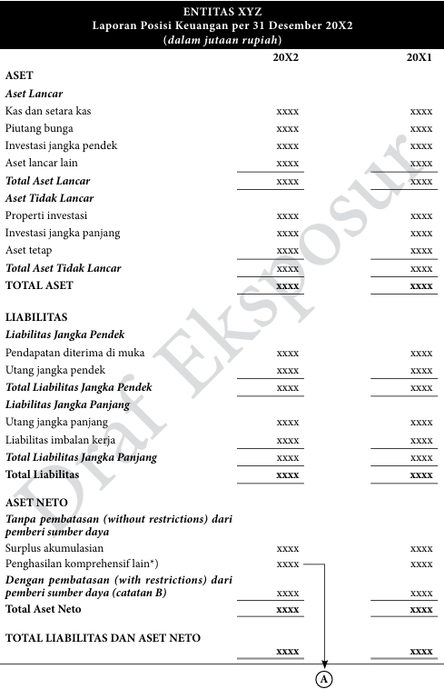
Figure 2. 1 Form of Financial Statement Position A
Source: SAK IAI ONLINE (ISAK 35)
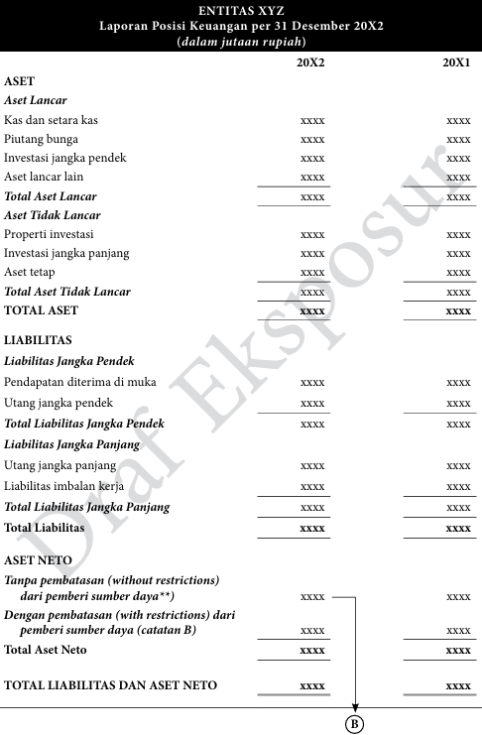
Figure 2. 2 Form of Statement of Financial Position B
Source: SAK IAI ONLINE (ISAK 35
- Statement of comprehensive income
A comprehensive income statement is a financial statement of a non-profit entity that presents all income, expenses, and changes in net assets, both with and without restrictions from resource providers. This statement provides a comprehensive overview of the organization's financial performance, including other comprehensive income, if any, so that transparency and accountability in resource management can be achieved. There are two formats for the Comprehensive Income Statement presented as examples in this appendix. Each format has its own advantages.
- Format A presents information in a single column. Format A facilitates the preparation of comparative reports; or
- Format B presents information in accordance with the classification of net assets.
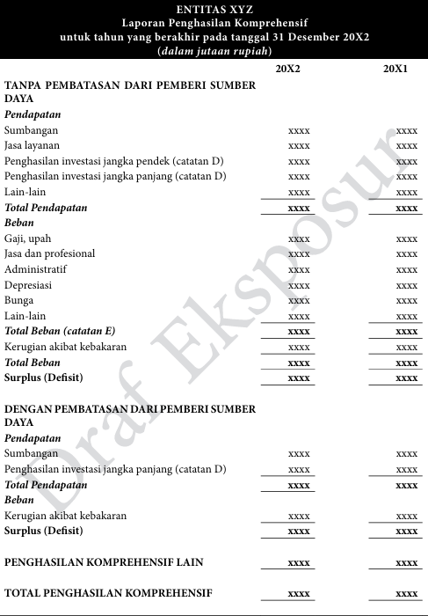
Figure 2. 2 Form of Comprehensive Income Statement A
Source: SAK IAI ONLINE (ISAK 35)
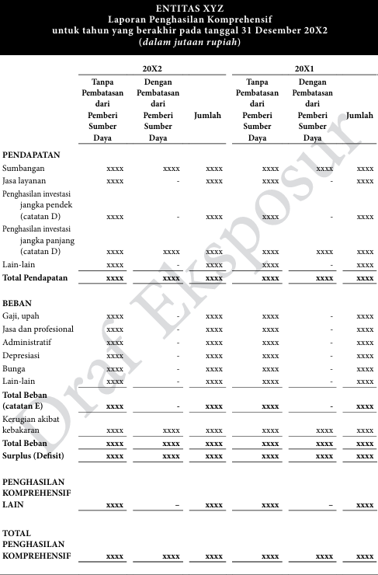
Figure 2. 3 Form of Comprehensive Income Statement B
Source: SAK IAI ONLINE (ISAK 35)
- Statement of changes in net assets
The statement of changes in net assets presents the movements in a nonprofit entity’s net assets during a reporting period. It explains how the balance of resources increases or decreases as a result of operational performance and other financial events. Changes in net assets may arise from a surplus or deficit reported in the statement of comprehensive income, the receipt of donor-restricted contributions, the release of restrictions when specified conditions have been fulfilled, and other adjustments such as gains or losses recognized directly in net assets. This statement provides a structured overview of how financial activities affect the organization’s overall resource position.
Net assets themselves represent the residual interest in the assets of a nonprofit entity after deducting liabilities. In nonprofit organizations, net assets function similarly to equity in for-profit entities, as they reflect the accumulated resources available to support the entity’s mission and programs. In accordance with applicable accounting standards, net assets are classified into net assets without donor restrictions and net assets with donor restrictions. This distinction is essential because certain resources may only be used for specific purposes or within specific timeframes as determined by donors. The classification ensures transparency in demonstrating how funds are managed and whether the organization complies with imposed limitations.

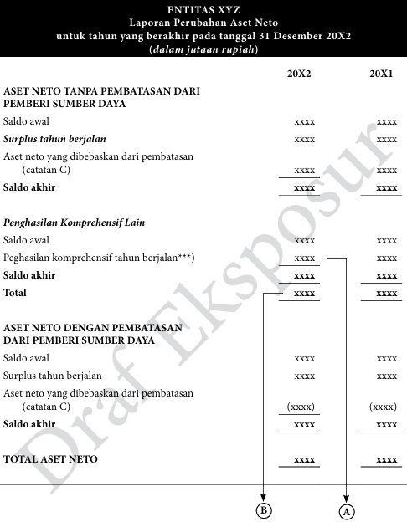
Figure 2. 4 Form of changes in net assets statement
Source: SAK IAI ONLINE (ISAK 35)

- Statement of cash flow
The The cash flow statement presents information about the cash receipts and cash disbursements of a nonprofit entity during a reporting period. It is classified into three categories: operating, investing, and financing activities. The primary objective of this statement is to explain how an organization generates and uses cash, enabling stakeholders to evaluate liquidity, financial flexibility, and the entity’s capacity to sustain its operations.
Operating activities include the principal revenue-generating activities of the organization and other activities not classified as investing or financing. In nonprofit entities, this generally consists of cash received from donations, grants, and program-related revenues, as well as cash payments for operational expenses such as utilities, maintenance, and other routine costs. This section indicates whether daily operations are capable of generating sufficient cash without relying on external support.
Investing activities involve the acquisition and disposal of long-term assets and other non-current investments, such as property and equipment. These activities reflect the organization’s efforts to maintain or expand its operational capacity in support of its mission.
Financing activities relate to transactions that affect borrowings and net assets, including loan proceeds, debt repayments, and donor-restricted contributions for long-term purposes. This section shows how the organization finances its broader strategic and operational needs.
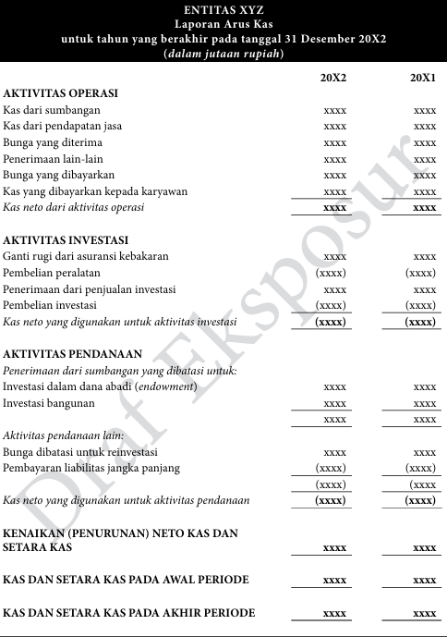
Figure 2. 5 Form of cash flow statement (direct method)
Source: SAK IAI ONLINE (ISAK 35)
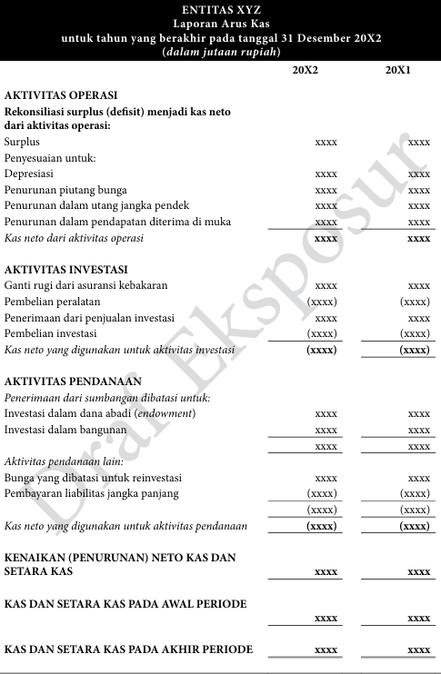
Figure 2. 6 Form of cash flow statement (undirect method)
Source: SAK IAI ONLINE (ISAK 35)
- Notes to the financial statements
Notes to the financial statements are an integral part of the above reports. They are intended to provide additional information about the estimates stated in the financial statements . These notes to the financial statements are details of an estimate presented, such as fixed assets. Notes to the financial statements provide details of the names of assets, liabilities, and net assets. For example, for fixed assets, the notes to the financial statements will explain how to calculate the depreciation of fixed assets, as well as other accounting policies used by the entity.
- Previous Research Table
Table 2. 1 Previous Research
No | Researcher Name | Research Title | Research Methodology | Research Result
1 | Dwikasmanto (2020) | Penyusunan laporan keuangan masjid nurul iman al-hidayah desa barumanis berdasarkan isak 35 | Qualitative | The results of this study can be concluded that the preparation of financial statements for the Nurul Iman Al-Hidayah Mosque in Barumanis Village has not been based on ISAK 35 regarding the presentation of financial statements for non-profit entities.
2 | Octisari et al. (2021) | Akuntabilitas Masjid Berdasarkan Isak 35 di Wilayah Kecamatan Kedungbanteng, Kabupaten Banyumas | Qualitative descriptive | The mosque administrators in the Kedungbanteng subdistrict have managed the mosque's finances in an accountable manner in accordance with the specified criteria. Record keeping is done well, although it is still simple.
3 | Alfarizi et al. (2024) | Analisis Penerapan ISAK 35 tentang Penyajian Laporan Keuangan Entitas Berorientasi Nonlaba | Qualitative descriptive | Of the five ISAK 35 structures, only three have been prepared in accordance with ISAK 35, namely the statement of financial position, the statement of comprehensive income, and the notes to the financial statements.
4 | Darojatul Ula et al. (2021) | Penerapan isak 35 pada masjid baitul hidayah puger jember | Qualitative | The basis of recording applied at the Baitul Hidayah Puger Mosque was incomplete and not sequential according to applicable standards. The financial statements that made a report, a report on changes in net assets, a cash flow statements and notes on financial statements
5 | Purba & Siregar (2021) | Penyajian Laporan Keuangan Entitas Berorientasi Non Laba Berdasarkan ISAK 35 Pada Gereja HKBP Km 55 | Qualitative | The financial statements of HKBP KM 55 Church are prepared in accordance with ISAK 35, covering comprehensive income statements, financial position, cash flow, and notes. In January 2020, there was a decrease in net assets of IDR 3,006,500. The total financial position reached IDR 12.31 billion with a closing cash balance of IDR 1.2 billion.
6 | Novita Alaika Sari et al. (2022) | Akuntabilitas Dan Transparansi Laporan Keuangan Pada Masjid Sabilillah Di Kota Malang Berdasarkan ISAK 35 | Qualitative | The Sabilillah Mosque has implemented several forms of accountability and transparency, ranging from planning and implementation to financial accountability, which have been carried out openly in front of the congregation and leaders. However, the financial reports are still not based on ISAK 35 and still refer to the old standards.
7 | Juniaswati & Murdiansyah (2022) | Akuntabilitas Pengelolaan Keuangan Masjid Sabilillah Kota Malang Berdasarkan ISAK 35 | qualitative | Sabilillah Mosque Malang has implemented accountability indicators but is not yet accountable because the financial statements of the Sabilillah Mosque Malang have not implemented ISAK 35. Meanwhile, transparency has not been fully implemented because it has not complied with Law No. 28 of 2004.
8 | Simbolon & Purba (2022) | Application of ISAK 35 Concerning Financial Statements of Non-Profit Organizations at the HKBP Bolon Pangururan Church | qualitative | The financial statements of HKBP Bolon are limited to income and expenditure reports, which do not comply with current standards, particularly ISAK 35. This study concludes that HKBP Bolon has not yet structured its financial reporting in line with the applicable standards, especially ISAK 35.
9 | (Saiffuddin, 2020) | Akuntabilitas dan transparansi keuangan masjid berdasarkan psak no.45 tentang pelaporan organisasi | qualitative | it was proven that the mosque had managed its finance accountably. In other words, there was financial statement book-keeping. In addition, the financial statement was reported well and in had successfully increased society on mosque financial statement report.

- Framework of thinking
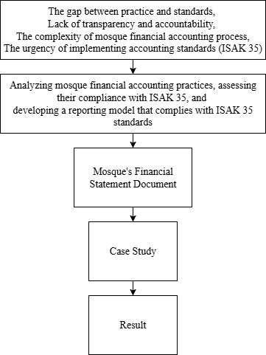
Figure 2. 7 framework of thinking

CHAPTER III
METHODOLOGY
- taType of Research
This research employs a qualitative approach with a case study method. A qualitative approach is used because this study seeks to explore and understand the financial reporting practices of mosques in their real life context.
The case study design was chosen because it allows researchers to conduct an in-depth investigation of a single unit of analysis, namely the financial reporting practices at the Nurul Ilmi Mosque in Samarinda. According to Creswell (2013) a case study is an approach in which the researcher explores a real-life, contemporary bounded system through detailed, in-depth data collection involving multiple sources of information. By applying this approach, the study can comprehensively capture how the mosque implements financial reporting and to what extent these reports conform to ISAK 35 standards.
Thus, the use of a qualitative case study provides a suitable framework to analyze the financial reporting practices of the mosque

- Research Focus
The focus of this research is on the financial accounting practices of mosques, with special attention to their conformity with ISAK 35 as an accounting standard for non-profit entities.
- Research Informants
This study involves 1 informants who are critical to understanding the financial statement practices system at Nurul Ilmi Mosque,. The informants were selected due to their direct involvement in the mosque's preparation of financial reports and governance, providing essential insights into the financial statement practices.
Table 3. 1 Research Informant
No | Subject | Reason
1 | The Mosque Treasurer | The Mosque Treasurer was selected as an informant due to their direct responsibility for managing the mosque's financial resources. As the person in charge of overseeing the mosque’s financial transactions, the Treasurer has valuable insights into the financial reporting statement

- Data Collection Techniques
To gather relevant data for this study, several techniques will be employed to ensure comprehensive insights into the financial statement at Nurul Ilmi Mosque. The primary methods of data collection will include interviews, document analysis, and observation. These techniques will provide both qualitative and contextual data that will contribute to understanding of the mosque’s financial statement:
- Interviews
In this interview technique, researchers conduct interviews using a non-structured method, which allows for more freedom in its implementation. The purpose of this interview is to discover more open issues about the financial reporting.
- Document Analysis
Document analysis focuses on existing mosque financial reports, such as cash receipts and expenditure records, monthly/annual reports, transaction evidence, and other supporting documents. This technique helps researchers understand the current reporting format and identify gaps between actual reports and the provisions contained in ISAK 35.
- Observation
The observation technique is a careful and statistical direct observation of existing activities to obtain results in line with the objectives. In this study, the author observed several things related to financial reports, such as income
obtained from zakat, infaq, sodakoh, and funds from parties who provide donations.
- Data Analysis Techniques
This study employed a thematic analysis approach to interpret the data. Thematic analysis is a qualitative method used to discover, examine, and present recurring patterns or themes within the data. According to Miles & Huberman (1994), the thematic analysis process consists of the following steps:
- Data Reduction
The data will be transcribed, coded, and organized to focus on key themes relevant to the research questions. Unnecessary data will be filtered out, and key concepts related to financial statement will be identified.
- Data Presentation
Data presentation involves organizing and presenting the reduced data in an accessible form so that relationships and patterns can be easily understood. The data will be presented in the form of narrative descriptions, tables, and comparative matrices. For example, the existing financial statements of the mosque will be compared with the requirements outlined in ISAK 35.
- Conclusion Drawing
The final stage consists of drawing conclusions and verifying them continuously throughout the research process. Conclusions will be formulated based on the interpretation of the data presented, and verification will be conducted through cross-checking among the different sources of evidence (interviews, documents, and observations). This iterative process ensures the validity and reliability of the findings. Ultimately, the analysis will lead to a reconstructed model of the mosque’s financial statements in accordance with ISAK 35, highlighting its implications for transparency and accountability.

CHAPTER IV
RESULTS AND DISCUSSION
- Description of the Financial Report of Nurul Ilmi Mosque
Based on observations and documentation, the financial recording system at Nurul Ilmi Mosque still uses a very simple method. All transactions are recorded by the mosque treasurer in the form of cash inflows and outflows, without the use of accounting accounts as required in financial reporting standards for non-profit entities.
During the 2024 period, there were 984 transactions recorded in one year, consisting of various routine mosque receipts and expenditures. All transactions were recorded in an Excel file using simple addition and subtraction formulas. Each transaction was only given a brief description such as “air minum,” “khotib jumat,” or “honor ustad,” without account classification or category separation.
Mosque expenditures were made even when the available cash balance was insufficient. In practice, these expenditures were temporarily financed using the personal funds of the treasurer. When subsequent cash receipts were received and exceeded the required amount, the mosque reimbursed the treasurer in full.
This recording model basically only produces information about cash movements, not a complete financial report. There is no accrual-based recording, and no separation between net assets with restrictions and without restrictions. Thus, although the treasurer's records are helpful in monitoring daily cash flow, this form of recording does not yet meet the reporting elements recommended by ISAK 35.
Figure 4. 1 Mosque Financial Report
Source: Treasurer's Notes Of Nurul Ilmi Mosque

- Reconstruction of Financial Reporting
The financial records of the Nurul Ilmi Mosque during the research period only took the form of a list of cash inflows and outflows without the use of accounting accounts. The records contained a total of 984 transactions, all of which were recorded by the mosque treasurer using Microsoft Excel with simple addition and subtraction formulas. Given these limitations, a reconstruction process was carried out to convert the simple cash records into accounting records.
- Reconstruction of the Entry Journal
In the original recording system, financial transactions were documented solely in the form of cash receipts and cash disbursements accompanied by brief narrative descriptions. These records did not distinguish between income, expense, asset, or net asset accounts, nor did they apply systematic debit and credit classifications.
The reconstruction process involved converting each transaction into a general journal entry by assigning appropriate account titles, determining the correct debit and credit positions, and ensuring that each entry adhered to the dual-entry accounting system. This process also required interpreting transaction descriptions provided by the treasurer to determine the appropriate classification, especially in cases where the original descriptions were minimal or ambiguous.
During the journal reconstruction process, several transactions resulted in a negative cash balance when recorded solely based on cash inflows and outflows. A negative cash balance is not acceptable under accounting principles because cash represents an asset that cannot have a credit balance under normal conditions. Therefore, adjustments were required to reflect the actual financial position more appropriately.
To address this issue, an accounts payable (liability) account was introduced in the reconstructed journal entries. The negative cash balance indicates that certain expenditures were incurred before sufficient cash was available, implying the existence of unpaid obligations at the time of transaction. By recognizing accounts payable, the cash balance is maintained at a non-negative amount, while the corresponding liability reflects the mosque’s obligation to settle these expenditures in the future.
Figure 4. 2 Account Receiveable Adjustment
Figure 4. 3 Reconstructed Entry Journal
- Preperation Of General Ledger
The ledger serves to group all financial transactions based on their respective accounts so that the ending balance of each account for a given period can be determined. The ledger is prepared by transferring (posting) all transactions that have been reconstructed in the entry journal to the appropriate accounts. Each account in the ledger reflects the accumulation of debit and credit transactions originating from the entry journal
The ledger is compiled by grouping transactions based on accounts and summarized in the form of the closing balance of each account. The presentation of the ledger in this thesis uses a summary format to facilitate reading and analysis.
Figure 4. 4 Reconstructed General Ledger
- Preparation of the Asset Register
Nurul Ilmi Mosque previously did not maintain a systematic fixed asset register. The assets owned by the mosque, including worship equipment, operational tools, and vehicles, were acquired through purchases and donations; however, they were not recorded in a structured manner. This condition resulted in the absence of reliable information regarding the quantity, value, and condition of the assets owned. Furthermore, several donated assets did not have identifiable acquisition values due to the lack of supporting documentation at the time the assets were received. The absence of an asset register consequently led to the inability to calculate depreciation and prevented the proper presentation of asset values in the statement of financial position.
Based on this condition, the preparation of an asset register was carried out as part of the effort to improve the financial reporting process. The preparation process involved physical identification of assets located within the mosque and tracing purchase transactions recorded in previous financial reports. For assets acquired through purchase, acquisition costs were determined based on the amounts recorded at the time of transaction. Meanwhile, for donated assets whose acquisition values were unknown, fair value estimation was conducted by comparing prices of similar items in comparable condition through online platforms such as Facebook Marketplace and Google Shopping. This approach was applied to obtain a reasonable and market-based valuation estimate.
The asset register prepared includes information on asset name, quantity, year of acquisition, source of acquisition, estimated useful life, and acquisition cost or fair value. Based on the identification and valuation process, the total recorded value of the mosque’s assets amounted to Rp196,899,700.
Figure 4. 5 Asset List
Subsequently, the estimated useful life of each asset was determined based on its characteristics and usage pattern within mosque operations. The depreciation method applied is the straight-line method, which allocates depreciation expense evenly over the useful life of the asset. Depreciation was calculated up to December 31, 2024, resulting in a carrying amount of Rp186,118,133 after accumulated depreciation.
Figure 4. 6 Asset List Per 31 Desember 2024
- Reconstruction of Financial Statements Based on ISAK 35
The reconstruction aims to transform the simple cash recording system previously used by mosque administrators into financial reports that are systematically organized, structured, and in accordance with non-profit entity accounting standards. ISAK 35 requires that non-profit entities, including mosques as religious organizations, prepare financial reports that reflect their financial position, financial performance, and changes in net assets during the current period.
- Comprehensive Income Statement
Nurul Ilmi Mosque received unrestricted income from resource providers amounting to Rp 310,978,540. This income consisted of donations, parking fees, and zakat (alms). In the financial records compiled by the mosque treasurer, this income was not accompanied by any specific information or indication regarding restrictions on the use of funds by resource providers. Therefore, all of this income is classified as unrestricted income, in accordance with (ISAK 35), which states that an entity presents grants or endowments in the form of land, buildings, and equipment as unrestricted contributions, unless there are restrictions that explicitly state the purpose of the utilization of the assets or the use of future economic benefits obtained from the assets from the resource providers.
The unrestricted expenses presented in the comprehensive income statement represent all operating expenses of the Nurul Ilmi Mosque during 2024. These expenses include water, electricity, consumption, ustad honoraria, lectures, marbot, Friday prayers, depriciation expense and other operating expenses that support the mosque's worship and social activities. All of these expenses are classified as unrestricted expenses because the funds come from unrestricted income. The total unrestricted expenses for the current year are Rp310.964.539, which indicates that the mosque's operating expenses exceed the unrestricted income received during the same period.
Nurul Ilmi Mosque also receives restricted income from resource providers amounting to Rp 3.889.000. This income is identified from the treasurer's financial records, which explicitly state the purpose of the funds, such as donations for curtains, donations for partitions, and donations for people. This information indicates that there are restrictions from resource providers regarding the purpose of the funds, so that in accordance with (ISAK 35), the Entity presents grants or waqf, in the form of cash or other assets, as contributions with restrictions, if the grants or waqf are received with restrictions on the use of assets or on the future economic benefits obtained from these assets.
Expenses with restrictions from resource providers are expenses deducted from income received with those restrictions. In the treasurer's financial records, clearly identifiable expenses are those related to the cost of constructing partitions. Therefore, the depriciation expense of Rp 590.000 is classified as an expense with restrictions.
Based on the comprehensive income statement calculations, Nurul Ilmi Mosque experienced a Surplus in unrestricted activities of Rp 14.001 while restricted activities generated a surplus of Rp 3.229.000 Thus, the mosque's total comprehensive income for the current year shows a surplus of Rp 3.313.001
Figure 4. 7 comprehensive income Statement

- Cash Flow Statement
The The Statement of Cash Flows of Nurul Ilmi Mosque for the year ended December 31, 2021 presents information regarding cash receipts and cash disbursements classified into operating, investing, and financing activities. This statement provides an overview of how the mosque generated and utilized cash during the reporting period and reflects its liquidity position at year-end.
Cash flows from operating activities represent the primary cash-generating activities of the mosque. Total cash receipts from operating activities amounted to Rp314,867,540, consisting of Rp297,367,540 from donations (infak), Rp12,900,000 from parking fees, and Rp4,600,000 from zakat. These figures indicate that the mosque’s operations are predominantly supported by community contributions, particularly donations.
Total cash disbursements for operating activities amounted to Rp310,862,872. These expenditures include payments for water, electricity, religious events, lectures, ustad honoraria, marbot compensation, Friday prayer activities, Ramadan programs, and other operational necessities. The total net cash provided by operating activities was Rp4,004,668. This positive operating cash flow indicates that routine operational activities were able to generate slightly more cash than they consumed during the year.
Cash flows from investing activities reflect expenditures related to long-term asset acquisition. During the reporting period, the mosque recorded cash outflows of Rp7,100,000 for the purchase of equipment. As there were no cash inflows from investing activities, the total net cash used in investing activities was Rp7,100,000. This indicates that part of the operational cash surplus was allocated to support asset acquisition aimed at improving or maintaining operational capacity.
Cash flows from financing activities show the receipt of Rp23,199,941 from borrowings and the repayment of the same amount within the same period. As a result, net cash from financing activities was zero. This suggests that the borrowing was temporary in nature, likely used to cover short-term cash shortages and subsequently repaid when sufficient funds became available. Although there is no remaining financing balance at year-end, the existence of temporary borrowing reflects short-term liquidity pressure during the period.
Overall, the net decrease in cash and cash equivalents during the year amounted to Rp3,095,332. Cash and cash equivalents at the beginning of the period were Rp13,186,146, resulting in an ending balance of Rp10,090,814 as of December 31, 2021.

Figure 4. 8 Cash Flow Statement

- Change in Net Assets Statement
The Statement of Changes in Net Assets of Nurul Ilmi Mosque for the year ended December 31, 2021 presents the movement in net assets during the reporting period, classified into net assets without donor restrictions and net assets with donor restrictions in accordance with ISAK 35.
Net assets without donor restrictions at the beginning of the period were recorded at nil. During the year, the mosque generated a surplus from unrestricted activities amounting to Rp14,001. This surplus reflects the excess of unrestricted income over unrestricted expenses for the period. Consequently, the ending balance of net assets without donor restrictions as of December 31, 2021 amounted to Rp14,001. This indicates that operational activities funded by unrestricted resources resulted in a marginal positive balance at year end.
Net assets with donor restrictions also recorded a beginning balance of nil. During the reporting period, the mosque generated a surplus from restricted activities amounting to Rp3,229,000. This surplus represents the excess of restricted income over expenses incurred in accordance with donor-imposed conditions. As a result, the ending balance of net assets with donor restrictions amounted to Rp3,229,000. These funds remain subject to usage limitations as specified by resource providers.
The total net assets at the end of the reporting period amounted to Rp3,243,001, representing the combined balance of both unrestricted and restricted net assets. The increase in total net assets during the year entirely originated from the surplus generated in the current period, as there was no opening balance.
Figure 4. 9 Change in Net Assets Statement
- Balance Sheet Statement
The Statement of Financial Position of Nurul Ilmi Mosque as of December 31, 2024 presents the financial condition of the mosque after the reconstruction process. This statement reflects the classification of assets, liabilities, and net assets based on proper accounting recognition and measurement principles for non-profit entities.
Total assets recorded as of December 31, 2024 amount to Rp186,118,133. These assets are classified into current assets and non-current assets. Current assets consist of cash and cash equivalents amounting to Rp10,090,814. No other current asset accounts such as short-term investments or receivables were identified at the reporting date. The dominance of cash within current assets indicates that mosque operations are primarily cash-based and rely on direct receipts from donations and other contributions..
Non-current assets consist primarily of fixed assets with an acquisition value of Rp187,399,800 and accumulated depreciation of Rp1,281,667, resulting in a carrying amount that contributes significantly to total assets. The recognition of accumulated depreciation reflects the application of the straight-line depreciation method, which systematically allocates the cost of fixed assets over their estimated useful lives. The inclusion of depreciation represents a major improvement compared to the previous reporting system, where assets were not depreciated and therefore did not reflect their economic consumption over time.
No liabilities were identified at the reporting date. The absence of recorded short-term and long-term liabilities indicates that, formally, the mosque does not have outstanding obligations as of December 31, 2024. However, this condition must be interpreted carefully, considering that in prior periods temporary funding from the treasurer had been used when cash balances were insufficient. Through the reconstruction process, such transactions were properly recognized and settled, resulting in no remaining liability balance at year-end.
Net assets are presented in accordance with ISAK 35, which requires classification based on the presence or absence of donor-imposed restrictions. Net assets without donor restrictions show a positive balance of 14.001. This positive position indicates that unrestricted resources were sufficient to cover operational expenses and depreciation expenses during the reporting period. net assets with donor restrictions amount to Rp3,229,000, reflecting funds that are restricted by donors for specific purposes and therefore cannot be freely used for general operational activities. As a result, total net assets show a deficit of 3.243.001.
Figure 4. 10 Balance Sheet Statement
- Notes To The Financial Statements

Catatan A
Income in the form of donations, zakat, and other receipts is recognized as unrestricted income from the resource provider if it is not accompanied by explicit conditions or restrictions on the use of funds. Conversely, income received with specific conditions for use from resource providers is presented as restricted income. These restrictions are based on the purpose of use of the funds as stated in the mosque treasurer's transaction records, such as donations for curtains, donations for partitions, donations for ambulances, and donations for the pavilion. Nurul Ilmi Mosque does not receive grants or waqf in the form of fixed assets with restrictions on use or time periods that can be reliably measured. In addition, there are no appropriation policies, endowments, or time-based restrictions.
Catatan B

CHAPTER V
CONCLUTIONS AND SUGGESTIONS
- Conclusions
The financial reports of Nurul Ilmi Mosque could be presented in the form of a statement of financial position, statement of comprehensive income, statement of changes in net assets, and statement of cash flows. These reports classify transactions based on net assets without restrictions and net assets with restrictions from resource providers, allowing users of the financial statements to clearly understand the sources of funds, their utilization, and the financial position of the mosque.
The results also show that Nurul Ilmi Mosque recorded unrestricted income of Rp 310,978,540 and restricted income of Rp 3,889,000, while the expenses incurred for operational and restricted activities resulted in a total surplus of Rp 3,243,001 for the period. This indicates that the mosque was able to manage its financial resources effectively while still maintaining transparency regarding the use of funds provided by the community.
- Suggestions
Practical advice for community members
- Use of Excel in recording financial reports: Excel users are advised to use Excel with consistent formulas to avoid errors in calculations and suspicion in the reports created.
- Accounting entries in financial statements: financial statement preparers are advised to record transactions using the same accounts to make it easier to read and find each transaction.
- Asset Report: Financial report preparers are advised to create a list of asset reports so that mosque administrators can see the condition of mosque equipment and make appropriate purchases.
- Research Limitations
This research was conducted in accordance with the chosen qualitative methodology. However, there are several limitations inherent in the research design and context that should be acknowledged and considered for future studies:
- Limitations of Fair Value of Fixed Assets: This study uses fair value by referencing the prices of fixed assets owned by mosques from online shopping sites because the researchers did not have historical data on these assets.
- Vacancy of land and building values in the financial position report: this study does not have any values in the financial position report for land and buildings because the researchers and treasurer did not have historical data on the land and buildings, and the researchers don’t have the ability to perform due diligence on this section.

BIBLIOGRAPHY
Alfarizi, M. R., Lubis, A. W., & Nurwani, N. (2024). Analisis Penerapan ISAK 35 tentang Penyajian Laporan Keuangan Entitas Berorientasi Nonlaba. Al Qalam: Jurnal Ilmiah Keagamaan Dan Kemasyarakatan, 18(4), 2508. https://doi.org/10.35931/aq.v18i4.3611
Amalia. (2021). PENGARUH AKUNTABILITAS, TRANSPARANSI, DAN KUALITAS PELAYANAN TERHADAP MINAT MUZAKI MEMBAYAR ZAKAT (STUDI PADA LAZ SURABAYA).
Asdar, A., Ludigdo, U., & Widya P, Y. (2014). Phenomenological Study of Financial Accountability of Mosque. IOSR Journal of Economics and Finance, 5(4), 10–17. https://doi.org/10.9790/5933-0541017
asmarita, deva, wagini, & yanti, rina trisna. (2022). Analysis of the Application of PSAK No.45 Concerning Financial Reporting of Non-Profit Organizations in Achieving Transparency and Accountability (Case Study of At-Taqwa Great Mosque, Miftahul Jannah Mosque, Annasuha Mosque, Baitul Atieq Mosque, and Bengkulu City An-Nur Mosque).
Creswell, J. (2013). Qualitative, quantitative, and mixed methods approaches. In Research design.
Damin, M., & Mustaqim, F. (2021). AKUNTABILITAS PENGELOLAAN KEUANGAN MASJID MELALUI PENDEKATAN FENOMENOLOGI. ENTRIES, 3(2), 276–288.
Darojatul Ula, I., Halim, M., & Sita Nastiti, A. (2021). PENERAPAN ISAK 35 PADA MASJID BAITUL HIDAYAH PUGER JEMBER. PROGRESS, 4(2).
Dwikasmanto, Y. (2020). 2020-PENYUSUNAN LAPORAN KEUANGAN MASJID NURUL IMAN AL-HIDAYAH DESA BARUMANIS BERDASARKAN ISAK 35.
Dyah Prameswari, R., Nasution, H., Nindito, M., & Studi Akuntansi Sektor Publik, P. (2025). ANALISIS SISTEM PENGENDALIAN INTERNAL ATAS PENERIMAAN DAN PENGELUARAN KAS PADA MASJID JAMI’ AN-NUR JAKARTA SELATANANALISIS SISTEM PENGENDALIAN INTERNAL ATAS PENERIMAAN DAN PENGELUARAN KAS PADA MASJID JAMI’ AN-NUR JAKARTA SELATAN. https://doi.org/10.46306/rev.v5i2
Ibrahim, R. (2018). Akuntabilitas dan Transparansi Pengelolaan Keuangan Masjid Di Kota Banda Aceh. Jurnal Ilmiah Mahasiswa Ekonomi Akuntansi, 3(1), 111–119.
Juniaswati, K. T., & Murdiansyah, I. (2022). Akuntabilitas Pengelolaan Keuangan Masjid Sabilillah Kota Malang Berdasarkan ISAK 35. AKTSAR: Jurnal Akuntansi Syariah, 5(1), 118. https://doi.org/10.21043/aktsar.v5i1.15273
Mardiasmo, M. B. A. (2021). Akuntansi sektor publik-edisi terbaru. Penerbit Andi.
Miles, & Huberman. (1994). Qualitative Data Analysis.
Mim, J. (2018). Mosque Engagement in the Community Organizing: An Empirical Study in Sri Lanka. https://www.researchgate.net/publication/348298597
Novita Alaika Sari, Ana Sopanah, & Dwi Anggarani. (2022). Akuntabilitas Dan Transparansi Laporan Keuangan Pada Masjid Sabilillah Di Kota Malang Berdasarkan ISAK 35. Journal of Public and Business Accounting, 3(1), 27–40. https://doi.org/10.31328/jopba.v3i1.223
Octisari, S. K., Murdijaningsih, T., & Suworo, H. I. (2021). Akuntabilitas Masjid Berdasarkan Isak 35 di Wilayah Kecamatan Kedungbanteng, Kabupaten Banyumas. Jurnal Ilmiah Universitas Batanghari Jambi, 21(3), 1249. https://doi.org/10.33087/jiubj.v21i3.1648
Ortega-Rodríguez, C., Licerán-Gutiérrez, A., & Moreno-Albarracín, A. L. (2020). Transparency as a key element in accountability in non-profit organizations: A systematic literature review. In Sustainability (Switzerland) (Vol. 12, Issue 14). MDPI. https://doi.org/10.3390/su12145834
Peucker, M. (2017). The civic potential of Muslim community organisations for promoting social cohesion in Victoria (research report). https://www.researchgate.net/publication/315707534
Purba, S., & Siregar, A. (2021). Penyajian Laporan Keuangan Entitas Berorientasi Non Laba Berdasarkan ISAK 35 Pada Gereja HKBP Km 55. 14(2), 308–339. http://journal.stekom.ac.id/index.php/kompak€page308
Rusrina, R. (2021). Pengaruh Nilai-Nilai Transparansi dan Akuntabilitas terhadap The Effect of the Values of Transparency and Accountability on Public Sector Financial Management at the Regional Revenue Agency of South Sulawesi Province.
Saiffuddin, A. (2020). AKUNTABILITAS DAN TRANSPARANSI KEUANGAN MASJID BERDASARKAN PSAK NO.45 TENTANG PELAPORAN ORGANISASI.
Simbolon, S. I., & Purba, S. (2022). Application of ISAK 35 concerning Financial Statements of Non-profit Organizations at the HKBP Bolon Pangururan Church. Asian Journal of Applied Business and Management, 1(1), 19–30. https://doi.org/10.55927/ajabm.v1i1.1806
Siregar, D. P., Soemitra, A., & Nasution, J. (2023). Accountability and Financial Management of Mosques Based on ISAK 35 Concerning Financial Reporting of Non-Profit Organizations: Case Study at Al-Ikhlas Mosque. Journal of Business Management and Economic Development, 1(03), 505–509. https://doi.org/10.59653/jbmed.v1i03.212
Siskawati, E., Ferdawati, & Surya, F. (2016). Pemaknaan Akuntabilitas Masjid: Bagaimana Masjid dan Masyarakat Saling Memakmurkan? Jurnal Akuntansi Multiparadigma, 7(1). https://doi.org/10.18202/jamal.2016.04.7006
Standar, D., Keuangan, A., Akuntan Indonesia, I., Laporan, P., & Entitas Berorientasi, K. (2018). Draf Eksposur ini diterbitkan oleh ISAK 35.
Utaberta, N., Yin, L. C., Usman, I. M. S., Malaysia, P., Bina, J. S., Bina, A., & Kejuruteraan, F. (2015). Journal Design + Built Critical Analysis on The Role of Mosque as An Educational Institution Within the Contemporary Muslim Society in Malaysia CRITICAL ANALYSIS ON THE ROLE OF MOSQUE AS AN EDUCATIONAL INSTITUTION WITHIN THE CONTEMPORARY MUSLIM SOCIETY IN MALAYSIA.
Wicaksono, K. W. (2021). Akuntabilitas Organisasi Sektor Publik.

APPENDIX

Appendix 1 Request for financial report data


Appendix 2 Mosque financial report
https://docs.google.com/spreadsheets/d/197JpOiL-JqaZeYXR9cv7d_6SkSJ8QpwK/edit?usp=drive_link&ouid=107184839115142702677&rtpof=true&sd=true

Appendix 3 Additional Information About Mosque Financial Report
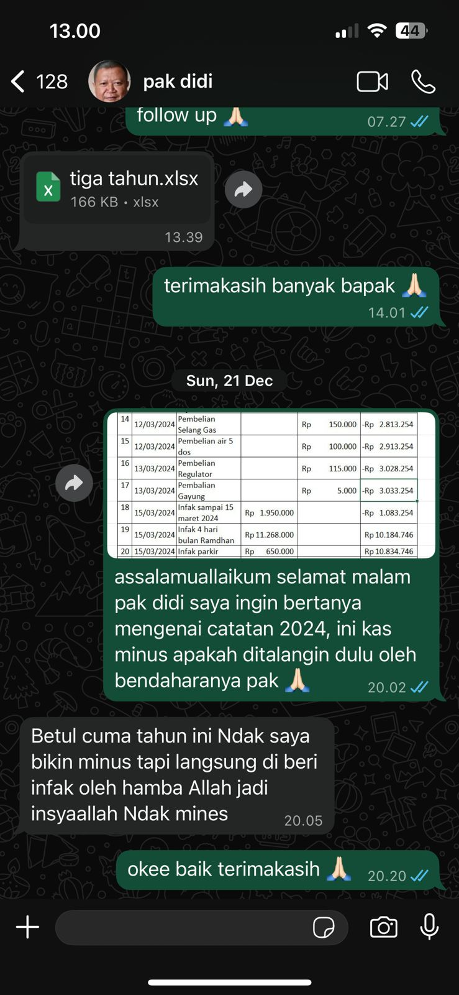

Appendix 4 Preparation of the financial report of the Nurul Ilmi Mosque
https://docs.google.com/spreadsheets/d/1f_qk3RYM7HyHC0gEWoWgf_D-Ue0IOB_O/edit?usp=drive_link&ouid=100189832280634142958&rtpof=true&sd=true

